**Discussion questions: 24 September**

**Shortcuts applied to curve sketching, continued**

I Using the shortcuts of differentiation *when appropriate*, compute the derivative of each of the following functions.

*(A) $y=2018+3x-πx^{4}+e^{1789}$*

$$\left(E\right) y= x^{3}\cos{x-x+1}$$

**

**

**

**

**

II (a) Find the equations of the *tangent* and *normal lines* to the curve

$$y=\frac{x-4}{x+1} at x=3.$$

(b) Find the equations of the *tangent* and *normal* lines to the curve

y = sin x at x = /4.

III Using appropriate shortcuts, find formulas for the derivatives of

y = tan x and y = sec x.

V Sketch the curve y = x3(x – 2)2. Over which interval(s) is the graph *rising?* *falling?*

Locate any local maxima or minima.

VI Sketch the curve $y=\frac{x-4}{x+1}$ (cf. problem II a). Over which interval(s) is the graph *rising*? *falling*? Locate any *local maxima* or *minima*.

VII Sketch the curve y = x ex. Over which interval(s) is the graph rising? *falling?* Locate any local maxima or minima.

X Sketch the curve y = 1/x + x2 over the interval (0, ∞). Over which interval(s) is the graph *rising*? *falling*? Locate any local maxima or minima.

XI Below is the graph of the function

*f*(*x*) = *rxe*−*qx,*

where *r* and *q* are constants. Assume that both *r* and *q* are greater than 1. The function *f*(*x*)

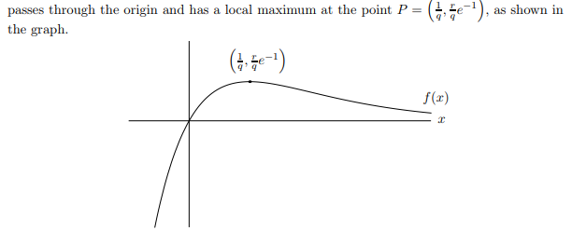

1. Justify, using the first-derivative test that the point *P* is a local maximum.
2. What are the *x*-coordinates of the global maximum and minimum of *f*(*x*) on the domain [0*,* 1]? (If *f*(*x*) does not have a global maximum on this domain, say “no”)
3. What are the *x*-coordinates of the global maximum and minimum of *f*(*x*) on the domain (−∞*,* ∞)? (If *f*(*x*) does not have a global maximum on this domain, say “no global maximum”, and similarly if *f*(*x*) does not have a global minimum.)



1. Suppose that *g*(*x*) is a function with *g*′(*x*) = *f*(*x*). Find *x*-values of all local maxima and minima of *g*(*x*). Justify that each maximum you find is a maximum and each minimum is a minimum.