Discussion questions: 26 September
Shortcuts applied to curve sketching

- By employing shortcuts, compute the derivatives of y = tan x and y = sec x .
- What can you say about $\frac{d}{dx} b^{x} where b is a positive constant?$
- (a) On the axes below, sketch graph of a single differentiable function, y = f(x), which has all of the following features.
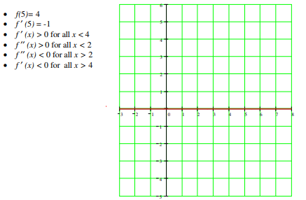
(b) Using the given information, find an equation of the line tangent to the graph of f at x = 5.
(c) Use your answer from part (b) to approximate f(6).
(d) From the given conditions (i.e., not just from your graph), will the approximation in part be an overestimate or an underestimate? Explain--using a complete sentence.

- Review: The graphs of $f, f^{'}, and f^{''}are shown below. Which is whch?$
- Review: A scientist is growing a very large quantity of mold. Initially, the mass of mold grows exponentially, but after many hours, the mass stabilizes at 24 kilograms.
Suppose that t hours after the scientist begins, the mass of mold, in kilograms, can be modeled
by the function M defined by the equation

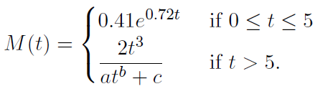
6. (a) Find the value of k between 0 and 5 so that M(k) = 1. Then interpret the equation M(k) = 1 in the context of this problem. Use a complete sentence and include units.
- Assuming that M is a continuous function of t, determine $\lim_{x→∞}{M(t)}$ and the values of a, b, and c.

7. (a) Find the equations of the tangent and normal lines to the curve
$$y=\frac{x-4}{x+1} at x=3.$$

(b) Find the equations of the tangent and normal lines to the curve
y = sin x at x = π/4.

8. Using appropriate shortcuts, find formulas for the derivatives of
y = tan x and y = sec x.

9. Charlotte, the spider, dances along the x-axis according to the rule
x(t) = t³ – 3t + 5. (Here time is measured in seconds and distance in cm.)
- Find Charlotte’s velocity at time t = 2 sec.

- Find Charlotte’s acceleration at time t = 2 sec.

10. Sketch the curve $y=\frac{x-4}{x+1}$ (cf. problem II a). Over which interval(s) is the graph rising? falling? Locate any local maxima or minima.
11. Sketch the curve $y=\frac{x-3}{x^{2}+1}.$Over which interval(s) is the graph rising? falling? Locate any local maxima or minima.

12. Consider the curve y = b + c sin x. For each of the following values of b and c, determine when the graph is rising and when it is falling:

- b = 3, c = 1
- b = c = 1
- b = 1, c = 2

13. Sketch the curve y = 1/x + x² over the interval (0, ∞). Over which interval(s) is the graph rising? falling? Locate any local maxima or minima.

14. Below is the graph of the function
f(x) = rxe^{−qx},
where r and q are constants. Assume that both r and q are greater than 1. The function f(x)
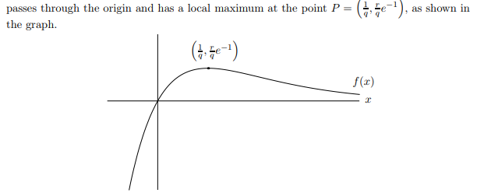
- Justify, using the first-derivative test that the point P is a local maximum.
- What are the x-coordinates of the global maximum and minimum of f(x) on the domain [0, 1]? (If f(x) does not have a global maximum on this domain, say “no
- What are the x-coordinates of the global maximum and minimum of f(x) on the domain (−∞, ∞)? (If f(x) does not have a global maximum on this domain, say “no global maximum”, and similarly if f(x) does not have a global minimum.)
- Suppose that g(x) is a function with g′(x) = f(x). Find x-values of all local maxima and minima of g(x). Justify that each maximum you find is a maximum and each minimum is a minimum.

What Romantic terminology called genius or talent or inspiration is nothing other than finding the right road empirically, following one’s nose, taking shortcuts.
- Italo Calvino (1923 – 1985)

