**Discussion: 5 September**

**limits & continuity**

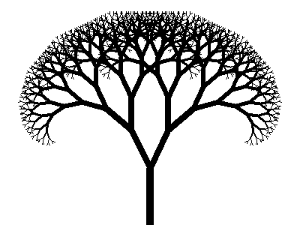

[***Fractal tree***](http://rosettacode.org/wiki/Fractal_tree)

**I** Evaluate each of the following limits or explain why the limit fails to exist.

**

**

**

**

**

**

**

**

**

**

**II**  State the *limit laws*.

**III** Define *continuity* of a function y = f(x) at x = a. What does it mean for a function to be *continuous*?

**IV** (a)For each of the four types of discontinuity (*removable, infinite, jump, essential*) give several examples.

(b) For the graph below, characterize each of the four discontinuities.

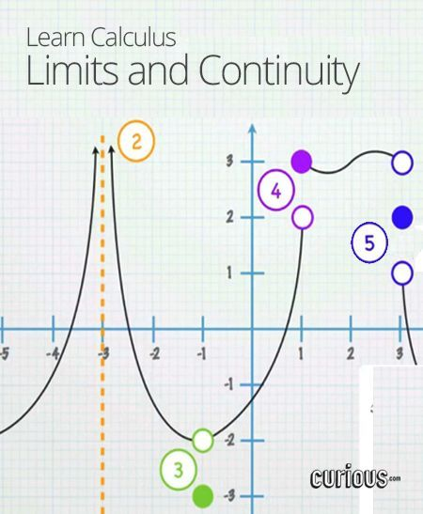

(c) Give an example of an *essential discontinuity.*

**V** Consider each of the following functions and the given point on the x-axis. Does the function have a *continuous extension* at the given point? Explain.

**

**

**

**

**VI** For which value of *a* is the following function *continuous everywhere?*

**

**VII** For which values of *a* and *b* is the following function *continuous everywhere?*

**

**VIII** State the *Intermediate Value Theorem.* Using the IVT, prove that the polynomial f(x) = x4 + 4x3 – 20x + 11 must have a root between x = 0 and x = 1 .

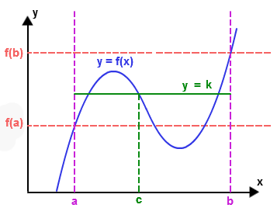

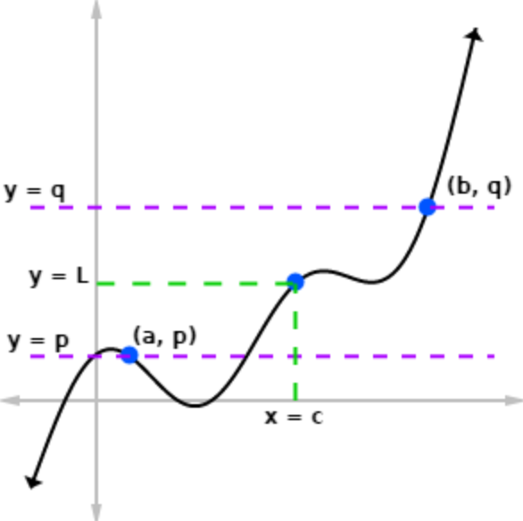

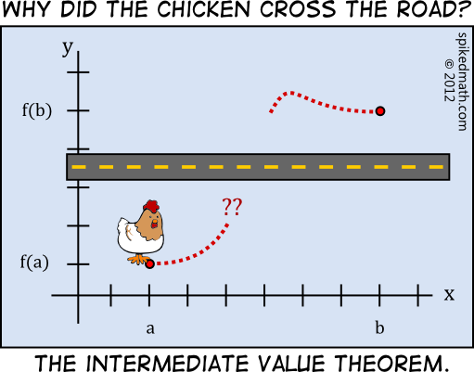

**IX** State the *Squeeze Theorem (a.k.a. Sandwich Theorem, Pinching Theorem, Two Gendarmes Theorem, Two Policemen and a Drunk Theorem)*.

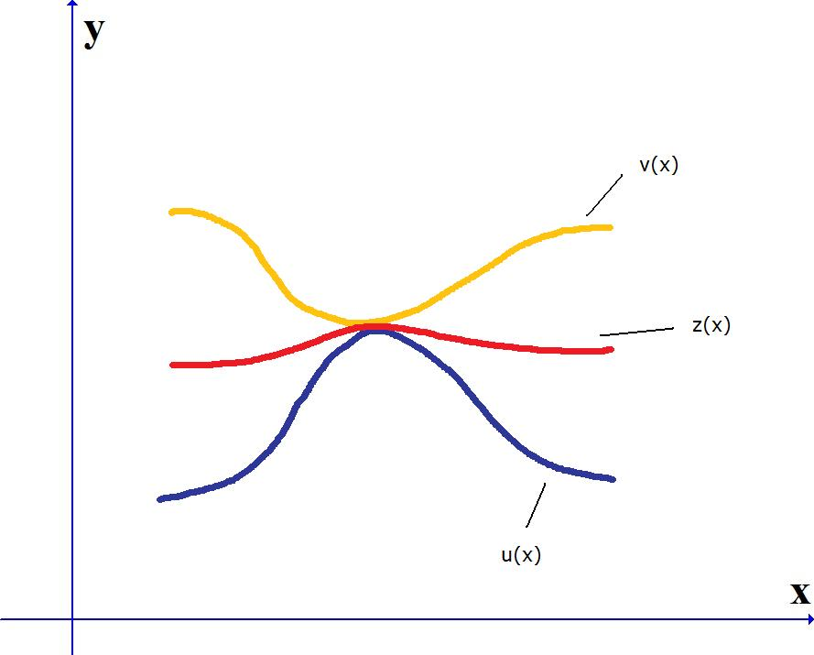

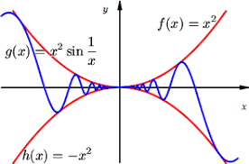

**X** (a) Is the function f(x) = (sin x)/x *even* or *odd* or neither?

(b) Using the Sandwich Theorem prove that $\frac{\sin{x}}{x}→1 as x→0$.

(This result is the key to our being able to differentiate the trig functions.)



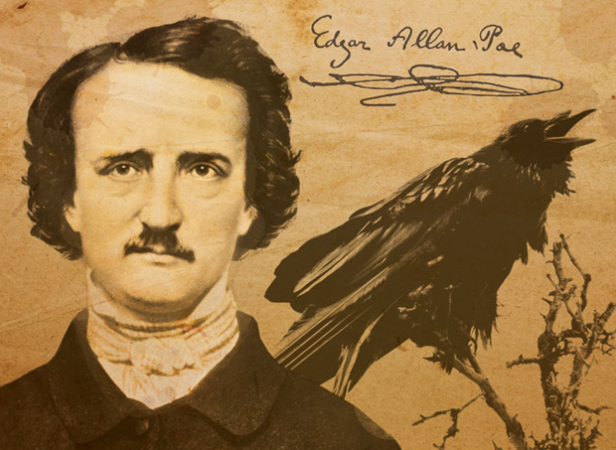

# “I could have clasped the red walls to my bosom as a garment of eternal peace. "Death," I said, "any death but that of the pit!" Fool! might I have not known that into the pit it was the object of the burning iron to urge me?”

# ― Edgar Allan Poe, The Pit and the Pendulum

[Course Home Page](http://www.math.luc.edu/~ajs/courses/161fall2018/index.pdf)          [Department Home Page](http://www.math.luc.edu/)        [Loyola Home Page](http://www.luc.edu/)