**Discussion: 5 & 7 September**

**limits & continuity**



[***Fractal tree***](http://rosettacode.org/wiki/Fractal_tree)

**I** Evaluate each of the following limits or explain why the limit fails to exist.

$$11. \lim_{x→∞}{\frac{x{(3x-2018)}^{3}}{{\left(9+x\right)}^{2}(x^{2}+x+2018)(2x-1)(x+11)}}$$

$$12. \lim_{x→-∞}{\frac{{3x}^{4}+4\sin{x}}{{(x-1)}^{4}+3x+\cos{5x}}}$$

$$13. \lim_{x→∞}{\frac{(4x+1){(x+3)}^{5}}{{\left(x+1\right)}^{3}{(x-99)}^{4}}}$$

**

**

**

**

**

**

**

**

**

**

**II**  State the *limit laws*.

**III** Define *continuity* of a function y = f(x) at x = a. What does it mean for a function to be *continuous*?

**IV** (a)For each of the four types of discontinuity (*removable, infinite, jump, essential*) give several examples.

(b) For the graph below, characterize each of the four discontinuities.

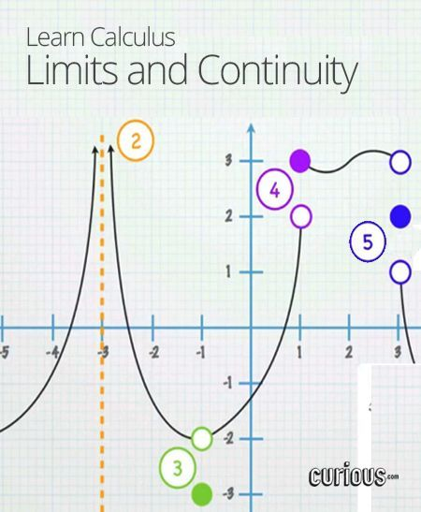

(c) Give an example of an *essential discontinuity.*

**V** Consider each of the following functions and the given point on the x-axis. Does the function have a *continuous extension* at the given point? Explain.

**

**

**

**

**VI** For which value of *a* is the following function *continuous everywhere?*

**

**VII** For which values of *a* and *b* is the following function *continuous everywhere?*

**

**VIII** State the *Intermediate Value Theorem.* Using the IVT, prove that the polynomial f(x) = x4 + 4x3 – 20x + 11 must have a root between x = 0 and x = 1 .

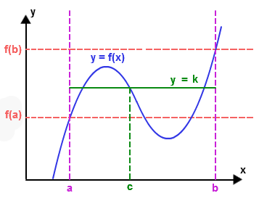

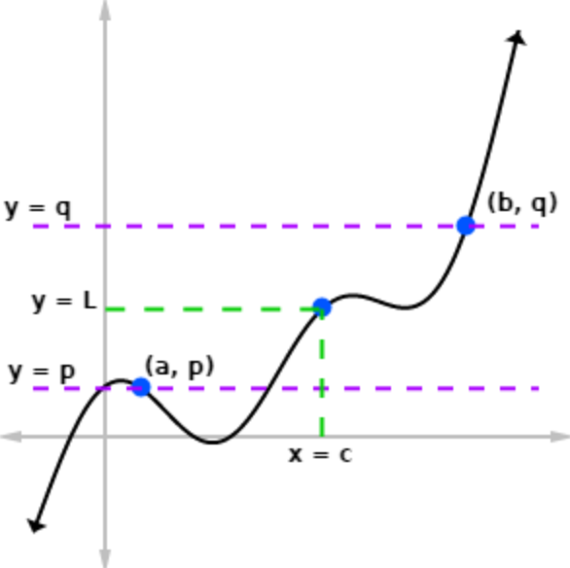

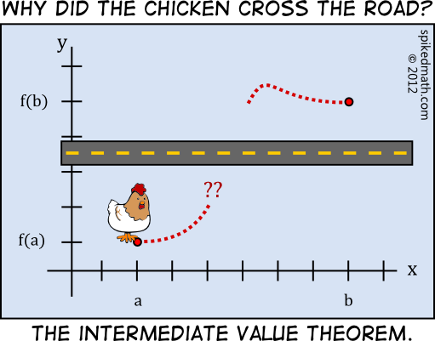

**IX** State the *Squeeze Theorem (a.k.a. Sandwich Theorem, Pinching Theorem, Two Gendarmes Theorem, Two Policemen and a Drunk Theorem)*.

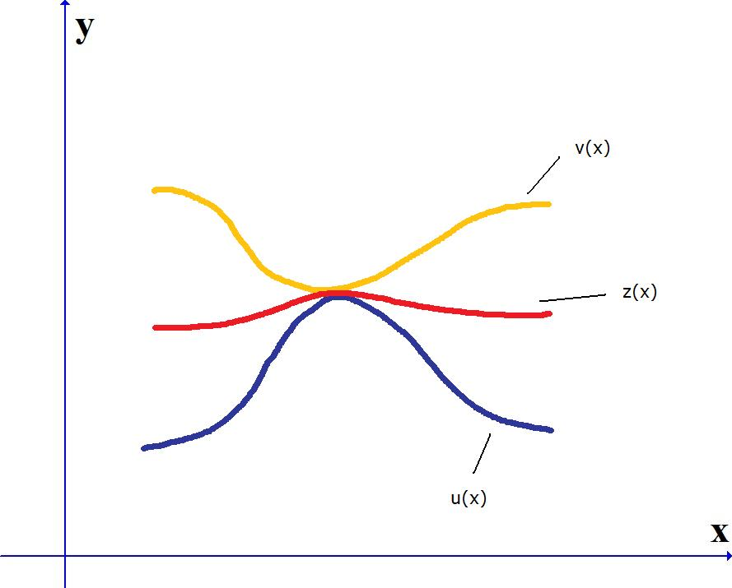

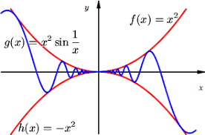

**X** (a) Is the function f(x) = (sin x)/x *even* or *odd* or neither?

(b) Using the Sandwich Theorem prove that $\frac{\sin{x}}{x}→1 as x→0$.

(This result is the key to our being able to differentiate the trig functions.)



**Additional exercises**

1. Compute each of the following limits. Explain your reasoning. Do not use calculators.

(a) 

(b) 

(c) 

(d) 

(e) 

2. Use the graph below to find approximate values for each of the following limits (if they exist).













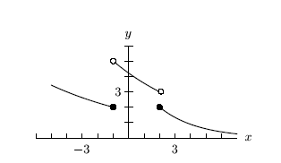

3. Calculate each of the following limits or explain why the limit does not exist. Justify each answer. If you use the *Squeeze Theorem*, be precise.

(a) 

(b) 

(c) 

(d) 

4. Compute each of the following limits or explain why the limit fails to exist. Justify your reasoning. Do not use a calculator.

(a) 

(b) 

(c) 

(d) 

(e) 

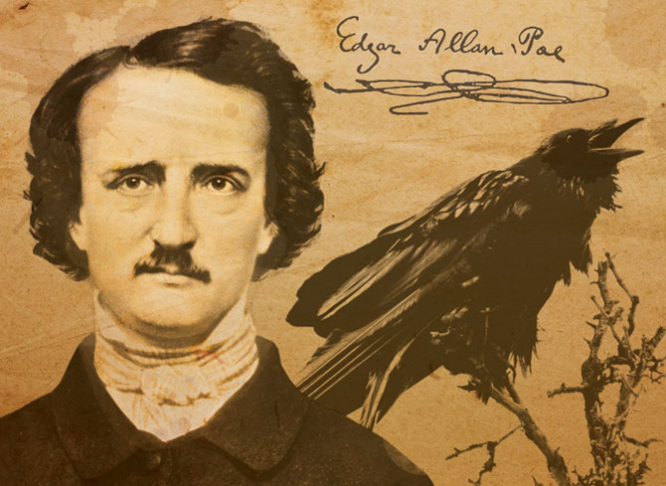

# “I could have clasped the red walls to my bosom as a garment of eternal peace. "Death," I said, "any death but that of the pit!" Fool! might I have not known that into the pit it was the object of the burning iron to urge me?”

# ― Edgar Allan Poe, The Pit and the Pendulum

[Course Home Page](http://www.math.luc.edu/~ajs/courses/161fall2018/index.pdf)          [Department Home Page](http://www.math.luc.edu/)        [Loyola Home Page](http://www.luc.edu/)