Questions for class discussion: MATH 161

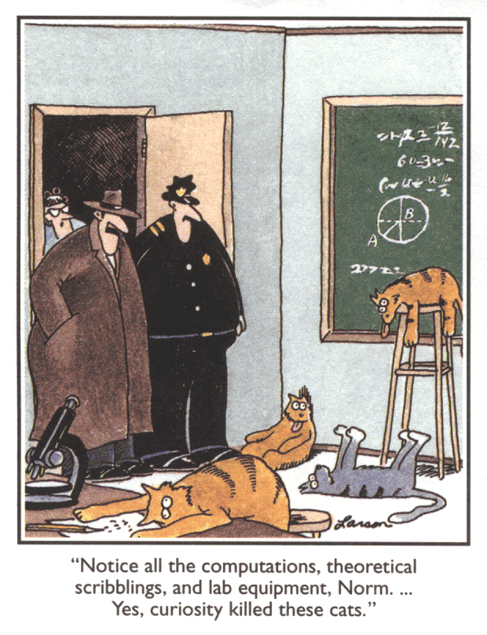

27 August 2018: riddles & UM pre-calculus final exam
29 August 2018: rational functions, zeroes, singularities, sign analysis, limiting behavior
31 August 2018: additional precalculus problems from U. Mich.
Old practice Math 117 (precalculus I) final exam
5 & 7 September 2018: limits, limit laws, continuity, types of discontinuities
10 September: Squeeze Theorem, Intermediate Value Theorem
12 September: Trigonometric limits; one-sided limits
17 September: an introduction to the derivative; geometric differentiation
19 September: the derivative, continued
21 and 24 September: shortcuts
26 September: shortcuts applied to curve sketching
1 October: higher-order derivatives; intro to the “game of anti-differentiation.”
3 October: linearization

Work! God wills it. That, it seems to me, is clear.
- Gustave Flaubert (letter to Louise Colet, 1845)

Department Home Page Loyola Home Page

