HOMEWORK: MATH 161
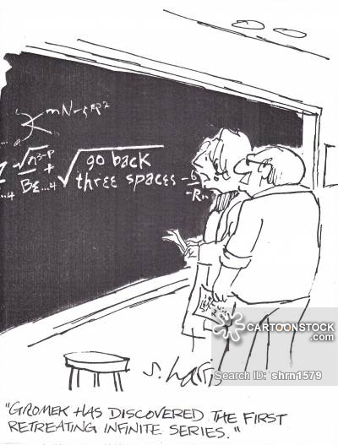

Homework 0: (Due: midnight, Wednesday, 29 August 2018)
Briefly provide (in one or two paragraphs) information about yourself that will help me get to know you. If you wish, you may let the following questions serve as a guide: Why are you taking Math 161? What is your major? Or possible majors? Any minors? Have you taken other math courses at Loyola? Describe your experience with high school math courses.
(Please post your response as a private message in Piazza with the subject HW 0.)

Never work when hungry.
- Hippocrates
Where our work is, there let our joy be.
- Tertullian
Let us work without protest; it is the only way to make life endurable.
- Voltaire
Work! God will it. That, it seems to me, is clear.
- Flaubert
Course Home Page Department Home Page Loyola Home Page

