Math 161 - 005

Calculus I

Fall 2018

MWF 1:40 – 3:35 pm

(236 Dumbach Hall)
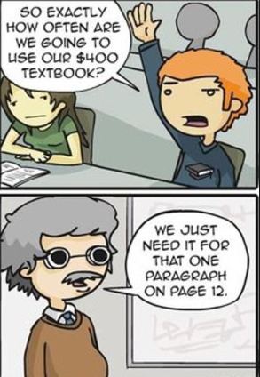
- Ground Rules
- Syllabus
- WebAssign (Getting Started)
- WebAssign Homework & Reading Assignments
- Written Assignments
- Quiz Solutions (1, 2, 3, 4, 5, 6, 7, 8, 9, $10$)
- Test Solutions (test 1, test 2, test 3)
- OldTests (test1, test 2, test 3)
- Practice Finals (Final A, Final B)
- Final Review Topics
- Class Discussion Questions
- Piazza
- Tutoring Services and Schedule
- Mathematica Examples: basic ops (pdf, nb), implicit differentiation (pdf, nb), area (pdf, nb)
- Mathematica Labs (Lab 1, Lab 2, Lab 3)
- Calculus test banks: University of Michigan; NYU; Washington University St. Louis
- MIT OCW for Calculus
- Project/Essay topics
- Useful References (Greek alphabet; Mathematica tutorials & websites; supplementary texts and calculus websites)
- History of Calculus
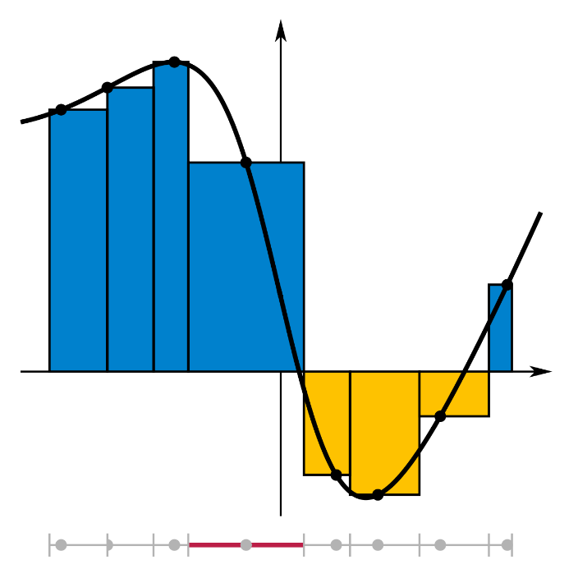

Department Home Page Loyola Home Page

