Mathematica Lab I
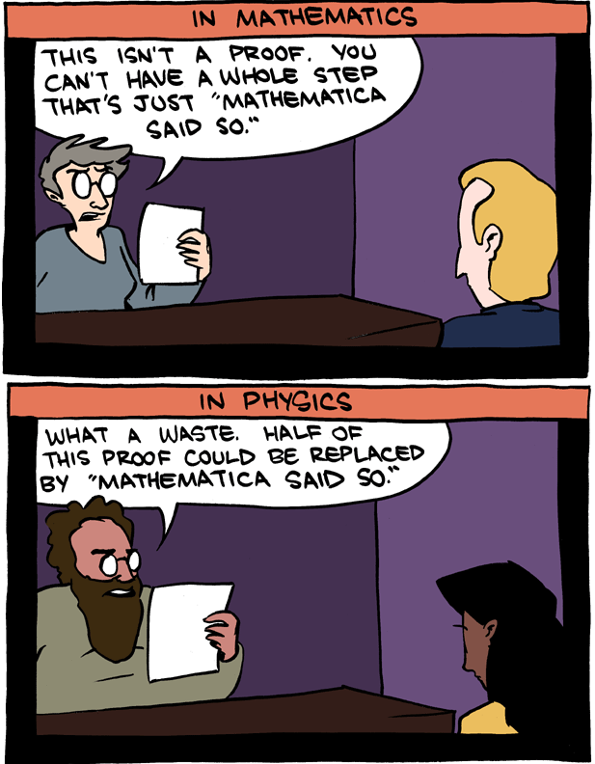
This cartoon is drawn from Saturday Morning Breakfast Cereal.
(Lab report due: September 26)
You may work with other students but you must submit your own lab report. At the top of the lab, please list any and all people (other than the instructor) who assisted you. If several people are submitting exactly the same results (especially identical errors), their scores may be reduced accordingly.
You must submit your lab as a notebook (for file name use: lab1.nb) that contains neither output from Wolfram Alpha, nor free-form linguistic input. If you do not know the proper commands then of course you may use free-form input to steer you in the right direction. But submit your solutions in the Mathematica language. Do not use calculators when Mathematica is far more powerful than any calculator yet conceived. When you need help, please see me or Collins.
You have the option of downloading Mathematica 11.2 on your laptop (for free) or else using Loyola’s network.

First read the following sections of Thomas’ An Introduction to Mathematica.
- Mathematica arithmetic
- Assigning names
- Mathematica commands
- Common problems and how to fix them

You are also encouraged to view several of Wolfram’s Mathematica tutorials http://www.wolfram.com/broadcast/screencasts/handsonstart/

Submit a printed version of your Mathematica notebook. On your front page (using Mathematica) state your name and “Mathematica Lab I” using an appropriate style, font, size and color in Mathematica.
Number each problem and restate the problem before giving the solution.

1. Which is larger?: e^{π} or π^{e} Explain why? (Hint: Consider the difference of the two numbers.)
2. Express 1.23^{4.567} correct to 13 significant digits.
3. Using the FactorInteger command, find the prime decomposition of 1234567890
4. Using the Simplify command, simplify the expression
(Hint: Be careful of the syntax when you enter this quantity.)
5. Find the largest prime factor of n = 88⁹ + 74⁴ + 1
6. A Mersenne prime is defined to be a prime number of the form 2^{n} – 1. Using basic algebra, it is easy to show that if 2^{n} – 1 is prime then n must be prime as well. In 1644, in the preface to his book, Cogitata Physica-Mathematica, Mersenne asserted that 2^{n} – 1 is prime for n = 2, 3, 5, 7, 13, 17, 19, 31, 67, 127. Was Mersenne correct? Explain. (Give a convincing argument!)
(Hint: Be careful!)
The 46th Mersenne prime found in 2008.
(chosen by Time Magazine as one of the “50 best inventions of 2008”)

7. Which is larger: 75! or 29⁷⁵? Why? (Give a convincing argument!) Hint: You may wish to consider the quotient rather than the difference.)
8. Using the Expand command, simplify fully the expression
(a + b – c)³ – (a – b – c)³

9. Simplify ${\left(1+\sqrt{11}\right)}^{8}-{\left(1-\sqrt{11}\right)}^{8}$

10. Simplify the algebraic expression $\frac{1}{x - \frac{1}{x + \frac{1}{x}}}-\frac{1}{x + \frac{1}{x - \frac{1}{x}}}$

11. Solve the quartic equation x⁴ – 8x³ + 10x² + 24x + 5 = 0 using
(cf. Thomas pg. 21– 22)
(a) the Solve command
(b) the NSolve command
(c) the FindRoot command
How do these three results differ, if at all?

“If you don't know where you are going, any road will get you there.”
- Lewis Carroll

Course Home Page Department Home Page Loyola Home Page

