MATH 161 Answers: TEST I

September 2017

1. Albertine orders a large cup of coffee at Metropolis on Granville. Let F(t) be the temperature in degrees Fahrenheit of her coffee t minutes after the coffee is placed on her tray.
(a) (2 pts) Explain the meaning of the statement: F(9) = 167. (Use complete sentences. Avoid any mathematical terms!)
(b) (3 pts) Explain the meaning of the statement: F⁻¹(99) = 17.5

(c) (3 pts) Give the practical interpretation of the statement: F′(9) = – 1.10. (Use complete sentences. Do not use the words “derivative” or “rate” or any other mathematical term in your explanation.)

(d) (1 pt) What are the units of F′(9)?

Answer: F/ minute (since F/ t represents change in temp/ change in time.)

(e) (3 pts) Using the information given in parts (a) and (c), estimate the temperature of Albertine’s coffee seven minutes after she has been handed the coffee.

Answer: 169.2 F.

(f) (3 pts) Extra Credit
Explain the meaning of the statement:
${\left(F^{-1}\right)}^{'}\left(99\right)=-1$

- (4 pts each) For each of the following three sets of axes, exactly one of the following statements (a) – (e) is true. You may use a letter more than once. In the space provided next to each figure, enter the letter of the true statement for that figure. For each graph, note that the x and y scales are not the same.
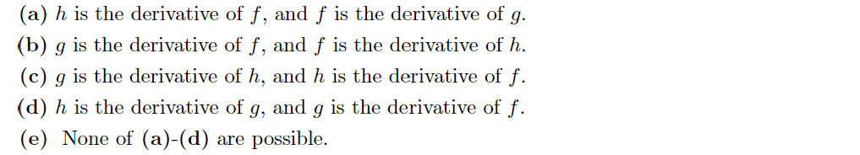
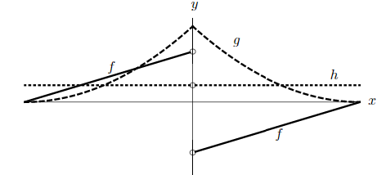
True Statement: A

True Statement: E

True Statement: D

- (12 pts) Using the limit definition of the derivative, write an explicit expression for the derivative of the function
g(x) = (cos x)^{x} at x = 3.
Do not try to calculate this derivative.

Answer:
$${ g}^{'}\left(3\right)=\lim_{h→0}{\frac{g\left(h+3\right)-g(3)}{h}}=\lim_{h→0}{\frac{{\left(\cos{(h+3)}\right)}^{h+3}-{(\cos{3)}}^{3}}{h}}$$

- (a) (6 pts) Find $\lim_{x→∞}{f\left(x\right) if, for all x>5,}$
Explain!
Which theorem are you using?
Answer: Use the Squeeze Theorem to conclude that f(x)$→4$ $as x→∞.$

(b) (6 pts) Show that y = f(x) = x³ + 5e^{x} + 1 has at least one real root. Explain!
Which theorem are you using?

Answer: Using the Intermediate Value Theorem we may conclude that f must have a root on the interval
(-10, 1). (Of course, this is only one of infinitely many correct answers.)

5. (12 pts) Find an equation of the normal line to the curve
$y=g\left(x\right)=\frac{x^{2}-1}{x^{2}+1}$ at x = 1.
You may use shortcuts.
Answer: y = 1 – x.

6. (12 pts) The graph of a function g is shown below. For each of the following, decide if the limit exists. If it does, find the limit. If it does not, decide if the “limit” is ∞, -∞, or neither. No justification is necessary for full credit, but show your work for purposes of partial credit.
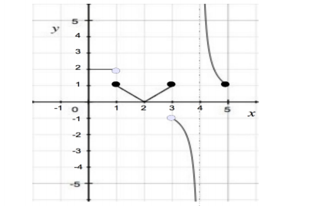
Answers:
- $\lim_{x→0^{+}}{g(x)}=2$
- $\lim_{x→1^{-}}{g(x)}$=2
- $\lim_{x→1^{+}}{g(x)}$=1
- $\lim_{x→1}{g(x)}$=does not exist; neither ± ∞.
- $\lim_{x→2}{g(x)}$= 0
- $\lim_{x→0^{+}}{g\left(x\right)= }$ [redundant]
- $\lim_{x→3^{-}}{g(x)}$=1
- $\lim_{x→3^{+}}{g\left(x\right)}= -1$
- $\lim_{x→3}{g\left(x\right)= }$does not exist; neither ± ∞.
- $\lim_{x→4^{+}}{g\left(x\right)=}$∞
- $\lim_{x→4^{-}}{g\left(x\right)= }$ -∞
- $\lim_{x→4}{g(x)}=$does not exist; neither ± ∞.
- $\lim_{x→5^{-}}{g(x)}=$1

7. Suppose that f(x) is a function that is continuous on the interval [-2, 2]. The graph of $f^{'}\left(x\right)on the interval \left[-2, 2\right] is given below.$

- (6 pts) Let y = L(x) be the local linearization of f(x) at x = -1. Using the fact that f(-1) = -4, write a formula for y = L(x).

Answer: L(x) = -4+3(x+1)

- (6 pts) Use your formula for L(x) to approximate f(-0.5).

Answer: -5.5

8. Suppose that f and g are differentiable functions satisfying:
f(3) = -2, g(3) = -4, f ′(3) = 3, and g′(3) = -1.
- (6 pts) Let H(x) = (f(x) + 2g(x) + 1)(f(x) – g(x) – 4). Compute H′(3) (Hint: Use short cuts here.)
Answer: -38
Compute M′(3)
Answer: $\frac{45}{98}$
9. For each of the following, find any and all critical points. Then, using the first derivative test, classify them (local max, local min, neither).

- (6 pts) y = f(x) = x³ – 3x + 1

Answer: f achieves a local maximum at x = -1 and a local minimum at x =1.

- (6 pts) y = g(x) = 3x⁴ –16x³ + 18x² + 1

Answer: g achieves a local maximum at x = 4 and local minima at x = 1 and x = 6.

10. Let y = f(x) be a differentiable function with derivative
$$f^{'}\left(x\right)= \frac{e^{x}(x-1){\left(x-2\right)}^{2}{\left(x-4\right)}^{3}{\left(x-5\right)}^{4}{(x-6)}^{5}}{1+x^{4}}$$
- (4 pts) Find any and all critical points.

$$Answer: x=1, 2, 4, 5, and 6$$

- (8 pts) Classify each critical point (local max, local min, neither).

Answer: Using the first derivative test, we find that x = 4 is a local maximum; x= 1 and x = 6 are both local minima.

11. (3 pts each) Compute each of the following limits. Justify your reasoning.

Answer: 27/2
Answer: - 2/27
Answer: 0

Answer: ½

12. (3 pts each) For each of the following functions, determine the type of discontinuity at the given point. If it is a removable discontinuity, find a continuous extension of the function.

- $y= \frac{x^{3}-x^{2}-2x}{\left(x-2\right)(x+5)}$ at x = 2

Answer: This is a removable discontinuity. The continuous extension requires that y be defined as $\frac{6}{7}$ when x = 2.

- $y= \frac{x^{3}-x^{2}-2x}{\left(x-2\right)(x+5)}$ at x = -5

Answer: an infinite discontinuity.

- $y= cos\frac{3}{x} at x=0$

Answer: essential discontinuity.

- $y= \frac{|x|}{x} at x=0$

Answer: jump discontinuity

