# MATH 161 Old TEST I September 2017

**Instructions:** *Answer any 10 of the following 12 questions. You may solve more than 10 to obtain extra credit.* ☺

1. Albertine orders a large cup of coffee at Metropolis on Granville. Let F(t) be the temperature in *degrees Fahrenheit* of her coffee *t* *minutes* after the coffee is placed on her tray.

(a) Explain the meaning of the statement: F(9) = 167. (Use complete sentences. Avoid any mathematical terms!)



(b) Explain the meaning of the statement: F-1(99) = 17.5

(c) Give the *practical* interpretation of the statement: F′(9) = – 1.10. (Use complete sentences. Do not use the words “derivative” or “rate” or any other mathematical term in your explanation.)

(d) What are the *units* of F′(9)?

(e) Using the information given in parts (a) and (c), estimate the temperature of Albertine’s coffee *seven* minutes after she has been handed the coffee.

(f) [Extra Credit] Explain the meaning of the statement:

${\left(F^{-1}\right)}^{'}\left(99\right)=-1$

1. For each of the following three sets of axes, exactly one of the following statements (a) – (e) is true. You may use a letter more than once. In the space provided next to each figure, enter the letter of the true statement for that figure. For each graph, note that the x and y scales are not the same.

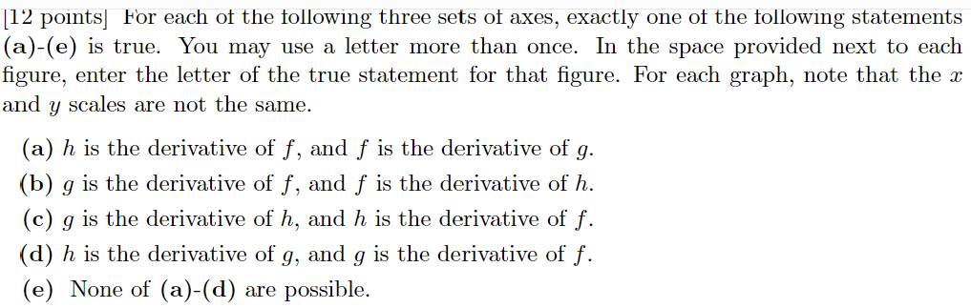

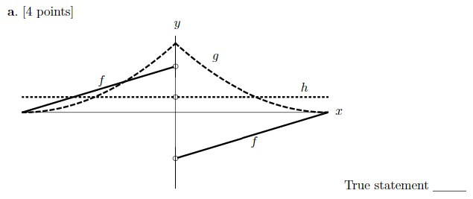

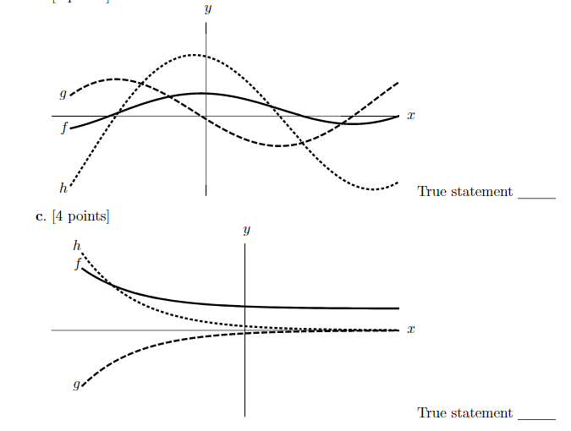



1. Using the limit definition of the derivative, write an explicit expression for the *derivative* of the function

g(x) = (cos x)x at x = 3. *Do not try to calculate this derivative.*

1. *(a) Find $\lim_{x→∞}{f\left(x\right) if, for all x>5,}$*

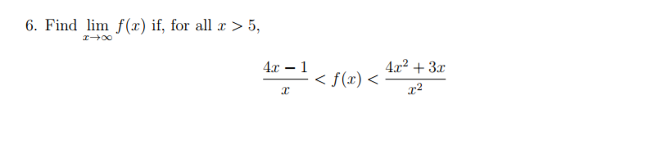

*Explain!*

*Which theorem are you using?*

(b) Show that y = f(x) = x3 + 5ex + 1 has *at least one* real root. *Explain!*

Which theorem are you using?

5. Find an equation of the *normal line* to the curve

$y=g\left(x\right)=\frac{x^{2}-1}{x^{2}+1}$ at x = 1.

You may use short cuts.

6. The graph of a function *g* is shown below. For each of the following, decide if the limit exists. If it does, find the limit. If it does not, decide also if the “limit” is ∞, -∞, or neither. No justification is necessary for full credit, but show your work for purposes of partial credit.

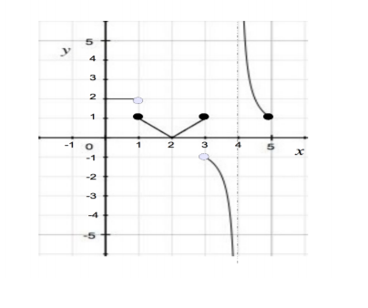

1. *=*
2. *=*
3. *=*
4. *=*
5. *=*

7. Suppose that f(x) is a functon that is continuous on the interval [-2, 2]. The graph of $f^{'}\left(x\right)on the interval \left[-2, 2\right] is given below.$

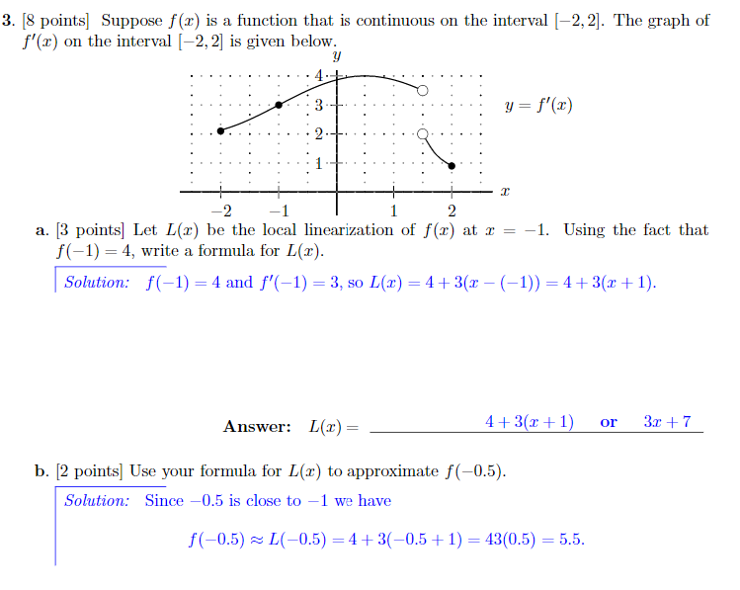

1. Let y = L(x) be the local linerariztion of f(x) at x = -1. Using the fact that f(-1) = -4, write a formula for y = L(x).
2. Use your formula for L(x) to approximate f(-0.5).

8. Suppose that *f* and *g* are differentiable functions satisfying:

f(3) = -2, g(3) = -4, f ′(3) = 3, and g′(3) = -1.

1. Let H(x) = (f(x) + 2g(x) + 1)(f(x) – g(x) – 4). Compute H′(3) (Hint: Use short cuts here.)

 Compute M′(3)

9. For each of the following, find any and all critical points. Then, using the first derivative test, classify them (local max, local min, neither).

1. y = x3 – 3x + 1
2. y = 3x4 –16x3 + 18x2 + 1

10. Let y = f(x) be a differentiable function with derivative

$$f^{'}\left(x\right)= \frac{e^{x}(x-1){\left(x-2\right)}^{2}{\left(x-4\right)}^{3}{\left(x-5\right)}^{4}{(x-6)}^{5}}{1+x^{4}}$$

1. Find any and all critical points.
2. Classify each critical point (local max, local min, neither).

11. Compute each of the following limits. *Justify your reasoning.*









12. For each of the following functions, determine the type of discontinuity at the given point. If it is a *removable* discontinuity, find continuous extension of the function.

1. $y= \frac{x^{3}-x^{2}-2x}{\left(x-2\right)(x+5)}$ at x = 2
2. $y= \frac{x^{3}-x^{2}-2x}{\left(x-2\right)(x+5)}$ at x = -5

$y= cos\frac{3}{x} at x=0$

$y= \frac{|x|}{x} at x=0$

*It is a hypothesis that the sun will rise tomorrow: and this means that we do not know whether it will rise.*

**- Ludwig Wittgenstein**



