# MATH 161 Solutions: QUIZ I

*No graphing calculators permitted!*



1. *[10 pts]*  How many real roots does each of the following polynomials possess? List all of the roots. In case there are no real roots, write NONE. (You need not show your work.)
2. y = x4 – 16 *Answer:* number of roots = 2 ; the roots are: x = 2, -2
3. y = x2 + 1789 *Answer:* number of roots = 0 ; the roots are: do not exist
4. y = x3– 1 *Answer:* number of roots = 1 ; the roots are: x = 1
5. y = (x – 9)99(x + 2018)5(x – 11)x4 *Answer:* number of roots = 4; the roots are: x = 9, -2017, 11, 0
6. y = (x2 – 81)(x2 + 7x + 12345) *Answer:* number of roots = 2 ; the roots are: x = -9, 9
7. *[10 pts]*  In this problem, we consider two functions:

* W(s)* is the wind-chill (in degrees Fahrenheit) when the temperature is 30 degrees Fahrenheit and the wind speed is *s* mph (miles per hour).
* B(c) is the time (in minutes) it takes to develop frostbite on exposed skin when the wind- chill is *c* degrees Fahrenheit.

Assume both W and B are invertible (that is, each function has an inverse).

Fill in each blank below with one of the possible answers given below.

*Note that a given answer may be used in more than one blank and that not all possible answers will be used.*

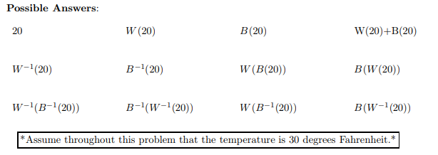

a. If the wind-chill is _**W(20)_** degrees Fahrenheit, the wind speed is 20 mph.

b. When the wind-speed is 20 mph, exposed skin will develop frostbite in _**B(W(20))**_minutes.

c. If the wind-chill is 20 degrees Fahrenheit, then the wind speed is **W-1(20)** mph.

d. If the wind-chill is 20 degrees Fahrenheit, then it will take exposed skin _**B(20)**_ minutes to develop frostbite.

e. When the wind-chill is B−1 (20) degrees Fahrenheit, exposed skin will develop frostbite in _**20**_ minutes.

* *Wind-chill* is the temperature “it feels like.

3. *[10 pts]*  Write an equation of a rational function that is represented by the following graph. (Note: there are many possible correct answers.)

*Assume that*

Zeroes: 2, 7/2, -6

Singularities: x = 0, x = 4

Limiting behavior: y $→$ 4 as x $→$ $±∞$

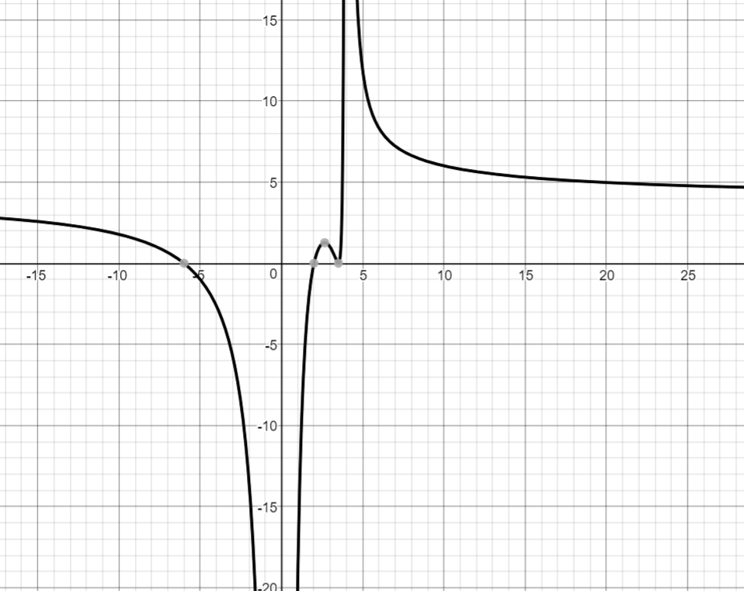

***Answer:*** *Note there is no sign change at x = 0, x = 7/2, and x = 4.*

*Thus y must be similar in form to $f\left(x\right)=\frac{(x-2){\left(x-\frac{7}{2}\right)}^{2}(x+6)}{x^{2}{(x-4)}^{2}}$*

*But the limiting behavior of f as $x→∞ is y→1.$ To compensate for this, we multiply f(x) by 4 to obtain:*

$$g\left(x\right)=\frac{4(x-2){\left(x-\frac{7}{2}\right)}^{2}(x+6)}{x^{2}{(x-4)}^{2}}$$

1. *[8 pts]*

**MATCHING**

|  |  |
| --- | --- |
|  |  |
|  |  |

* **Enter your answers here:**

$f\left(x\right)=x^{2}{(x-4)}^{3} (x+5) c$ orresponds to Graph **B**

$f\left(x\right)=x^{2} {(x-4)}^{2} {(x+5)}^{2}$ corresponds to Graph **A**

$f\left(x\right)=x (x-4){(x+5)}^{2}$ corresponds to Graph **D**

$f\left(x\right)=x {(x-4)}^{3}(x+5)$ corresponds to Graph **C**

***Extra Credit Riddle:*** *[7 pts]* On the island of Oz, each of the residents is either a knight or a knave. Knights *always* tell the *truth*; Knaves *always* *lie*. A reporter for Loyola’s *Phoenix* approaches two residents of the island, Albertine, and Beatrice. Albertine says "We are the same kind," but Beatrice says "We are of different kinds." What, if anything, can the reporter conclude? Explain!

*Solution: Albertine says "We are the same kind," but Beatrice asserts "We are of different kinds.” They are making contradictory statements and so one must be lying and one telling the truth. That is, one is a knave, and one must be a knight. Since that is exactly what Beatrice said, Beatrice must be the knight, and Albertine be the knave.*

