# **MATH 161 Solutions: QUIZ III**

# Consider the functions f(x) and g(x) given by the formula and graph below.

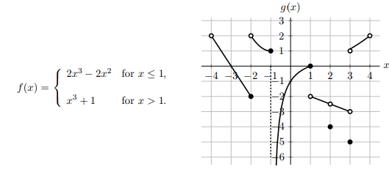

1. Circle the correct answer(s) in each of the following questions.
2. At which of the following values of x is the function g(x) *not* continuous?
3. At which of the following values of x is the function f(x) + g(x) continuous?



Note that g(x) is linear on each of the intervals (−4, −2), (1, 2) and (2, 3). All your answers below should be *exac*t. If any of the quantities do not exist, write DNE.

1. *Find $\lim_{x→2}\left(2f\left(x\right)+g(x\right))$*

*Solution: $\lim_{x→2}\left(2f\left(x\right)+g(x\right))=\underset{x→2}{2 lim}{f\left(x\right)+}\lim_{x→2}{g\left(x\right)=}$*



$$2\left(9\right){+\left(-2.5\right)=15.5}$$

$Find\lim_{x→∞}{\frac{f(2x)}{x^{3}}}$

Answer: **8**



$Find\lim_{x→∞}{g\left(x^{2}e^{-x}+3\right)}$

Answer: **1**

1. *For which value(s) of p does $\lim_{ x→p+}{g\left(x\right)=1}$*

Answer: **-3.5, 3**

1. *Find $\lim_{x→{-1}^{-}}{f\left(-x\right)}$*

***Solution:*** Let t = -x. Then as $x→{-1}^{-}, t→1^{+}.$

$Thus \lim_{x→{-1}^{-}}{f\left(-x\right)}=\lim_{t→1^{+}}{f\left(t\right)}=$**2**

1. Using the IVT explain why the function f(x) = x + 3 – 2 sin x must have *at least one real root.*

***Solution:*** *Note that f(0) = 3 > 0 and $f\left(-π\right)$ = - $π$ + 3 – 2 sin $(-π)$ = 3 – $π<0.$*

*Also note that f is continuous on the interval [, ] since f is a sum of continuous functions. Since f) < 0 < f(), the IVT guarantees the existence of a root of the equation G(x) = 0 in the interval [, ].*

1. Using the *Squeeze Theorem*, show that the function



has a limit as x → 0 and find the value of this limit. (You need not state the general theorem; only show how it can be applied here.)

***Solution:*** *First, a brief review of the Squeeze theorem.*

*Theorem: Let v(x), z(x), u(x) be functions defined on an interval (a, b) except possibly at the point p, where p(a, b)*

*In addition, assume that*

**

*Then*

**

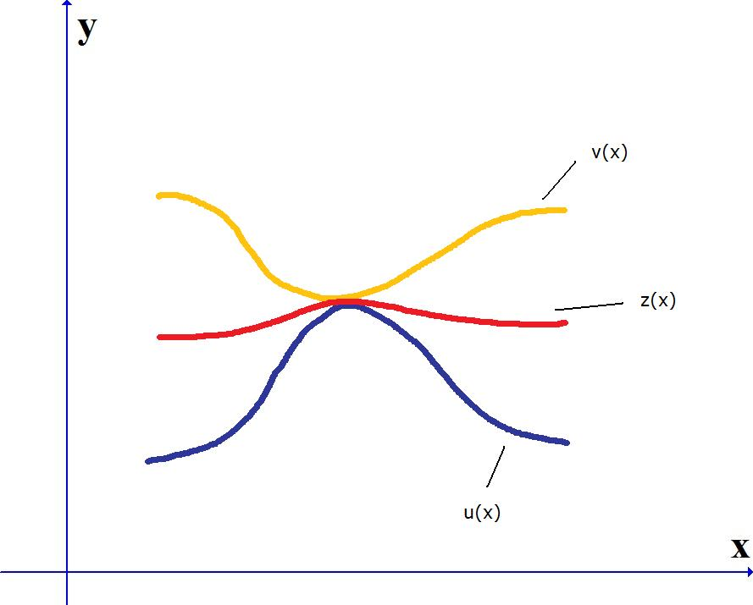

*Returning to the original question:*

**

*Now, as x → 0, 3x4 → 0 and -3x4 → 0.*

*Thus, invoking the Squeeze Theorem, we obtain:*

$$\lim_{x→0}{3x^{4}\cos{\frac{x+1732}{x^{3}}=0}}$$

1. Compute each of the following limits. As usual, show your work
2. Find $\lim_{ x→ \frac{π}{2}}{\frac{\sin{x}}{x}}$

***Solution:*** *Since* we can use the limit law for quotients:



1. Find $\lim_{ x→0}{\sqrt{\frac{\sin{9x}}{x}}}$

***Solution:***

$$\lim_{ x→0}{\sqrt{\frac{\sin{9x}}{x} }=\sqrt{\lim_{ x→0}\frac{\sin{9x}}{x}}}=\sqrt{9}=3$$

1. Find $\lim_{ x→0}{ \frac{\tan\left(21x\right)}{x cos\left(3x\right) }}$

***Solution:***

$$\lim_{ x→0}{ \frac{\tan\left(21x\right)}{x cos\left(3x\right) }}=\lim_{ x→0}\frac{\sin\left(21x\right)}{x cos\left(3x\right)\cos{21x} }=$$

$$\lim_{ x→0} \frac{1}{\cos\left(3x\right)\cos{21x} }\lim_{ x→0}\frac{\sin\left(21x\right)}{x }=$$

$$\left(1\right)\left(21\right)=21$$

1. Find $\lim_{ x→∞}{\frac{ sin⁡(7x+3)}{7x+3}}$

***Solution:*** *Since $-1≤$ $sin⁡(7x+3)≤1$ it follows that*

$\frac{-1}{7x+3}≤$ $\frac{sin⁡(7x+3)}{7x+3}≤\frac{1}{7x+3}$*for all x>0.*

*Noting that $\lim_{ x→∞}{\frac{ 1}{7x+3}=0,}$ we may apply the Squeeze Theorem to conclude:*

$$\lim_{ x→∞}{\frac{ sin⁡(7x+3)}{7x+3}}=0$$

***5.***Consider the rational function *F* defined by 

(a) Where is *F* undefined? (*Hint:* Your answer should consist of two x values.)

*Solution: Begin by factoring: $F\left(x\right)=\frac{x(2x+3)(x-1)}{(2x+3)(x-4)}$*

*Now F is undefined when its denominator is 0:*

*This occurs at x = -3/2 and at x = 4.*

(b) Let *p* denote the smaller of the two numbers found in part (a). Is it possible to extend *F* to a function that is continuous at x = p? If not, explain; if so, how should F(p) be defined?

*Solution: Clearly p = -3/2.*

*Since $F\left(x\right)=\frac{x\left(2x+3\right)\left(x-1\right)}{\left(2x+3\right)\left(x-4\right)}$, it follows that, when $x≠ -\frac{3}{2},$*

$F\left(x\right)= \frac{x(x-1)}{x-4}$ $→\frac{-\frac{3}{2}(-\frac{3}{2} -1)}{-\frac{3}{2}-4} =-\frac{15}{22} as x→-\frac{3}{2}.$

*So, since this limit exists, the function* ***has a continuous extension at x = -3/2.***

***I****n other words, x = -3/2 is a* ***removable discontinuity****.*

*Furthermore, we should assign the value* ***-15/22*** *to F(-3/2).*

(c) Let *q* denote the larger of the two numbers found in part (a). Is it possible to extend *F* to a function that is continuous at x = q? If not, explain; if so, how should F(q) be defined?

*Solution: Clearly q = 4.*

*Now $as x→4, the numerator of F approaches 12 while the denminator of F approaches 0.$*

*Thus we have an infinite discontinuity, implying there is no continuous extension of F at x = 4.*

**6.** Give the *type* of discontinuity for each function below at the given point.

1. At x = -1 answer: infinite discontinuity



1. At x = 2 answer: removable discontinuity

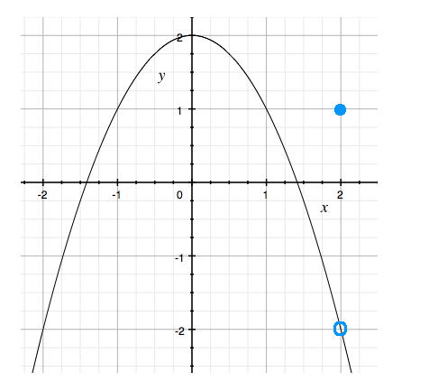

1. At x = 2 answer: jump discontinuity

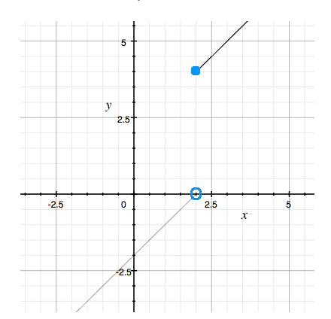

1. At x = 1 answer: essential discontinuity



*It is a hypothesis that the sun will rise tomorrow: and this means that we do not know whether it will rise.*

**- Ludwig Wittgenstein**

