# MATH 161 Solutions: quiz Iv 21 September 2018

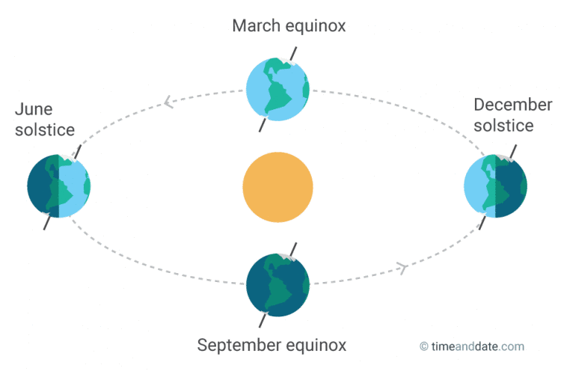

1. *[5 pts]*  For the graph of y = f (x) in the figure below, arrange the following numbers from ***smallest to largest:***

**A** The slope of the curve at A.

**B**  The slope of the curve at B.

**C** The slope of the curve at C.

**AB** The slope of the line *AB*.

1. The number 0.
2. The number 1.

Explain the positions of the number 0 and the number 1 in your ordering. Any unclear answers will not receive credit.

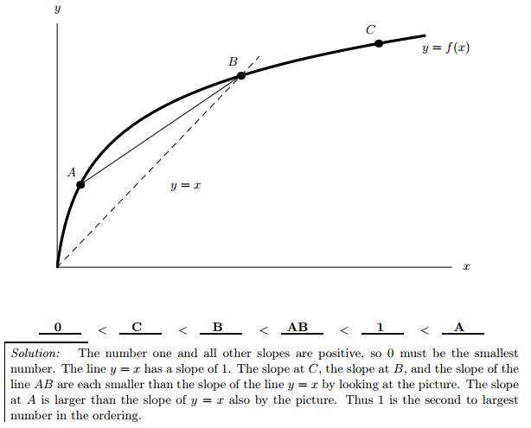

**Answer: ______ <______ <______ <_____ <______ <______**



**2.** *[4 pts]*  Let $f\left(x\right)=\frac{x}{x^{2}+1}$ at x = 2. Your trustworthy friend, Albertine, tells you that

$f'\left(x\right)=\frac{1-x^{2}}{ {\left({1+x}^{2}\right)}^{2}}$.

Write an equation of the tangent line to y = f(x) at x = 2.

*Solution:* The point of tangency is P = (2, f(2)) = (2, 2/5).

The slope of the tangent line at x = 2 is $f^{'\left(2\right)}=\frac{1-2^{2}}{ {\left({1+2}^{2}\right)}^{2}}=-\frac{3}{25}.$

Thus an equation of the tangent line is:

$$y-\frac{2}{5}=-\frac{3}{25} (x-2)$$

**3.** *[6 pts]*  Using the *limit definition* of derivative find the slope of the curve

g $\left(x\right)=3x^{2}-5x+7 at the point x= -1.$

*Solution:*

4. *[6 pts]* Using the process of “geometric differentiation,” sketch the graph of the derivative of the function y = G(x) whose graph is given below.

FYI: This is the graph of $y=x{\left(x-1.6\right)}^{2}\left(x-3\right){\left(x-4.7\right)}^{2}{(x-8)}^{2}\left(1+\sqrt{x}\right)e^{-x/8}$



*Solution: Begin by finding the zeroes of dy/dx by looking for critical points (horizontal tangent lines) in the graph of y = f(x). Then perform a sign analysis on dy/dx by looking for regions of increase and decrease*

*in y = f(x).*



**5**. *[2 pts each]* Suppose that W(h) is an increasing function which tells us how many gallons of water an oak tree of height h feet uses on a hot summer day.

(a) Give practical interpretations for each of the following quantities or statements. Use a complete sentence for each with no technical jargon.



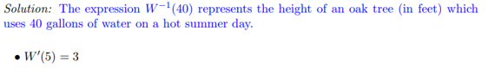

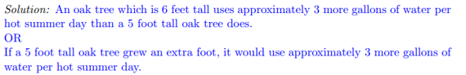

(b) Suppose that an average oak tree is *A* feet tall and used *G* gallons of water on a hot summer day. Answer each of the questions below in terms of the function *W*. You may also use the constants *A* and/or *G* in your answers.

* A farmer has a grove with 25 oak trees, and each one is 10 feet taller than an average oak tree. How much water will be used by her trees during a hot summer day?



* The farmer also has some oak trees which use 5 fewer gallons of water on a hot summer day than an average oak tree does. How tall is one of these trees?



***6.*** *[University of Michigan]* Odette, a daredevil, jumps off the side of a bungee jumping platform while attached to a magically elastic bungee cord. Just a few moments after the jump begins, a timer is started, and her position is recorded. At *t* seconds after the timer begins, her distance in feet below the platform is given by the function

*J* (*t*) = −150 cos(0*.*125*π*(*t* + 3)) + 150*.*

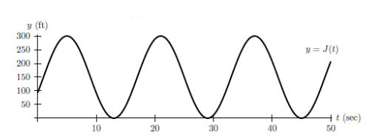

*Throughout this problem, do not make estimates using the graph.*

1. *[2 pts]* Compute the *average velocity* of the bungee jumper during the first 16 seconds after the timer begins.

*Solution:* First note that the period of the function $J\left(t\right) equals\frac{2π}{(0.125)π }=16.$

Hence, the change in distance over 16 seconds must be 0. Consequently, the *average* velocity during the first 16 seconds must be 0 as well.

*(b) [4 pts]* Use the *limit definition* of instantaneous velocity to write an explicit expression for the instantaneous velocity of the bungee jumper 2 seconds after the timer begins. *Your answer should not involve the letter J. Do not attempt to evaluate or simplify the limit.*



1. *[2 pts]* Find all values of *t* in the interval 0 ≤ *t* ≤ 30 when the instantaneous velocity of the bungee jumper is 0 feet per second.

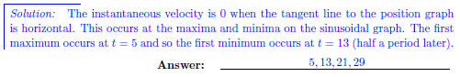

Extra Credit

Marcel, a Math 161 student, realizes that the more caffeine he consumes, the faster he completes his WebAssign homework. Before starting tonight’s assignment, he buys a cup of coffee containing a total of 100 milligrams of caffeine.

Let *T*(*c*) be the number of minutes it will take Marcel to complete tonight’s assignment if he consumes *c* milligrams of caffeine. Suppose that *T* is continuous and differentiable.

1. *[1 pt]* What are the units of $T^{'}?$

*Answer:* minutes per milligram

1. *[1 pt]* Circle the one sentence below that is best supported by the statement

“the more caffeine Marcel consumes, the faster he completes his online homework assignments.”

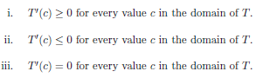

*Solution: Sentence* ***ii****, since more caffeine results in faster performance.*

1. Explain, in the context of this problem, why it is reasonable to assume that *T*(*c*) has an inverse. (In other words, T-1 exists.)

*Solution: Note that the more caffeine that Marcel consumes, the faster he will succeed in completing his assignment. So T(c) is a strictly decreasing function, and hence has an inverse.*

1. *[2 pts]* Interpret the equation *T*−1(100) = 45 in the context of this problem. Use a complete sentence and include units.

*Solution: For Marcel to complete his WebAssign homework in 100 minutes, he must consume 45 milligrams of caffeine.*

1. *[2 pts]* Which of the statements below is best supported by the equation ${\left(T^{-1}\right)}^{'}\left(20\right)=-10$? *Circle the* one *best answer.*
   * 1. If Marcel has consumed 20 milligrams of caffeine, then consuming an additional milligram of caffeine will save him about 10 minutes on tonight’s assignment.
     2. The amount of caffeine that will result in Marcel finishing his homework in 21 minutes is approximately 10 milligrams greater than the amount of caffeine that Marcel will need to finish his homework in 20 minutes.
     3. The rate at which Marcel is consuming caffeine 20 minutes into his homework assignment is decreasing by 10 milligrams per minute.
     4. **To complete tonight’s assignment in 19 rather than 20 minutes, Marcel needs to consume about 10 milligrams of additional caffeine.**
     5. If Marcel consumes 20 milligrams of caffeine, then he will finish tonight’s assignment approximately 10 minutes faster than if he consumes no caffeine.

*Answer: Statement iv.*

*The only time my education was interrupted was when I was in school.*

- George Bernard Shaw