# MATH 161 Solutions: quiz v 5 October 2018

1. *[4 pts]*

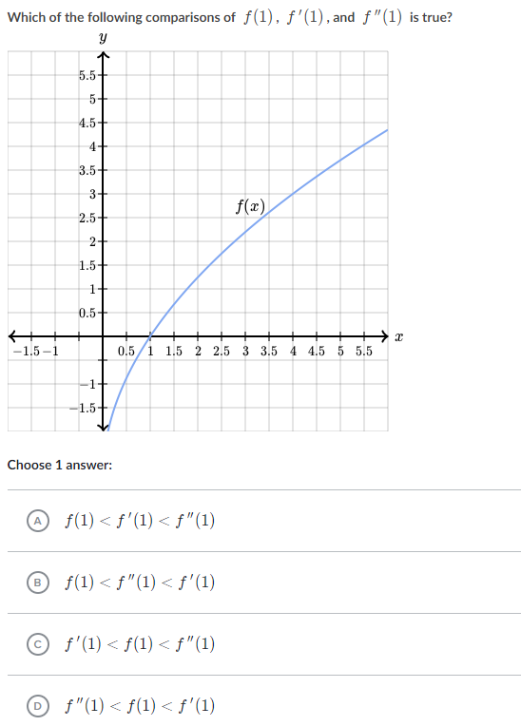

*Solution:* ***D*** *is the correct answer. Note that $f^{''}\left(1\right)<0$*

*Since f is concave down over an interval that includes x = 1.*

*Next, f(1) = 0 which we can see from the graph.*

*Finally $f^{'}\left(1\right)>0$ since f is increasing on an interval containing x = 1.*

1. *Given a function y = f(x) for which $\frac{dy}{dx}=x^{3}\left(x-4\right)$*

*(a) [2 pts] Find the critical points of f(x)?*

*Solution: We are given that $f'(x)$ = $x^{3}\left(x-4\right)$. Setting $f'(x)$ = 0, we find x = 0, x =4 are critical points.*

*(b) [2 pts ] Determine the interval(s) upon which f(x) is rising.*

*Solution: f(x) is rising when $f^{'}\left(x\right)>0$. Now the sign analyisis of $f'(x)$ has two transition points, x = 0 and x = 4.*

*We see that $f^{'}\left(x\right)>0 when x<0 or when x>4.$*

*(c) [3 pts] Determine the interval(s) upon which f(x) is concave up.*

*Solution: Using the product rule, $f^{''}\left(x\right)=x^{3}\frac{d}{dx}\left(x-4\right)+\left(x-4\right)\frac{d}{dx} x^{3}= x^{3}+\left(x-4\right){3x}^{2}=$*

$x^{2}\left(x+3(x-4)\right)$*= $x^{2}\left(4x-12\right)$ = 4 $x^{2}\left(x-3\right).$*

*In performing a sign analysis on $f^{''}\left(x\right)$ we have only one transition point, viz. x =3 $.$*

*Hence f is concave up on $\left(3, ∞\right).$*

1. Find an *anti-derivative* for each of the following functions. The method of *judicious* guessing is highly recommended. *Show your work.*
2. *[2 pts]* ex – 3x8

*Answer:*

1. *[2 pts]* sec2 x + 5 sec x tan x + π9

*Answer: $\tan{x}+5\sec{x+π^{9}}x$*

*Notice that $π^{9}$ is a constant!*

1. *[2 pts]* 1 + 3x2 – 18x5

*Answer: $x+x^{3}-3x^{6}$*

1. *[2 pts]* 1 +3 ex + 4 cos x

*Answer: ${x+3e}^{x}+4\sin{x}$*

1. *[3 pts] ${\left(3+x^{3}\right)}^{2}$*

*Solution: Using algebra: ${\left(3+x^{3}\right)}^{2}=9+6x^{3}+x^{6}$. Hence an antiderivative of ${\left(3+x^{3}\right)}^{2} is$*

$$9x+\frac{3}{2} x^{3}+\frac{1}{7} x^{7}$$

1. *[3 pts] $\frac{1+x+x^{3}}{x^{3}}$*

*Solution: Using algebra: $\frac{1+x+x^{3}}{x^{3}}= x^{-3}+x^{-2}+1$. Hence an antiderivative of*

4. *[7 pts]* (a) Using an appropriate function and an appropriate point, estimate $\frac{1}{\sqrt{8.994}}$. Sketch!

*Solution: Let $f\left(x\right)=\frac{1}{\sqrt{x}}=x^{-\frac{1}{2}} and let the point be x=9.$*

**

*Since $f^{'\left(x\right)}=-\frac{1}{2}x^{-\frac{3}{2}}, f^{'}\left(9\right)= -\frac{1}{54}$*

*So the linearization of f(x) at x = 9 is given by $L\left(x\right)=\frac{1}{3}-\frac{1}{54}\left(x-9\right).$*

*Thus our approximation of $\frac{1}{\sqrt{8.994}}$ is $L\left(8.994\right)=\frac{1}{3}-\frac{1}{54}\left(8.994-9\right)=\frac{1}{3}-\frac{1}{54}\left(-0.006\right)=\frac{1}{3}+\frac{0.006}{54}≈0.33344444444.$*

*[ 3 pts]* (b) Is this an over or an underestimate? Why? (No credit for calculator answers.)

*Solution: This is an* ***underestimate*** *since the tangent line to y = f(x) at x = 9 lies below the curve. Cf. sketch above. Equivalently f(x) is concave up at x = 9 because $f^{''\left(9\right)}>0.$*

