MATH 161 Solutions: quiz vI 12 October 2018

- Find an anti-derivative of each of the following functions:
- $\frac{ 2+x^{7} }{x^{9}}$

Solution:$\frac{ 2+x^{7} }{x^{9}}=2x^{-9}+x^{-2}$
A good first guess might be $x^{-8}+x^{-1}$
Correcting for constants the answer is ${-\frac{1}{4} x}^{-8}-x^{-1}$

- $3e^{x}+4\sec^{2}{x+π}$

Solution: A good first guess might be $e^{x}+\tan{x+πx}.$

Correcting for constants the answer is $3e^{x}+4 \tan{x+πx}$

- $\cos{x}\tan{x}$

Solution: First note that $\cos{x}\tan{x}=\cos{x \frac{\sin{x}}{\cos{x}}}=\sin{x}$
Thus an antiderivative that we seek is $-\cos{x }$

- [1 pt] Which of the graphs below is that of $\sin\left(x^{2}\right) ?$

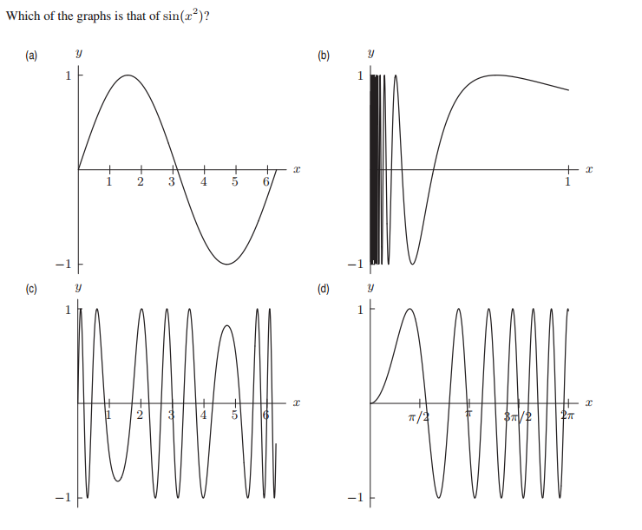

Answer: D
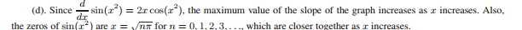

- [1 pt] Given the graphs of the functions f(x) and g(x) in figures 3.7 and 3.8, which of the following (a) – (d) is a graph of $f∘g\left(x\right)?$
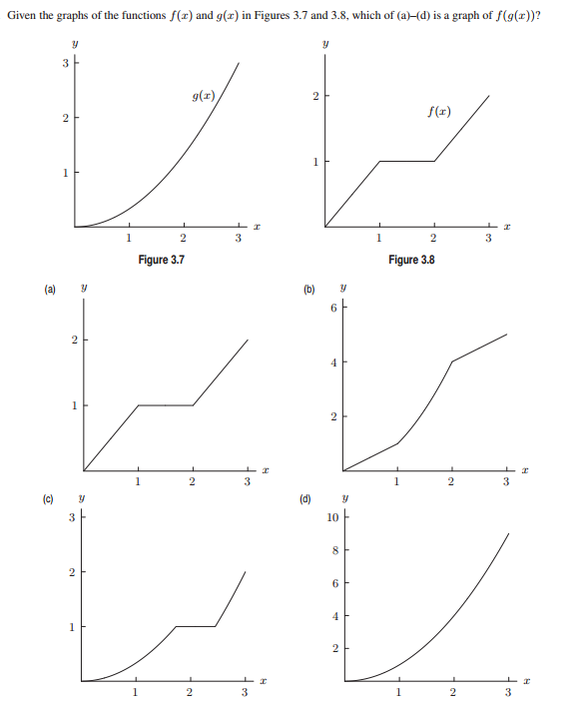
Answer: C
Reason: Because (f(g(x)))′ = f ′ (g(x))g ′ (x), we see f(g(x)) has a horizontal tangent whenever g′(x) = 0
or f ′(g(x)) = 0. Now, f ′(g(x)) = 0 for 1 < g(x) < 2 and this approximately corresponds to 1.7 < x <2.5.

- Using the chain rule compute the derivative of each of the following functions. You need not simplify.
- $e^{1+x^{3}}$
Solution: Using the chain rule (shortcut):
${\frac{d}{dx}e}^{1+x^{3}}=e^{1+x^{3}}\frac{d}{dx}(1+x^{3})=3x^{2}e^{1+x^{3}}$

- $tan⁡(\sin{x)}$

Solution:
Using the chain rule (shortcut):

$$\frac{d}{dx}tan⁡(\sin{x)}=\sec^{2}(\sin{x) }\frac{d}{dx}(\sin{x)=(cos{x)\sec^{2}(\sin{x) } }}$$

- ${(1+x+x^{3})}^{2019}$

Solution: Using the general power rule:

$${\frac{d}{dx}(1+x+x^{3})}^{2019}=2019{\left(1+x+x^{3}\right)}^{2018}\frac{d}{dx}\left(1+x+x^{3}\right)=$$

$$2019{\left(1+x+x^{3}\right)}^{2018}(1+{3x}^{2})=2019(1+{3x}^{2}){\left(1+x+x^{3}\right)}^{2018}$$

- $e^{5x}\cos{(3x+1)}$

Solution: First using the product rule:

$${\frac{d}{dx }e}^{5x}\cos{(3x+1)}=e^{5x}\frac{d}{dx }\cos{(3x+1)}+\cos\left(3x+1\right)\frac{d}{dx }e^{5x}=$$

$$e^{5x}\left(-\sin\left(3x+1\right)\frac{d}{dx }(3x+1)\right)+\cos\left(3x+1\right)e^{5x}\frac{d}{dx }(5x)=$$

$${-3e}^{5x}\sin\left(3x+1\right)+5e^{5x}cos\left(3x+1\right)$$

Extra Credit:

Consider the piecewise linear function f(x) graphed below:
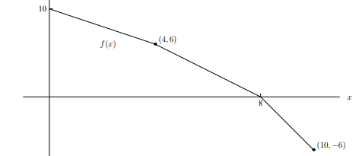
For each function g(x) find the value of $g^{'}\left(3\right).$
$\left(a\right) g\left(x\right)=\sin\left(\left({f(x)}^{3}\right)\right)$

Solution: Using the chain rule:
$$g\left(x\right)=\frac{d}{dx}sin\left(\left({f(x)}^{3}\right)\right)=\cos\left(\left({f(x)}^{3}\right)\right)\frac{d}{dx}\left({f(x)}^{3}\right)=$$
$$\cos\left(\left({f(x)}^{3}\right)\right)\frac{d}{dx}\left({f(x)}^{3}\right)=\cos\left(\left({f\left(x\right)}^{3}\right)\right)3{\left(f(x)\right)}^{2}f'(x)$$
Now: Since the slope of the curve at x=3 is $\frac{6-0}{4-10}=-1$, the equation of the curve in the vicinity of x = 3 is
f(x) = -1(x) + 10.
So f(3) = 7 $and f^{'}\left(3\right)=-1.$
$$Hence g'(3)=\cos\left(\left({f\left(3\right)}^{3}\right)\right)3{\left(f(3)\right)}^{2}f^{'}\left(3\right)=$$
$$\cos\left(7^{3}\right)3{\left(7\right)}^{2}\left(-1\right)=-147\cos\left(7^{3}\right) ≅124.04$$

$\left(b\right) g\left(x\right)=\frac{f\left(x^{2}\right)}{x}$
Solution: Using the quotient rule,
$$g'\left(x\right)=\frac{x\frac{d}{dx}f\left(x^{2}\right)-f\left(x^{2}\right)\frac{d}{dx}(x)}{x^{2}}$$

Invoking the chain rule to compute $\frac{d}{dx}f\left(x^{2}\right), we find that$
$$g^{'}\left(x\right)=\frac{x\left(f'\left(x^{2}\right)\right)2x-f\left(x^{2}\right)}{x^{2}}$$
And so $$g^{'}\left(3\right)=\frac{3\left(f'(9)\right)2(3)-f\left(9\right)}{9}$$
Since f(9) = -3 and $f'(9)=-3, we have:$
$$g^{'}\left(3\right)=\frac{3(-3)2(3)-(-3)}{9}=-\frac{17}{3} ≅-5.67$$

$.$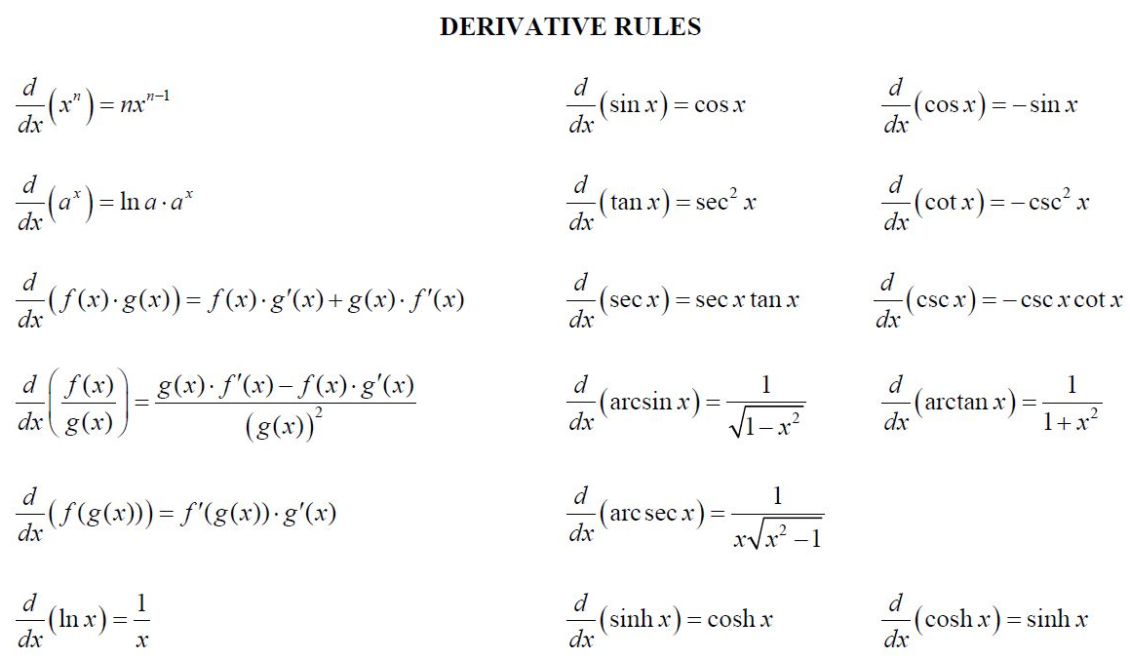

O dear Ophelia!
I am ill at these numbers:
I have not art to reckon my groans.

- HAMLET (Act II, Sc. 2)

