# MATH 161 Solutions: Quiz VIII 2 November 2018

***1.*** *[14 pts]* Let g(x) = 3x5 – 5x3 be defined on the real line.

1. Find all the *critical points* of *g*.

***Solution:*** Since $g^{'}\left(x\right)=15x^{4}-15x^{2}=15x^{2}(x+1)(x-1)$, the critical points of g are x = 0, 1, -1

1. Where is *g* *rising*? (Give the appropriate intervals.)

***Solution:*** Performing a sign analysis on $g^{'}\left(x\right)$ we discover that g rises on $\left(-∞, -1\right)and on \left(1, ∞\right).$

1. Find and classify all local extrema. Justify your answer. (Do not say “because the calculator tells me.”)

***Solution:*** Using the first-derivative test, we discover that *g* has a local maximum at x = -1 and a local minimum at x = 1.

1. Does g achieve a global max or global min? Explain.

***Solution:*** Neither a global max nor a global min. In the long run, g(x) behaves as x5 which is unbounded above as well as unbounded below.

1. Where is *g* *concave up*? (Give the appropriate intervals.) Find any and all *points of inflection*.

***Solution: $g^{''}\left(x\right)=\frac{d}{dx}\left(15x^{4}-15x^{2}\right)=60x^{3}-30x=30x\left(2x^{2}-1\right)=60x\left(x+\sqrt{\frac{1}{2}} \right)\left(x-\sqrt{\frac{1}{2}} \right)$*** .

***Performing a sign analysis on $g^{''}$***  , we find three points of inflection: $x=0, x=±\frac{\sqrt{2}}{2}$

***Moreover, g is concave up on $\left(-\frac{ \sqrt{2}}{2}, 0\right)and$ $\left(\frac{ \sqrt{2}}{2}, ∞\right)$*** *.*

1. Sketch a graph of y = g(x). Label **all local and global extrema** and **all inflection points**. Show regions of increase and decrease. Show regions where the function is concave up and concave down.



2. *[8 pts]* Albertine is designing a rectangular poster to contain 50 in2 of printing with a 4-inch margin at the top and bottom and a 2-inch margin at each side. Which overall dimensions *minimize* the amount of poster board used?

***Solution:*** Let x = width of the printed region (in inches) and let y = length of printed region (in inches).

Hence the outer width is x + 4 inches and the outer length is y + 8 inches.

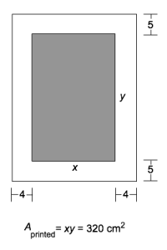We are asked to minimize A = (x + 4)(y + 8).

We area given that xy = 50, from which we see that $y=\frac{50}{x}.$

Thus $=\left(x+4\right)\left(\frac{50}{x}+8\right)=82+8x+\frac{200}{x}$.

The appropriate domain of A is $\left(0, ∞\right).$

Next

$$\frac{dA}{dx}=8-\frac{200 }{x^{2}}=8\left(1-\frac{25}{x^{2}}\right)=\frac{8(x+5)(x-5)}{x^{2}}$$

So the critical points are $x=±5$. Of course, we reject $-5$, so the unique critical point in our domain occurs at x = $5.$

And $here y=\frac{50}{x}=10$.

The first derivative test verifies that this is a local minimum, and hence, in our domain, a global minimum.

Hence the overall dimensions are:

**9 inches by 18 inches.**

3. *[8 pts]* Build a rectangular pen with three parallel partitions using 500 feet of fencing. What dimensions will *maximize* the total area of the pen? 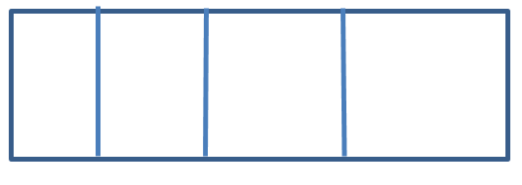

***Solution:*** Let x = length (in ft) of the pen and let y = width (in ft) .

Then the total amount of fencing is 500 = 2x + 5y.

We wish to maximize the area of the pen: A = xy.

Now $= \frac{500-2x}{5}$. The constraints on x are: $0<x<250$.

So $A=xy=\frac{x\left(500-2x\right)}{5} .$ Next, $\frac{dA}{dx}=\frac{1}{5} \left(500-4x\right)=\frac{4}{5} \left(125-x\right).$

This concave-down parabola has a maximum at **x = 125 feet. And at x = 125, y = 50 feet.**



4. *[8 pts]* A container in the shape of a right circular cylinder with no top has surface area ft2. What height *h* and base radius *r* will maximize the volume of the cylinder?

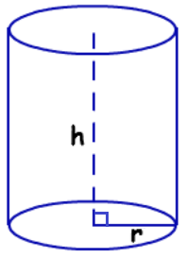

***Solution:*** We are given that $3π=2πrh+πr^{2}$, or equivalently, $3=2rh+r^{2}$, from which $h=\frac{3-r^{2}}{2r} .$

The constraints on *r* are $0<r<\sqrt{3}$

We are asked to maximize $V\left(r\right)=πr^{2}h=πr^{2}\left(\frac{3-r^{2}}{2r}\right)=\frac{π}{2} r(3-r^{2})$ subject to the above constraints.

Now $\frac{dV}{dr}=\frac{π}{2} \left(3-3r^{2}\right)=\frac{3π}{2} (1-r)(1+r)$. Now the unique critical point in our domain is r = 1.

We can easily confirm, using the first derivative test, that r = 1 is a global max in our domain. Now, when r = 1, h = 1.

So the volume of the cylinder is maximized when **r = 1 ft and h = 1 ft.**



Extra Credit *[University of Michigan problem]*

The cable of a suspension bridge with two supports *2L* meters apart hangs *H*

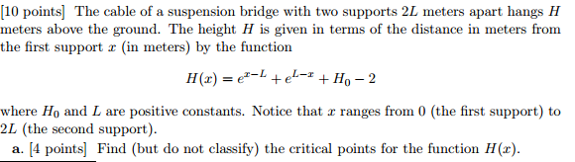

1. Find (but do not classify) the critical points for the function *H(x).*

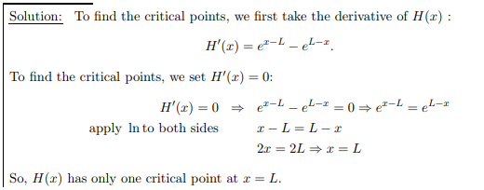

1. Find the *x* and *y* coordinates of all global maxima and minima for the function *H(x)*. Justify your answers!

