# MATH 161 Solutions: TEST I 28 September 2018

**Instructions: *Answer any 7 of the following 9 questions. You may solve more than 7 to obtain extra credit.* ☺**

1. A portion of the graph of a function f is shown below.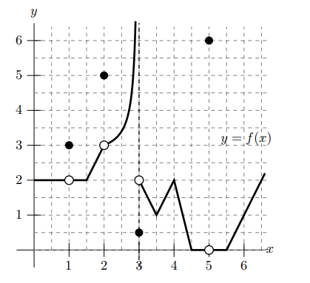

Note: You may assume that pieces of the function that appear linear are indeed linear. Use the graph above to evaluate each of the expressions below. If any of the quantities do not exist (including the case of limits that diverge to ∞ or −∞), write DNE.

1. $f(1)$ = 3 $\left(f\right) \lim_{h→0}{\frac{f\left(4.25+h\right)-f(4.25)}{h}}=$-4
2. $\lim_{x→5}{f(x)}$ = 0 (g) $\lim_{p→0.5}{\frac{f\left(p\right)}{p}=}$ 4
3. $\lim_{q→3}{f\left(q\right) }$ = DNE (h) $\lim_{t→3}{f\left(t\right)f(t+2)}=$ 0
4. $\lim_{x→2}{f(2)}$ = 5 (i) 3
5. 1 (k) 5

2. (a) Below is the graph of a function f(x).

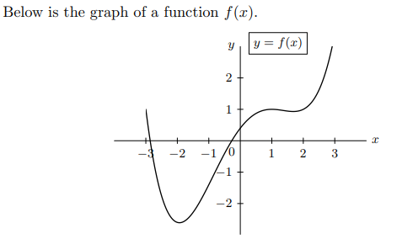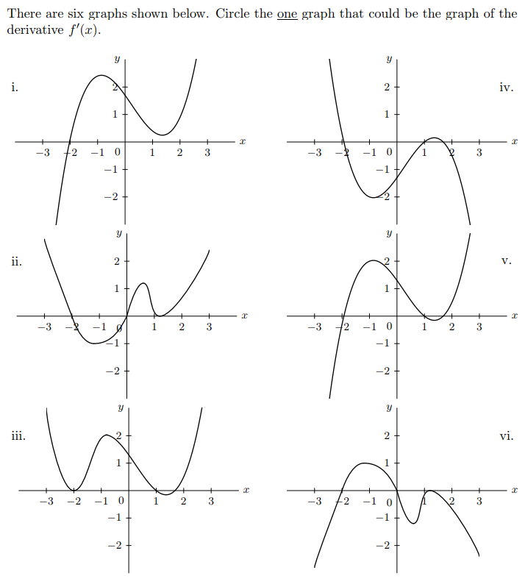

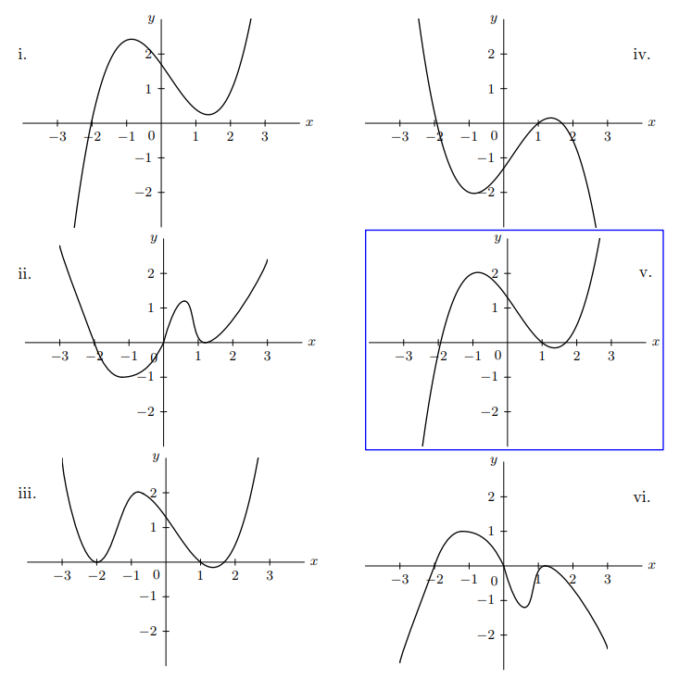

*(b)* Find ***all*** real numbers *B* and ***positive*** integers *k* such that the rational function

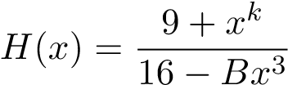

satisfies the following two conditions:



If no such values exist, write none.

*Solution: For $\lim_{n→∞}{H\left(x\right) }$ to exist, the degree of the polynomial in the numerator has to be smaller or equal to 3 (the degree of the polynomial in the denominator).*

*For x = 2 to be a vertical asymptote, we need the denominator to be zero.*

*Hence 16 – B (23) = 16 − 8B = 0 which implies that B = 2.*

*In this case $H\left(x\right)= \frac{9+x^{k}}{16-{2x}^{3}}$ with k = 1, 2 or 3. Since 9 + 2k ≠ 0, it follows that H(x) has a vertical asymptote at x = 2 when B = 2.*

***Thus B = 2 and k may assume the values 1, 2, or 3.***

*(c)* Determine the value of *a* for which the function 

is continuous?

*Solution: To be continuous at x = 3 means that $\lim_{t→3-}f\left(t\right)=\lim_{t→3+}f\left(t\right)=f(3)$*

$$Now \lim_{t→3-}f\left(t\right)=3-a,$$

$$\lim_{t→3+}f\left(t\right)=9+30=39,$$

$$and f\left(3\right)=3-a$$

Thus f is continuous if and only if 3 – a = 39.

So **a = -36**

3. Each of the following limits exists. Compute each value. *Show your work.*

(a) As originally stated the problem made no sense since the denominator is 0 infinitely often as $x→0$

*Corrected version: $\lim_{x→0}{\frac{x^{3}}{\tan^{3}(4x)}}$*

*Solution:*

$$\frac{x^{3}}{\tan^{3}(4x)}={\left(\frac{x}{tan⁡(4x)}\right)}^{3}= {\left(\frac{ 1 }{\left(\frac{\tan{4x}}{x}\right)}\right)}^{3}→{\left(\frac{1}{4}\right)}^{3}=\frac{1}{64}$$

(b) $\lim_{x→∞}{\frac{sin⁡(2018x)}{3x}}$

*Solution:*

*Since -1 ≤ sin t ≤ 1 for all t, we see that for positive x: $$-\frac{1}{x}≤sin (2018 x){ ≤ }\frac{1}{x}$$*

*Since both 1/x and –1/x→ 0 as x → ∞, we may apply the Squeeze Theorem to conclude that {sin(2018)} / x → 0 as x → ∞.*

(c) $\lim_{x→0}{x^{5}sin⁡(x+4e^{x}})$

*Solution:*

*Since -1 ≤ sin t ≤ 1 for all t,*

*If x > 0 then*

$$-x^{5}≤x^{5}\sin{x ≤}x^{5}$$

*Since both x5 and –x5 → 0 as x → 0+, we may apply the Squeeze Theorem to conclude that $x^{5}sin⁡(x+4)→0 as x→0^{+}{.⁡ }$*

*We can use a similar argument if x < 0.*

(d) 

*Solution:*



4. Identify the type of discontinuity that each of the following functions has at ***x = 0***. (Choose from *removable*, *infinite*, *jump*, or *essential* discontinuity.) Briefly justify your answers.

(a) 

*This discontinuity, as proven in class, is a removable discontinuity.*

(b) 

*infinite discontinuity*



(c) 

*infinite discontinuity*



(d) .

*infinite discontinuity*



(e) $y=\cos\left(\frac{2018}{x}\right)$

*essential discontinuity*



(f) 

*jump discontinuity*



*5.* Albertine has found a job as captain of a ship. She is making a round trip voyage between two ports. The ship sets sail from Alphaville at noon, arrives at Betaville Sur la Mer, at some time later, waits there for a while, and then returns to Alphaville. Let s(t) be the ship’s distance, in kilometers, from its starting point of Alphaville, *t* hours afternoon. A graph of d = s(t) is shown below.



***When answering each of the following questions, use appropriate units!***

1. How *far* is Betaville Sur la Mer from Alphaville?

*Answer: 100 km*

1. How *long* does the ship wait in Betaville Sur la Mer?

*Answer: 2 hours*

1. What is the ship’s *average* *speed* from Alphaville to Betaville Sur la Mer?

*Answer: *

*Since this number is positive, it also represents the average speed.*

1. What is the ship’s average *speed* during the return trip from Betaville Sur la Mer

to Alphaville?

*Answer: *



6. The fuel efficiency (in miles per gallon) of a car traveling at *v* miles per hour is given by a function E = g(v).

1. Explain the meaning of the statement: g(55) = 27. (Use complete sentences. Avoid using mathematical terms.)

*When the car is traveling at 55 mph, then its fuel efficiency is 27 mpg.*

(b) Give the practical interpretation of the statement: g′(55) = – 0.54. (Use complete sentences. Do not use the word “derivative” in your explanation.)

*If the car is traveling at 55 mph then driving at, say, 56 mph would reduce the efficiency to*

*27 – 0.54 = 26.46 mpg.*

1. What are the *units* of g′(55)?

*The units are mpg/mph.*

1. Using the information given in parts (a) and (b), estimate the fuel efficiency of a car traveling at 51 miles per hour.

*If the change in speed from 55 mph is -4 mph, then the fuel efficiency of the car increases to*

*27 + (-4)(-0.54) = 29.16 mpg.*

7. The graph below gives a rock climber’s height as a function of time as she climbs a small mountain. The height is measured in feet and the time is measured in hours. The line l(t) gives the tangent line to h(t) at time t = 1.

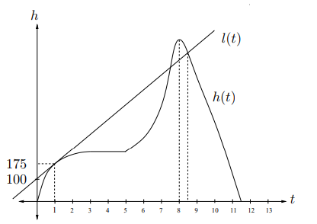

1. For which time(s), if any, is the climber stopped?

*Answer:* The climber has stopped between the 3rd and 5th hour, and then (possibly) again at the 8th hour.

1. Does the climber speed up or slow down over the first three hours?

*Answer:* The climber **slows down** over the first three hours, as can be seen by the fact that the graph is concave down on this interval. So she is climbing up at a decreasing rate.

1. What is the climber’s rate of ascent 1 hour into the climb?

*Solution:* The climber’s rate of ascent is the derivative of the function h(t), which happens to be the slope of the tangent line l(t). To find the slope of l(t), we use the points (0, 100) and (1, 175). slope of l(t) = 175 − 100 1 − 0 = **75 ft/hour**

1. What is the climber’s height after 8.5 hours?

*Solution:* Note that the line l(t) intersects h(t) at t = 8.5. The equation for l(t) is given by

l(t) = 75t + 100. Substituting t = 8.5, we have that h(8.5) = **737.5 feet.**

1. If the maximum height the climber reaches is 800 feet, what is her average rate of ascent over the last 3.5 hours of her trip (that is, for 8 < t < 11.5)?

*Solution:* The average ascent is given by

avg. ascent = 800 − 0 8 − 11.5 = −228.57 ft/hour 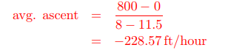

= **– 228.57 ft/hour**

Note that the climber is climbing down, hence the negative rate of ascent.

8. Albertine’s cousin, Mimi, has chartered a helicopter that is rising straight up in the air, but she is scared of heights. Let A(w) be Mimi’s fear (in “scared units”) when she is *w* km above the ground. For 0 < w ≤ 2, a formula for A(w) is given by

$$A\left(w\right)=\frac{w^{2}+2}{w^{w}+1}$$

1. Use the limit definition of the derivative to write an explicit expression for the instantaneous rate of change of Mimi’s fear, in scared units per km, when she is 1.5 km above the ground. Your answer should not involve the letter A. Do not attempt to evaluate or simplify the limit.

*Solution:* The instantaneous rate of change of Mimi’s fear, in scared units per km, is given by the derivative

$$A^{'}\left(1.5\right)=\lim_{h→0} \frac{A\left(1.5+h\right)-A(1.5)}{h}=\lim_{h→0} \frac{\left(1.5+h\right)-A(1.5)}{h}=$$

$$\lim_{h→0} \frac{\frac{{\left(1.5+h\right)}^{2}+2}{{\left(1.5+h\right)}^{\left(1.5+h\right)}+1}-\frac{{1.5}^{2}+2}{{1.5}^{1.5}+1}}{h}$$

1. When Mimi has reached a height of 2 km above the ground, Mimi regains control of her fear, and her fear starts decreasing at a constant rate of 0.8 scared units per km. Write a formula for a piecewise-defined continuous function A(w) giving Mimi’s fear, in scared units, for 0 < w < 3.

*Solution:* We are given that $A\left(w\right)=\frac{w^{2}+2}{w^{w}+1} for 0<$ w $≤2.$ So it remains to find a formula for A(w) that is valid for 2 < w < 3. Since Mimi’s fear is decreasing at a constant rate for w > 2, A(w) is linear for 2 < w < 3, and the slope of this linear piece is −0.8. In order for A(w) to be continuous, this linear piece must pass through the point (2, A(2)) which is (2, 6/5). Using point slope form, this gives the formula 1.2 − 0.8(w − 2) = 2.8 − 0.8w for the linear piece. Hence

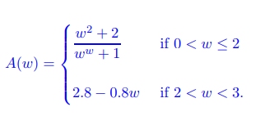

9. (a) Let .

(i) Find all critical points of H.

*Solution:* 

*The critical points occur at x = 0 and x = -4.*

(ii) When is H increasing?

Solution; H is increasing when $H^{'}(x)>0.$ This occurs on the intervals (-∞ , -4) and (0,∞ ).

(iii) When is H decreasing?

Solution; H is decreasing when $H^{'}\left(x\right)<0.$ This occurs on the intervals (0,-4 ).

(b)Consider the function y = f(x) defined below.

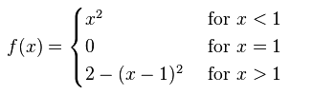

Does *f* have a discontinuity? If not, explain. If so, is it a removable discontinuity?

If it is removable, find the continuous extension.

*Solution:*

*Since f(x) → 1 as x → 1-, and f(x) → 2 as x → 1+, we conclude that x = 1 is a jump discontinuity, and thus not removable.*

**Rules of the game**

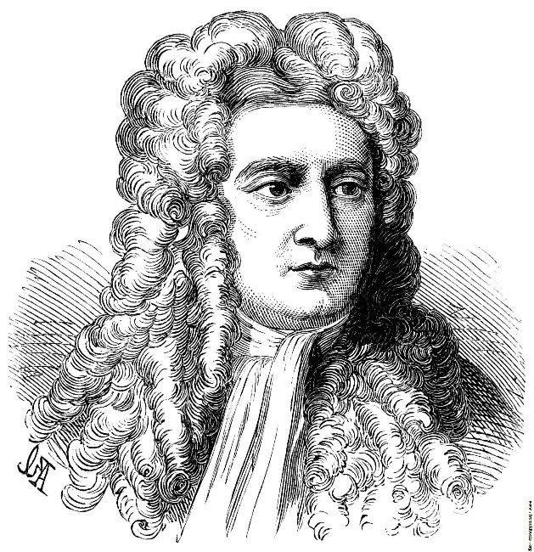

*I do not know what I may appear to the world; but to myself, I seem to have been only like a boy playing on the seashore, and diverting myself, in now and then finding a smoother pebble or a prettier shell than ordinary, whilst the great ocean of truth lay all undiscovered before me.*

- Sir Isaac Newton