# MATH 161 Solutions: TEST II 20 October 2018

*Instructions: Answer any* ***7*** *of the following* ***9*** *questions. You may answer more than 7 to earn extra credit. Each problem is worth 10 pts.*



1. Differentiate each of the following functions. You *need not* simplify. Show your work.
2. y = $\frac{x}{1+x+x^{2}}$

***Solution:*** *Using the quotient rule, $\frac{dy}{dx}=\frac{\left(1+x+x^{2}\right)\left(1\right)-x(1+2x)}{{(1+x+x^{2})}^{2}}=\frac{1-x^{2}}{{(1+x+x^{2})}^{2}}$*

$$\left(b\right) y=\arcsin\left(x^{100}\right)$$

***Solution:*** *Using the chain rule, $\frac{dy}{dx}=\frac{1}{ \sqrt{1-{\left(x^{100}\right)}^{2}}}100x^{99}=\frac{100x^{99}}{ \sqrt{1-x^{200}}}$*

$$\left(c\right) {y=e}^{arc\tan{x}}$$

***Solution:*** *Using the chain rule,*

$$\frac{dy}{dx}=\left(\frac{1}{1+x^{2}}\right)e^{arc\tan{x}}=\frac{e^{arc\tan{x}}}{1+x^{2}}$$

$\left(d\right) y=x^{3}\cos\left(4x\right)$

***Solution:*** *Using the product rule in conjunction with the chain rule,*



$$\frac{dy}{dx}=x^{3}\frac{d}{dx}cos\left(4x\right)+\cos\left(4x\right)\frac{d}{dx}x^{3}=$$

$$x^{3}\left(-4 sin \left(4x\right)\right){+3x^{2}cos\left(4x\right)=}$$

$${-4x}^{3}sin \left(4x\right){+3x^{2}cos\left(4x\right)}$$

$y=x\ln{x}-x+\sqrt[3]{2019}$

***Solution:*** *Using the product rule,*

$$\frac{dy}{dx}=x\frac{d}{dx}ln{x}+\ln{x}\frac{d}{dx}\left(x\right)-1+0=$$

$x\left(\frac{1}{x}\right)+\left(\ln{x}\right)1-1+0$ =

$$1+\ln{x}-1=\ln{x}$$

Observe that this calculation has, as a consequence, a formula for an anti-derivative of ln x.

1. Find an *anti-derivative* for each of the following functions. Use the method of *judicious guessing*. *Show your work. You need not simplify your answers.*

**(a) $\frac{1+x+x^{3}}{x^{2}}$**

***Solution:*** *Using basic algebra,*

$$\frac{1+x+x^{3}}{x^{2}}=\frac{1}{x^{2}}+\frac{x}{x^{2}}+\frac{x^{3}}{x^{2}}=x^{-2}+\frac{1}{x}+x$$

So a first guess for an anti-derivative might be:

$$x^{-1}+\ln{x}+x^{2}$$

Differentiating our first guess and making constant corrections:

$$-x^{-1}+\ln{x}+{\frac{1}{2}x}^{2}$$

$(1+x^{6})(3+x^{2})$

***Solution:*** *Using basic algebra,*

$$\left(1+x^{6}\right)\left(3+x^{2}\right)=3+x^{2}+x^{6}+x^{8}$$

*Using the GPR in reverse, we obtain an anti-derivative,*

$$3x+{\frac{1}{3}x}^{3}+\frac{1}{7}x^{7}+{\frac{1}{9} x}^{9}$$

${(\arctan{x)}}^{2018}\frac{1}{1+x^{2}}$

***Solution: ${\frac{1}{2019}(\arctan{x)}}^{2019}$***

$\left(\tan^{8}x\right)\sec^{2}x$

***Solution: ${Let f\left(x\right)=tan}^{9}x$*** *be our first guess.*

*Then $=f^{'}\left(x\right)=9\tan^{8}{x\sec^{2}x}$*

***Second guess: $g\left(x\right)=\frac{1}{9} \tan^{9}{x}$***

*Differentiating, we see that g(x) is a correct anti-derivative.*



${(x+13)}^{-99}$

***Solution:*** *Let $f\left(x\right)={(x+13)}^{-98}$ be our* ***first guess.***

*Then, using the GPR, $f^{'}\left(x\right)={-98(x+13)}^{-99}$*

***Second guess: $g\left(x\right)={-\frac{1}{98}(x+13)}^{-98}$***

*Differentiating, we see that g(x) is a correct anti-derivative.*

**Extra credit:** cos2 x – 4 + sin2 x

*Solution: First note that cos2(x) – 4 + sin2(x) = cos2(x) + sin2(x) – 4 = 1 – 4 = -3.*

*Hence, an anti-derivative that we seek is -3x.*

1. Consider the curve f(x) = (2x – 1)75(x + 8)74.
2. Find *all* critical points of f(x).



***Solution:***

*(2x – 1)75 d/dx* (x + 8)74*+* (x + 8)74 *d/dx* (2x – 1)75 *=*

*(x + 8)73 (74)* (2x - 1)75 *+* (x + 8)74 (75)*2* (2x – 1)74 *=*

*2* (2x – 1)74(x + 8)73{37() +75 } =*2* (2x – 1)74(x + 8)73{149x + 563}

*Thus the “critical points” (or points at which g(x) has horizontal tangent lines) are:*

$$x=-8, x=\frac{1}{2}, x=-\frac{563}{149}≈-3.78$$

1. Determine the intervals upon which the graph of y = f(x) is rising and those where it is falling.

***Solution:***

f is *increasing* on $\left(-∞, -8\right) and (-3.78, ∞)$ and

f is *decreasing* on (-8, $∞)$

**4.** Note: Parts (a) and (b) of this problem are independent of one another.

(a) Estimate the value of $\frac{1}{\sqrt{1.003}}$ to three decimal places.

Is this an under- or an over-estimate? Why? Sketch your chosen function.

***Solution:*** *Let $f\left(x\right)=x^{-\frac{1}{2}}$ and let P = (1, 1) be the point of tangency.*

*Then $f\left(1\right)=1, f'(x)={-\frac{1}{2}x}^{-\frac{3}{2}} and so f'\left(1\right)=-\frac{1}{2}$*

*So the linearization of y – f(x) at P = (1, 1) is*

$$L\left(x\right)=1-\frac{1}{2}(x-1)$$

*So $$L\left(1.003\right)=1-\frac{1}{2}\left(1.003-1\right)=1-0.0015=0.9985$$*

*This is an* ***underestimate*** *since the tangent line to the curve y = f(x) at x = 1 lies below the curve.*



(b) Let Q = (6, 25) Find equations of any and all tangent lines to the curve $y=x^{2}+x+1$ that pass through the point Q.

*Solution:*

*The equation of any line passing through the point P = (6, 25) is y – 25 = m(x – 6) where m is the slope of the line. Let T = (a, a2 + a +1) be a point of tangency.*

*Then the slope of the curve at T $is y^{'}=2a+1$.*

*Now the slope of the line joining P and T is $\frac{a^{2}+a+1-25}{a-6}$*

*These two slopes must agree. Hence*

$2a+1=\frac{a^{2}+a+1-25}{a-6}$

*H $ence \left(2a+1\right)(a-6)=a^{2}+a+1-25$*

*Expanding and simplifying, we obtain: $a^{2}-12a+18=0$*

*Solving for a, we obtain*

$$a=\frac{12±\sqrt{72}}{2}=6±3\sqrt{2}=1.76, 10.24$$

*And so $m=2a+1=4.5, 21.5$*

*Finally t,he equations of the two tangent lines are:*

***y – 25 = 4.5(x – 6)***

***y – 25 = 21.5(x – 6)***

*Here is the graph:*



1. For each of the following, use logarithmic differentiation to find $\frac{dy}{dx}$ if
2. (Harvard) y = (x + 1)x

***Solution:*** *ln y = x ln(x + 1)*

$\frac{1}{y}\frac{dy}{dx} =x \frac{1}{x+1}+\ln\left(x+1\right)=\frac{x}{x+1}+\ln\left(x+1\right).$ So $\frac{dy}{dx} =\left(\frac{x}{x+1}+\ln\left(x+1\right) \right){(x+1)}^{x}$

1. (Lamar University, Texas)

$$f\left(x\right)={\left(5-3x^{2}\right)}^{7} \sqrt{6x^{2}+8z-12}$$

***Solution:***

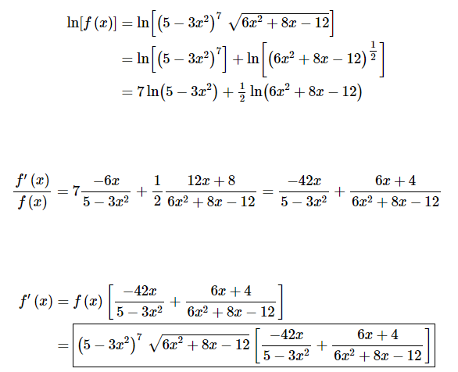

1. Suppose that *f* and *g* are differentiable functions with the following values:

$$f\left(0\right)=3, f^{'}\left(0\right)=4, g\left(0\right)= -1 and g^{'}\left(0\right)=2.$$

For each of the following show your work.

1. Find $h^{'}\left(0\right) given that h\left(x\right)=\frac{g(x)}{f(x)}$

***Solution****: $h^{'}\left(x\right)=\frac{f\left(x\right)g^{'}\left(x\right)-g\left(x\right)f^{'}\left(x\right)}{{\left(f\left(x\right)\right)}^{2}}.$*

*Hence $h^{'}\left(0\right)=\frac{f\left(0\right)g^{'}\left(0\right)-g\left(0\right)f^{'}\left(0\right)}{{\left(f\left(0\right)\right)}^{2}}=\frac{3\left(2\right)-\left(-1\right)\left(4\right)}{3^{2}}=\frac{10}{9}$*

1. **(i)** Find $k^{'}\left(0\right)given that k\left(x\right)={\left(g\left(x\right)\right)}^{2}f\left(x\right).$

***Solution****: $k^{'}\left(x\right)={\left(g\left(x\right)\right)}^{2}f^{'}\left(x\right)+f\left(x\right)2g\left(x\right)g'(x)$*

*And so $k^{'}\left(0\right)={\left(g\left(0\right)\right)}^{2}f^{'}\left(0\right)+f\left(0\right)2g\left(0\right)g^{'}\left(0\right)={\left(-1\right)}^{2}\left(4\right)+\left(3\right)2\left(-1\right)\left(2\right)=-8$*

**(ii)** Determine the local linearization of k(x) near x = 0 and use that to approximate k(0.001).

***Solution: $L\left(x\right)=k\left(0\right)+k^{'}\left(0\right)\left(x-0\right)=3-8x$***

So L(0.001) = 3 – 8(0.001) = **2.992**

1. Find $m^{'}\left(0\right)$ given that $m\left(x\right)=\sin\left({(f\left(x\right))}^{3}\right)$

***Solution*: $m'(x)=3{\left(f\left(x\right)\right)}^{2}f^{'}\left(x\right)cos\left({\left(f\left(x\right)\right)}^{3}\right)$**

*So $m'(0)=3{\left(f\left(0\right)\right)}^{2}f^{'}\left(0\right)cos\left({\left(f\left(0\right)\right)}^{3}\right)=3{\left(3\right)}^{2}\left(4\right) COS\left( 3^{3}\right)=108\cos{27≈31.5}$*

**7.** In Modern Portfolio Theory, a client’s portfolio is structured in a way that balances risk and return. For a certain type of portfolio, the risk, x, and return, y, are related by the equation

$$x-0.45{\left(y-2\right)}^{2}=2.2$$

This curve is shown in the graph below. The point P represents a particular portfolio of this type with a risk of 3.8 units. The tangent line, l, through P is also shown.

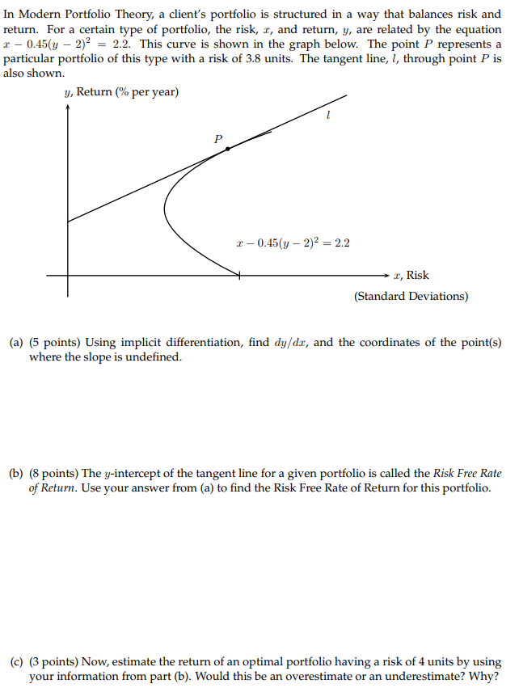

1. Using implicit differentiation, find $\frac{dy}{dx}$, and the coordinates of the point(s) where the slope is undefined.

***Solution:***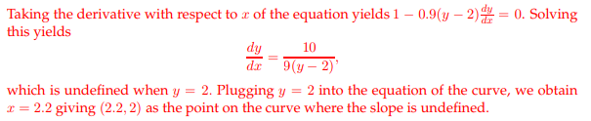

1. The y-intercept of the tangent line for a given portfolio is called the *Risk-Free Rate of Return*. Use your answer from (a) to find the Risk-Free Rate of Return for this portfolio.

***Solution:***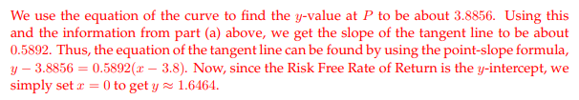

1. Now, estimate the return of an optimal portfolio having a risk of 4 units by using your information from part (b). Would this be an overestimate or an underestimate?

Hint: Use the linearization that you found in part (b).

***Solution:*** 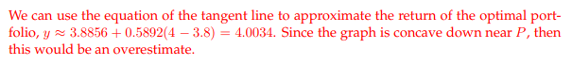

**8**. Below, there is a graph of the function h(x) defined by $h\left(x\right)=\frac{2x^{2}+10x}{(x+5)(x^{2}+4)}$

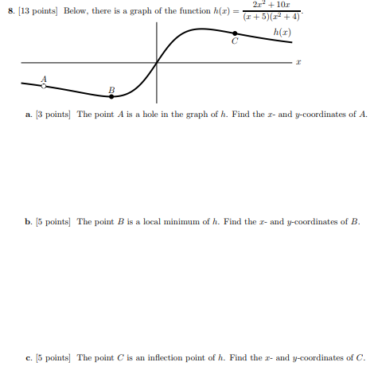

1. The point A is a hole in the graph of h. Find the x- and y-coordinates of A.

***Solution****: Note that the function is undefined when and only when x = -5.*

***Now $\lim_{x→-5}{\frac{2x^{2}+10x}{(x+5)(x^{2}+4)}=}\lim_{x→-5}{\frac{2x(x+5)}{(x+5)(x^{2}+4)}=\lim_{x→-5}{\frac{2x}{x^{2}+4}=-}}\frac{10}{29}$***

Thus $A=\left(-5, -\frac{10}{29}\right)$

1. The point B is a local minimum of h. Find the x- and y-coordinates of B.

***Solution:*** *Note that if we avoid x = -5, we can write $h\left(x\right)=\frac{2x}{x^{2}+4}$*

$$h'(x)=\frac{\left(x^{2}+4\right)2-2x\left(2x\right)}{{\left(x^{2}+4\right)}^{2}}=\frac{8-2x^{2}}{{\left(x^{2}+4\right)}^{2}}=-\frac{(x+2)(x-2)}{{\left(x^{2}+4\right)}^{2}}$$

Since the only critical points are ±2, the x-coordinate of B must be -2.

Now, since $h\left(-2\right)=\frac{2(-2)}{2^{2}+4}=-\frac{1}{2}$, we see that $B=\left(-2,-\frac{1}{ 2}\right)$

1. The point C is an inflection point of *h*. Find the x- and y-coordinates of C.

*Hint: $h^{''}\left(x\right)=0 at an inflection point.$*

***Solution:***

$$h^{''}\left(x\right)=-\frac{{\left(x^{2}+4\right)}^{2}\left(2x\right)-\left(x^{2}-4\right)2\left(x^{2}+4\right)2x}{{\left(x^{2}+4\right)}^{4}}=$$

$$-\frac{2x\left(x^{2}+4\right)(x^{2}+4-2\left(x^{2}-4)\right)}{{\left({-x}^{2}+4\right)}^{4}}=$$

$$-\frac{-2x\left(x^{2}+4\right)({-x}^{2}+12)}{{\left(x^{2}+4\right)}^{4}}$$

To find the coordinates of the points of inflection, we set $h^{''}\left(x\right)=0 to obtain x=±2 \sqrt{3}$

Since *C* is in the first quadrant, we choose the positive value of x.

Thus $C=\left(2\sqrt{3} ,\frac{1}{4}\sqrt{3}\right)≈(3.46, 0.43)$

**9.** *[MIT Practice test 18.01]* A hawk is pursuing a mouse. We choose a coordinate system so the mouse runs along the x-axis in the negative direction, and the hawk is flying over the x-axis, swooping down along the exponential curve, $y=e^{kx}$ for some positive constant *k*. The hawk in flight is always aimed directly at the mouse. It is noon at the equator, and the sun is directly overhead. When the hawk’s shadow on the ground is at the point x0, where is the mouse?

***Solution:***



*We must find the equation of the tangent line to the curve $f\left(x\right)=e^{kx} at the point T=\left(x_{0}, e^{kx_{0}}\right)$*

*Now the slope of the tangent line at the point T is $f'\left(x_{0}\right)$ $=ke^{kx_{0}}$*

*Thus, the equation of the tangent line to f at x = $x_{0}$ is $y-e^{kx_{0}}={ke}^{kx_{0}} (x-x_{0})$*

*Now, to locate the position of the mouse on the x-axis, we set y = 0:*

$$0-e^{kx_{0}}={ke}^{kx_{0}} (x-x_{0})$$

*So $$x=-\frac{e^{kx_{0}}}{{ke}^{kx_{0}}}+ x_{0}=x_{0}-\frac{1}{k}$$*

Rules of the Game

$\frac{d}{dx}\ln{x=\frac{1}{x}}$

$\frac{d}{dx}a^{x}=(\ln{a)a^{x}}$

$$\frac{d}{dx}\arcsin{x}=\frac{1}{\sqrt{1-x^{2}}}$$

$$\frac{d}{dx}\arctan{x}=\frac{1}{{1+x}^{2}}$$

$$\frac{d}{dx}\operatorname{arcsec}{x}=\frac{1}{x\sqrt{x^{2}-1}}$$

