# MATH 161 Solutions: TEST III 16 November 2018

***Instructions:*** Answer any 6 of the following 8 problems. You may answer more than 6 to earn extra credit.



**Instructions**: Answer any *6* of the following *8* problems. You may answer more than 6 to earn extra credit.

**1.** Consider the curve f(x) = ln x. Compute each of the following to *the nearest hundredth.*

Using **four** rectangles *estimate* the area under y = f(x) above the interval [2, 6] using

1. left-hand sums *(Sketch)*

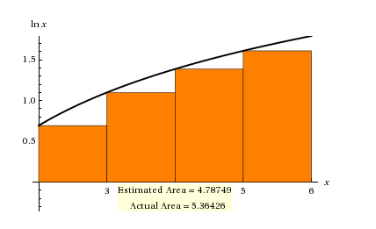

**Answer:** **4.79** (to the nearest hundredth)

**Over or underestimate?** *Underestimate*

(b) right-hand sums *(Sketch).*

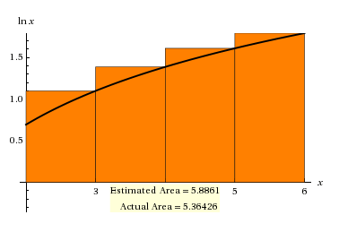

**Answer:** **5.89** (to the nearest hundredth)

**Over or underestimate?** *Overestimate*

1. How many rectangles of equal width would one need to estimate the area if the error must be less than 10-4?

***Solution:*** *Let n be the number of rectangles required. Then the width of each rectangle is $\frac{6-2}{n}= \frac{4}{n}$. As we saw in class, the total error is smaller than the rectangle of width $\frac{4}{n}$ and height $\ln{6-\ln{2=\ln{3. }}}$ Such a rectangle has area $\frac{4}{n}\ln{3.}$ Now we want to be certain that this area is smaller than the requisite error of 10-4, viz.*

*This implies that $n>4\left(\ln{3}\right){10}^{4}≈43,945$*

**2.** No matter what is done with the other exhibits, the octopus tank at the Lincoln Park Zoo must be rebuilt. (The current tank has safety issues, and there are fears that the giant octopus might escape!) The new tank will be 10 feet high and box-shaped. It will have a front made out of glass. The back, floor, and two sides will be made out of concrete, and there will be no top. The tank must contain at least 1000 cubic feet of water. If concrete walls cost $2 per square foot and glass costs $10 per square foot, use calculus to find the dimensions and cost of the least-expensive new tank. *[Be sure to show all work.]*

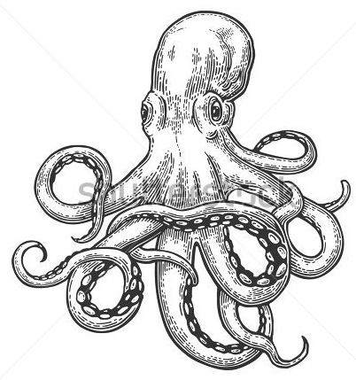

**GIANT OCTOPUS (Enteroctopus)**

***Solution:***

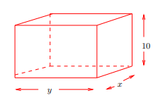

*Let x be the width of the tank, and let y be the length of the tank (both in feet).*

*The height of the tank is given as 10 feet.*

*We know that the volume of the tank must be at least 1000 cubic feet, so let V denote the desired volume of the tank, where V ≥ 1000.*

*Then, for a fixed value of V, we know that 10xy = V so that x and y are related by the equation $x=\frac{V}{10y}$. Now assuming that one of the y by 10 sides is the front of the tank (i.e., the glass panel), the total cost of the tank is given by:*

*C = 10(10y) + 2[(2)10x + 10y + xy] = 120y + 40x + 2xy.*

*Substituting for x, we can write C as a function of one variable:*

$C(y)=120y+\frac{4V}{y}+\frac{V}{5}$*.*

*Since the cost function increases as V increases, to minimize the cost of building the tank we must have V be as small as possible, so we set V = 1000.*

*Our cost equation is now:*

$$C(y)=120y+\frac{4000}{y}+200.$$

*Taking the derivative:*

$\frac{dC}{dy }=120-\frac{4000}{y^{2}}$

*and setting the derivative equal to 0:*

$120-\frac{4000}{y^{2}}=0$

*We find that the cost function has a unique positive critical point at*

$$y=\sqrt{\frac{100}{3}} ≈5.774 feet$$

*Since the second derivative $\frac{d^{2}C}{{dy}^{2}}=\frac{8000}{y^{3}}>0 for all y>0, we know$ that C(y) is concave up on (0, ∞). By the second-derivative test, our unique critical point must be a local (and in this case, global) minimum.*

*Solving for x, we find x ≈ 17.321 feet.*

*Thus, the glass side is the small side, and the dimensions and cost are:*

***Dimensions: 5.774 $×$ 17.321*** *x* ***10 feet***

***Minimum Cost: $≈$ $ 1585.70***

**3.** (a) Verify that $f\left(x\right)=\frac{x}{x+2}$ satisfies the hypotheses of the Mean Value Theorem on the interval [1, 4] and then find all of the values, *c*, that satisfy the conclusion of the theorem.

***Solution:*** *Since f(x) is a rational function with a single singularity at x = -2, f(x) is continuous on [1, 4] and differentiable on (1, 4). Thus y = f(x) satisfies the hypotheses of the MVT.*

*Next, $f^{'}(x)=\frac{\left(x+2\right)\left(1\right)-x\left(1\right)}{{\left(x+2\right)}^{2}} =\frac{2}{{\left(x+2\right)}^{2}} .$*

*To find the desired value(s) of c, we must solve: $f^{'}(c)=\frac{f\left(4\right)-f(1)}{4-1}$. Equivalently:*

$$\frac{2}{{\left(c+2\right)}^{2}}=\frac{\frac{2}{3}-\frac{1}{3}}{3}=\frac{1}{9}$$

*So, cross-multiplying: ${\left(c+2\right)}^{2}$ = 18, from which we find $c+2=±\sqrt{18}=±3\sqrt{2}.$*

*Hence $c=-2±3\sqrt{2}$ We must reject the negative root, $c=-2-3\sqrt{2}$ since it does not lie in (1, 4). Now $-2+3\sqrt{2}≈2.24 lies within the interval \left(1, 4\right) and the c that we$ $seek is: c=-2+3\sqrt{2}$*

(b) Let F(x) = tan x. Show that F(π) = F(2π) = 0 but there is no number *c*, where  < c < 2 such that F′(c) = 0. Why does this not contradict Rolle's theorem?

***Solution:*** *First f() – f() = tan  – tan 2 = 0 – 0 = 0. Yet there is no solution to the equation $\frac{d}{dx}$ tan x = sec2 x = 0, since |sec t| ≥ 1 for all t.*

*This does not contradict Rolle’s Theorem because f(x) is not defined at 3/2; so of course, f is not continuous on [, 2].*

(c) Show that there is no value *c*, where 1 < c < 4, such that

$$g^{'}\left(c\right)=\frac{g\left(4\right)-g(1)}{4-1}$$

Why is this not a contradiction of the Mean Value Theorem?

***Solution:***

*We are asked whether the equation $$f^{'}\left(c\right)=\frac{f\left(4\right)-f(1)}{4-1}$$*

*has a solution in the interval (1, 4)?*

*Equivalently, is there a solution to the equation -2(c – 3)-3 = where 1 < c < 4 ?*

*Cross-multiplying: -8(c – 3)-3 = 1*

*Yet c = -1 does not lie in the given domain of f(x). This does not contradict the MVT since*

*y = f(x) is undefined at x = 3, and so is* ***not continuous*** *on [1, 4].*

**4**. **(a)** Solve the initial value problem:

$$\frac{dy}{dt}=\sin\left(5t\right) +\frac{1}{\cos^{2}t}$$

subject to the condition: y(/4) = 5.

***Solution:*** Using the method of judicious guessing we solve the differential equation:

$\frac{dy}{dt}=\sin{5t +\frac{1}{\cos^{2}t}}=\sin\left(5t\right)+\sec^{2}{x}$, to obtain:

$y=-\frac{1}{4}\cos\left(4t\right)+\tan{t +C.}$*To find C, we apply the initial conditions:*

$$5=-\frac{1}{5}\cos\left(5\left(\frac{π}{4}\right)\right)+\tan{\frac{π}{4} +C.}$$

*Hence $C=5+\frac{1}{5} \left(-\frac{\sqrt{2}}{2} \right)-1 ⇒C=4-\frac{\sqrt{2}}{10} ≈3.86$*

*Finally, our solution is $y=-\frac{1}{4}\cos\left(4t\right)+\tan{t +4-\frac{\sqrt{2}}{10}}$*

**(b)** Evaluate $\int_{-1}^{3 }{\left|7-2x\right| dx}$

***Solution:***

*Noting that |7 – 3x| = 7 – 3x when x>-1, we have only to compute the area of the straight-line y = 7 – 3x above the interval [-1, 3].*



*Hence: $\int_{-1}^{3 }{\left|7-2x\right| dx}=20$*

**(c)** Evaluate $\int_{0}^{5 }{\left(1+2\sqrt{25-x^{2}}\right) dx}$

***Solution:*** *Using the properties of the Riemann integral*

$\int_{0}^{5 }{\left(1+2\sqrt{25-x^{2}}\right) dx}=\int_{0}^{5 }{1 dx}+2\int_{0}^{5 }{\sqrt{25-x^{2}} dx}$ =

$$5+2\left(\frac{1}{4}\right)π{(5)}^{2}=5+\frac{25}{2}π$$

**(d)** Evaluate $\int{\frac{1+x^{3}}{\sqrt{4+4x+x^{4}}}} dx$

***Solution:*** *Begin by noticing that the numerator, 1 + x3, is almost the derivative of 4 + 4x + x4.*

So we are looking at an expression of the form $g^{- \frac{1}{2 }} g'$.

Using our method of judicious guessing, our first guess is

${guess \#1= \left(4+4x+x^{4}\right)}^{\frac{1}{2}}$.

Now d/dx ${guess \#1=\frac{1}{2}\left(4+4x+x^{4}\right)}^{-\frac{1}{2}}\left(4+4x^{3}\right)={ 2\left(4+4x+x^{4}\right)}^{- \frac{1}{2}}\left(1+x^{3}\right)$

Next, our second, and final guess is:

$${guess \#2=\frac{1}{2}\left(4+4x+x^{4}\right)}^{\frac{1}{2}}+C$$

**5.** Three congressional representatives leave a meeting at the White House and return home to watch the TV show, *The Simpsons*. In this episode, Homer needs to deliver Lisa’s homework to her at school, and he must do so before Principal Skinner arrives. Suppose Homer starts from the Simpson home in his car and travels with velocity given by the figure below. Suppose that Principal Skinner passes the Simpson home on his bicycle 2 minutes after Homer has left, following him to the school. Principal Skinner can sail through all the traffic and travels with a constant velocity of 10 miles per hour.

*Note:* Beware of the units, miles & minutes.

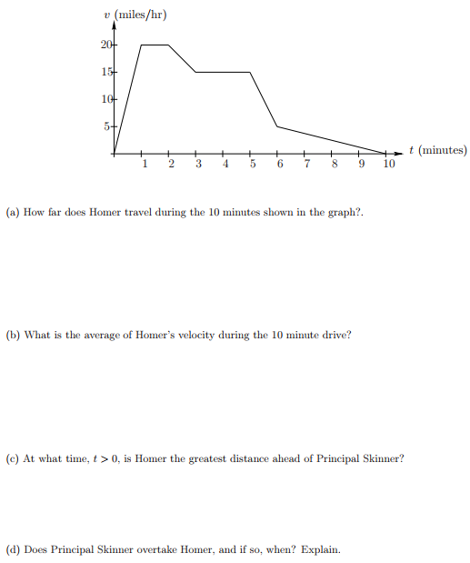

1. When (or during which interval(s) is Homer traveling at maximum speed? What is that speed?

***Answer:*** *Homer’s speed is maximum during the time interval t = 1 to t = 2 minutes. This speed is 20 mph.*

1. How far does Homer travel during the 10 minutes shown in the graph?

***Solution:*** *To calculate how far Homer travels during the 10 minutes shown in the graph we find the area under the graph of Homer’s velocity. Note that we must multiply by a constant so that the units are correct! This gives that distance equals $\frac{1}{60}$ (area under the curve)= $\frac{1}{60}\left(97.5\right)=1.625 miles.$*

1. A what time, t > 0, is Homer the greatest distance ahead of Principal Skinner?

***Solution:*** *As long as Homer’s velocity is greater than Principal Skinner’s velocity, Homer is moving farther from Principal Skinner. Since Principal Skinner is traveling at a constant velocity of 10 miles/hr, Homer is the greatest distance ahead of Skinner at* ***t ≈ 5.5 minutes.***

1. Does Principal Skinner overtake Homer, and, if so, when? Explain.

***Solution:*** *Principal Skinner will overtake Homer when the distance he has traveled is equal to the distance that Homer has traveled. Notice though that the area under Homer’s velocity curve and the area under Principal Skinner’s velocity curve overlap. So, they will have traveled the same distance when the area between Homer’s velocity curve and Skinner’s velocity curve from t = 0 to t = 5.5 equals the area between the two velocity curves from t = 5.5 to some time t > 5.5. Notice though that the area between the two curves from t = 0 to = 5.5 is greater than the area between the two curves from t = 5.5 to t = 10. So****, Skinner does not overtake Homer****. Or, more precisely, Principal Skinner travels $\frac{1}{60}\left(10\right)\left(8\right)=1.33 miles.$ This is less than the 1.625 miles that Homer traveled in the 10 minutes.*

**6.** *Parts (a), (b), and (c) are independent of each other.*

1. Suppose that y = h(x) is a twice differentiable function *defined for 0 < x < 2π* and that



Find all points of inflection of y = h(x) and list intervals where *h* is *concave up* and *concave down* *on its domain*.

***Solution:*** *Performing a sign analysis on $\frac{d^{2}y}{{dx}^{2}} ,$ we see that the only transition points in the*

*domain (0, 2) are  and 4.*

*Now >0 on (0, ) and on (4, 2). Also < 0 on (, 4).*

*This means that h is concave up on the intervals (0, ) and (4, 2) and that h is concave down*

*on (, 4). Consequently, h has* ***inflection points at x =  and at x = 4.***

1. Suppose that $\int_{3}^{9 }{\left(5-2f(x)\right) dx}$ = 22. Find $\int_{3}^{9 }{f\left(x\right) dx}$

***Solution:*** *Using the properties of the Riemann integral:*

$\int_{3}^{9 }{\left(5-2f(x)\right) dx=\int_{3}^{9 }{5 dx}-2\int_{3}^{9 }{f(x) dx}}=5\left(9-3\right)-22\int_{3}^{9 }{f(x) dx}$ $=$

$$30-22\int_{3}^{9 }{f(x) dx}$$

*Next, setting $$30-22\int_{3}^{9 }{f\left(x\right)dx=22}$$*

*we obtain: $\int_{3}^{9 }{f\left(x\right)dx=\frac{30-22}{22}}=\frac{4}{11}$*

1. Evaluate $\int{ }\left(\frac{x}{x^{2}+5 }+\frac{{(\ln{x)}}^{5}}{x}\right) dx$

***Answer:*** *Using the method of judicious guessing:*

$$\int{ }\left(\frac{x}{x^{2}+5 }+\frac{{(\ln{x)}}^{5}}{x}\right) dx=\frac{1}{2}ln (x^{2}+5){+\frac{1}{6} {(\ln{x)}}^{6}+C}$$

**7.** Suppose that H(c) is the average temperature, in degrees Fahrenheit that can be maintained in Oscar’s apartment during the month of December as a function of the cost of the heating bill, *c*, in dollars. Using *complete sentences*, give a practical interpretation of each of the following:

1. H(50) = 65

***Answer:***





$H^{'}\left(50\right)=2$

***Answer:***



Suppose T(t) gives the temperature (in degrees Fahrenheit) in Oscar’s apartment on December 18th as a function of time, *t,* in hours since midnight. Below is a graph of $T^{'}\left(t\right), the derivative of T.$

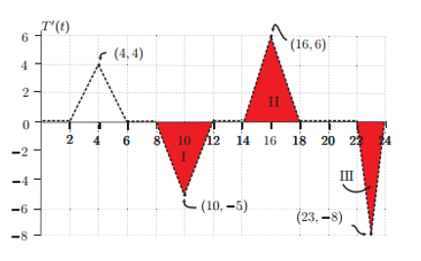

1. When Oscar returns home from work at 6 pm, the temperature in his apartment is 67 $℉$. What was the temperature when he left for work at 8 am?

***Solution:*** *The net change in temperature from t = 8 am to t = equals the area under the curve from 14 to 18 minus the area below the t-axis from 8 to 6 pm = 12 – 10 = 2. Hence the change in temperature from t = 8 am until t = 6 pm is $2 ℉.$ Thus when Oscar left his apartment at 8 am the temperature was $65 ℉$.*

1. If the temperature at 6 pm is 67 $℉$, what is the minimum temperature in the apartment on December 18th?

***Solution:*** 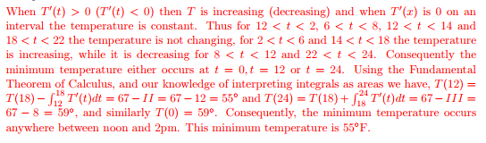

minimum temperature either occurs at t = 0, t = 12, or t=24. Using our knowledge of interpreting integrals as areas we have T(12) = 55 $℉$, T(24) = 59 $℉, and$ T(0) = $59℉.$

Consequently, the minimum temperature occurs anywhere between noon and 2 pm.

This minimum temperature is **55 $℉.$**

**8**. Water is being poured into a large vase with a circular base. Let V(t) be the volume of water in the vase, in cubic inches, t minutes after the water started being poured into the vase.

Let H be the depth of the water in the vase, in inches, and let R be the radius of the surface of the water, in inches. A formula for *V* in terms of *R* and *H* is given by



1. Suppose that the water is being poured into the vase at a rate of 300 cubic inches per minute. When the depth of the water is 5 inches, the radius of the surface of the water is 4 inches, and the radius is increasing at a rate of 1.2 inches per minute. Find the rate at which the *depth* of the water in the vase is increasing at that time. Show your work carefully.

***Solution:*** *Differentiating with respect to time:*

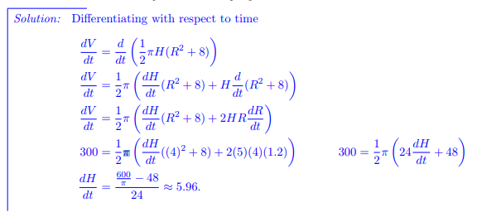

*Thus the rate at which the depth of the water changes is approximately* ***5.96 inches/minute****.*

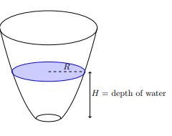***H* = depth of water**

1. Recall that *R* gives the radius of the surface of the water, in inches, *t* minutes after the water started being poured into the vase. Suppose that *R* is given by R = m(t) and

m′ (3) = 0.7. Use these facts to complete the following sentence:

*After the water has been poured into the vase for three minutes, over the next ten seconds, the radius of the surface of the water ______________________________*

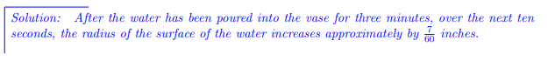

Extra Extra Credit:

For Valentine’s Day, Marcel decides to make a heart-shaped cookie for Albertine to try to win her over. Being mathematically-minded, the only kind of heart that Marcel knows how to construct is composed of two half-circles of radius *r* and an isosceles triangle of height *h*, as shown below. Marcel happens to know that Albertine’s love for him will be determined by the dimensions of the cookie she receives; if given a cookie as described above, her love L will be

L = hr2, where *r* and *h* are measured in centimeters and *L* is measured in pitter-patters, a standard unit of affection. If Marcel wants to make a cookie whose area is exactly 300 cm2, what should the dimensions be to maximize Albertine’s love?

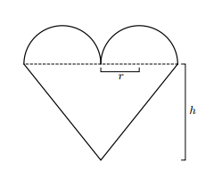

***Solution:*** The area of the heart shape is $A=πr^{2}+2rh$.

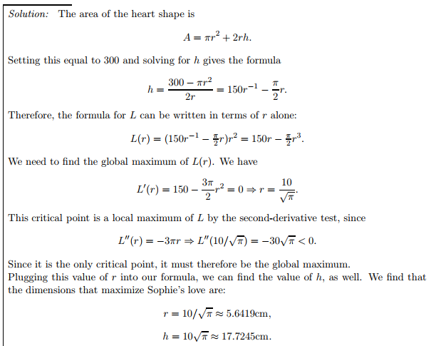

the dimensions that maximize Albertine’s love are $r=\frac{10}{\sqrt{π}}≅5.642 cm, and h=10\sqrt{π} ≅17.725 cm.$

*Thus mathematics may be defined as the subject in which we never know what we are talking about, nor whether what we are saying is true.*

– [Bertrand Russell](http://plato.stanford.edu/entries/russell/)