Math 162 Group Work Assignments

GW I (January 18th)
Solve selected problems from Worksheets 2 and 3.
GW II (January 30th)
Solve selected problems from Practice Quizzes 2a and 2b.
GW III (February 6th)
Solve selected problems from Practice Tests 1a and 1b.
GW IV (February 13th)
Solve selected problems from Practice Quiz III.
GW V (February 20th)
Solve selected problems from Practice Quiz IV.
GW VI (February 27th)
Solve selected problems from Practice Tests 2A and 2B.
GW VII (March 13th)
Solve selected problems from Practice Quiz V.
GW VIII (March 20th)
Solve selected problems from Practice Quiz VI.
GW IX (April 3rd)
Solve selected problems from Practice Quiz VII.
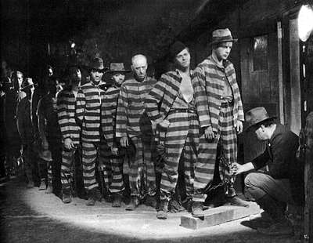
I Am A Fugitive from a Chain Gang (1932)

Course Home Page Department Home Page Loyola Home Page

