Math 162 - Calculus II

Spring 2013
Section 002: MWF 12:35 - 2:30 pm (103 Cuneo Hall)
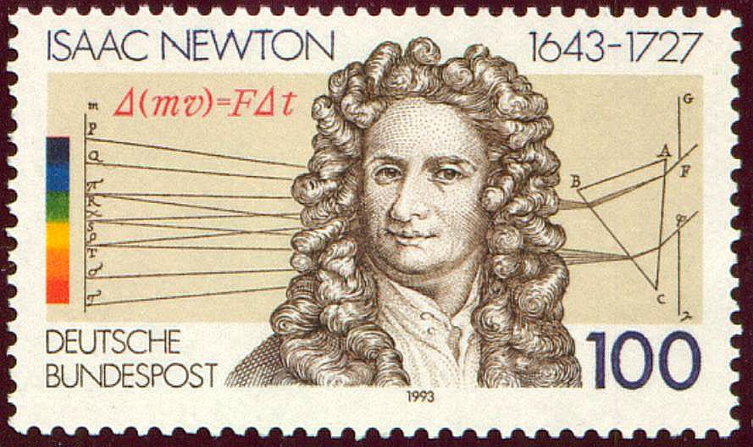
- Ground Rules
- Syllabus
- Homework & Reading Assignments
- Group Work
- Worksheets
- Blackboard
- MyMathLab (Getting Started)
- Tutoring Services and Schedule
- Project
- Practice Quizzes (1A, 1B, 1C, 2A, 2B, 3, 4A, 4B, 5, 6, 7, 8)
- Practice Tests (1A, 1B, 2A, 2B, 3)
- Mathematica Labs and Examples
- Quiz Solutions (Qz I, Qz II, Qz III, Qz IV, Qz V, Qz VI, Qz VII, Qz VIII)
- Test Solutions (Test I, Test II, Test III)
- Final Exam Review Sheet
- Practice Math 162 Finals (A, B)
- Useful References (Greek alphabet; Mathematica tutorials & websites; supplementary texts)
- Student Resources for Thomas
- MIT OCW for Calculus
- History of Calculus
- Grades

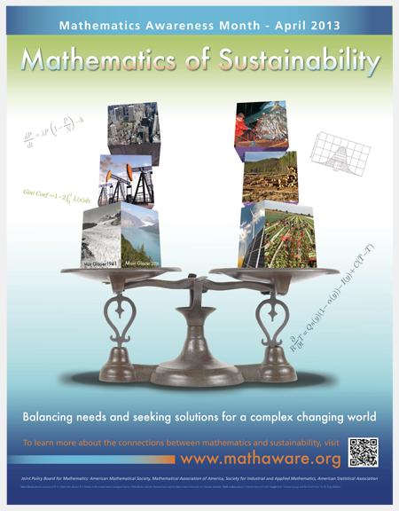

Department Home Page Loyola Home Page

