Mathematica LABS: MATH 162
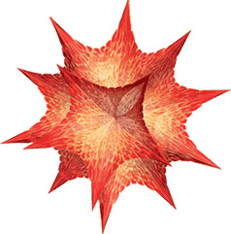
Lab I (Solids of Revolution)
assignment, examples
Lab II (Improper Integrals)
assignment, examples
Lab III (Sequences)
assignment, examples
LAB IV (Taylor series)
assignment, examples

Without laboratories men of science are soldiers without arms.
- Louis Pasteur (1822-95)
Course Home Page Department Home Page Loyola Home Page

