Calculus Projects for Math 162

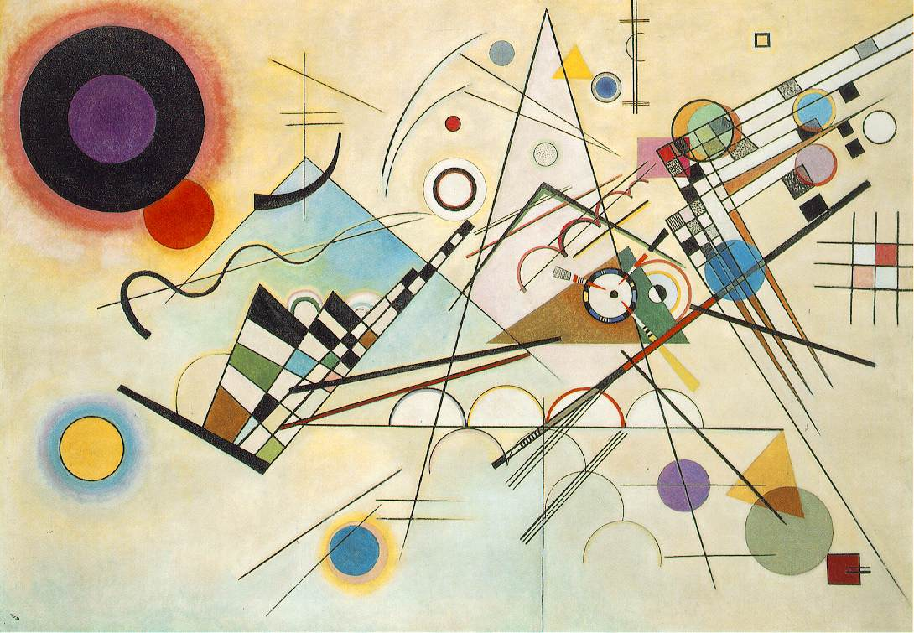

Wassily Kandinsky, Composition 8

Select one of the eleven calculus “research projects” written by Professor R. Grant Woods (Calculus Mysteries and Thrillers, MAA). The ratings for the projects are:

- Easy: The Case of the Parabolic Pool Table

- Easy: Calculus for Climatologists

- Difficult: The Case of the Swiveling Spotlight

- Moderate: Finding the Salami Curve

- Moderate: Saving Lunar Station Alpha

- Easy: The Case of the Cooling Cadaver

- Difficult: An Income Policy for Mediocria

- Moderate: Designing Dipsticks

- Difficult: The Case of the Gilded Goose-egg

- Difficult: Sunken Treasure

- Difficult: The Case of the Alien Agent

It is advisable to work in a group of size three, but you may choose to work on the project either individually or with only a single partner. Mathematica may be useful in presenting graphs or performing calculations, but there is no requirement that Mathematica be employed in your solution. Your solution must be written in essay form, including calculations in an appendix. Your project grade will take into account the difficulty level of your chosen project. Your solution must reflect the work of the group, not solutions that you may happen to find on the web. If you use any solution or portion of a solution that you have found on the web, then your project will be given a grade of F.

Due Date: Wednesday, April 24, 2013

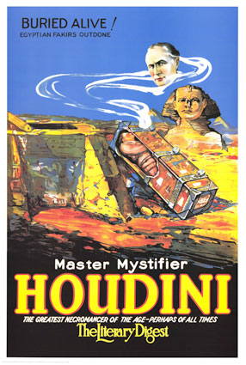
Course Home Page Department Home Page Loyola Home Page

