Math 162 Solutions: QUIZ I

1. Sketch the region in the first quadrant bounded by the curve y = 1 + ln x and the lines x = e, and y = 1. This region is rotated about the line x = -7. Using the shell method, write a definite integral that expresses the volume of this solid of revolution. *Do not evaluate.*

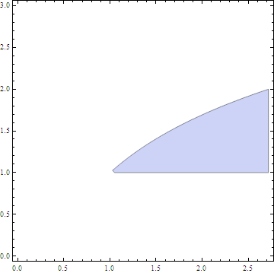

*To use shells, we fix x. Consider a thin vertical rectangle between x = 1 and x = e. The thickness of the rectangle is ∆x. The area of the shell associated with this rectangle is*

*A(x) = 2  (x – (-7)) ln x. Thus the total volume of the solid is:*

**

1. The base of a certain solid is an elliptical region given by the inequality

9x2 + 4y2 ≤ 36. Cross-sections perpendicular to the y-axis are semicircles. Express the volume of the solid as a definite integral. *Do not evaluate.*



*Consider a thin horizontal rectangle between y=-3 and y=3. The thickness of the rectangle is ∆y. The area of the semicircle associated with this rectangle is ( /2)x2, where*

*x = sqrt ((36 – 4y2)/9). Thus the total volume of the solid is:*



1. Let T be the triangular region with vertices (0, 0), (4, 4) and (0, 5). Suppose that T is rotated about the axis y = -8. Using the washer method, write a definite integral that expresses the volume of this solid of revolution. *Do not evaluate.*

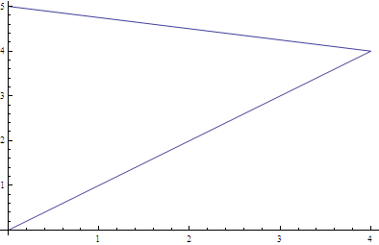

*The equation of the line joining (0,5) and (4,4) is y = 5 – x/4 and the equation of the line joining (0,0) and (4,4) is y = x.*

*To use washers, we fix the value of x (between 0 and 4). Consider a corresponding vertical rectangle with width ∆x. The outer radius of the washer is 5 – x/4 – (-8) = 13 – (x/4) and the inner radius of the washer is x + 8. Hence the volume of the solid is:*

**

***Extra Credit:***

A round hole of length *2h* is bored through the center of a solid sphere of radius *R*. (Assume that h < R). Find the volume of the solid that remains.



*If c denotes the radius of the hole, then c2 + h2 = R2. Consider the region in the upper half-plane bounded by the circle x2 + y2 = R2 and the line y = c. Rotate this region about the x-axis. Consider a thin horizontal rectangle y-units above the axis where c ≤ y ≤ R Rotate this rectangle about the x-axis to obtain a shell. The volume of this shell is*

*2 y(2x)∆y, where x = (R2 – y2)1/2. Thus the total volume of this solid of revolution is given by:*

**

*Notice the remarkable fact that this volume does not depend upon the radius of the sphere!*

