# MATH 162 Solutions: TEST I

***1.*** Consider the region bounded by the curves y = 3x + 4 and y = x2. Find the volume of the solid generated by revolving this region about the line x = 4. Express your answer as a Riemann integral.

*Using shells, we obtain:*



***2***. Evaluate 

*Using integration by parts, we let f(x) = x and g′(x) = cosh 3x. Then f ′(x) = 1 and g(x) = (sinh 3x)/3. Thus*



***3.*** Evaluate 

*Let us substitute u = ex + 2013. Thus du = ex dx, and so:*

**

***4.*** For each of the following statements answer *True* or *False*. Briefly justify each answer!

1. x3 ln x + x + 1 = *o*(x4)

*True since (x3 ln x + x + 1) / x4 → 0 as x→∞.*

1. sinh x = *O*(cosh x)

*True since sinh x / cosh x = (ex – e-x)/ (ex + e-x) → 1 as x→∞.*

1. 

*False since:*



***5.*** Consider the region in the first quadrant bounded by the curve y = cos x, 0 ≤ x ≤ /2, and the x and y-axes. This region is rotated about the axis y = 9. Express the volume of this solid of revolution as a Riemann integral.

*We will use washers to solve this problem. Fix x between 0 and /2. The inner radius is 9 – cos x; the outer radius is 9. Hence:*



***6.*** Evaluate 

*Integration by parts: Let f(x) = arc sin x and g′(x) = 1. Then f ′(x) = 1/(1–x2)1/2 and g(x) = x. So*



***7.*** The base of a solid is a disk of radius 5. Each cross section cut by a plane perpendicular to a diameter is an isosceles right triangle with hypotenuse on the base. Express the volume of the solid as a Riemann integral. You need not evaluate the integral.



*The equation of this circle is x2 + y2 = 25. Let us assume that the diameter referred to in the question lies on the x-axis. Then, taking a typical slice at x (in the interval [-5, 5], with thickness ∆x, the volume of the corresponding slice (an isosceles right triangle with hypotenuse 2y = 2 Sqrt(25 - x2) is given by*

*∆V= ½  y (2y) ∆x =(25 - x2) ∆x. Thus:*



***8.*** Let *S* be the surface of revolution obtained by rotating the curve



about the line x = 9. Find a Riemann integral that expresses the *surface area* of this region. (Do not evaluate the integral.)

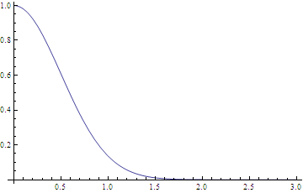

**

***9.*** Consider the triangle with vertices (0, 2), (6, 2), (3, 4). This triangle is rotated about the axis y = -3. Express the volume of this solid of revolution as a Riemann integral. Do not evaluate.



*The equations of the two non-horizontal sides are: y = (2/3)x + 2 and y = (-2/3)x + 6. Solving for x, we obtain: x = (3/2) (y – 2) and x = -(3/2) (y – 6), respectively.*

*Using shells, the radius of the shell at y is y – (-3) = y + 3 and the length of the shell is -(3/2) (y – 6) – ((3/2) (y – 2)) = 12 – 3y. Hence:*



***10.*** A conical tank with height 25 meters and radius *5* meters is filled with a fluid of density ** kilograms per cubic meter. How much work must be done to pump all the fluid over the top rim of the tank? Do not evaluate the integral.

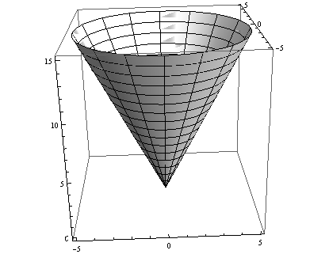



***11.*** Assume that *m* and *n* are positive integers. Using integration by parts, derive the following reduction formula:



*Let f(x) = (ln x)n and g′(x) = xm. Thus f′(x) = n(ln x)n-1(1/x) and g(x) = xm+1/(m+1). Thus:*



***12.*** The curve given by  is rotated about the y-axis. Compute the *area* of the generated surface. Do not evaluate your integral.



**Extra Credit:** Evaluate the following integral:



*Using the integration by parts formula:*

*Let f(x) = ln x and g′(x) = x -1/2. Then f′(x)=1/x and g(x) =2 x1/2. Hence:*

