Worksheets: MATH 162
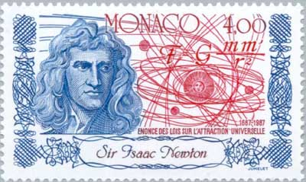

Worksheet I: review
Worksheet II: volume
Worksheet III: washers vs shells
Worksheet IV: parameterized curves
Worksheet V: arc length, surface area, work
Worksheet VI: integration by parts
Worksheet VII: review of hyperbolic functions
Worksheet VIII: little o and big 0
Worksheet IX: improper integrals

Worksheet X: numerical sequences

Worksheet XI: numerical series, part I

Worksheet XII: integral test, ratio test, root test

Worksheet XIII: absolute and conditional convergence

Worksheet XIV: brief introduction to probability

Worksheet XV: power series

Worksheet XVI: operations on power series

Worksheet XVII: Taylor polynomials, Taylor series

Worksheet XVIII: Euler’s formula, complex power series

Worksheet XIX: substitution, a review

Worksheet XX: integration of trig functions; trig substitutions

Worksheet XXI: partial fraction decomposition

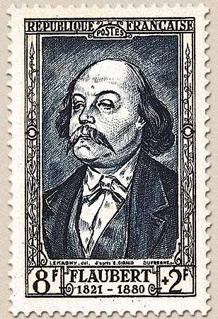
Work! God wills it. That, it seems to me, is clear.
- Gustave Flaubert (letter to Louise Colet, 1845)

Course Home Page Department Home Page Loyola Home Page

