**WORKSHEET I**

Review

1.   Find the area of the region bounded by the x-axis and the curve

y = x(x – 1)(x – 3)

2.   Find the area under one arch of the curve y = sin 4x.

3.   Find the area bounded between the curves y = x2/2 and y = x + 4.

4.   Evaluate by first interpreting as area:



5.   Evaluate



(*Hint:*  Think about the area interpretation of this integral.)

6.   Show that



7.   Using the Fundamental Theorem of Calculus, compute the derivative of the function



8.   Suppose that Charlotte, the spider, travels along the x-axis from time t = 0 until t = 3 hrs and that her velocity function is given by:

v(t) = t(1+t2)1/2  mph.

How far does Charlotte travel during these three hours?

9. Using the method of *judicious guessing* or *substitution*, evaluate each of the following indefinite integrals:

(a) 

(b) 

(c) 

(d) 

10. Find the *maximum* value of the function G(x) = - x4 ln x .

11. *Sketch* the curve below, finding all zeroes, singularities, horizontal and vertical asymptotes.



12. *Sketch* the following curve, finding all *local extrema* and *points of inflection*. Where is the function *concave up*? *concave down*? Find *global extrema* if they exist.



13. Compute the following limit:



14. Find the point on the line x/a + y/b = 1 that is closest to the origin.

15. Find the values of *p* and *q* for which the function f(x) = x3 + px2 + qx

(a) has a local max at x = -1 and a local min at x = 3.

(b) has a local min at x = 4 and a point of inflection at x = 1.

16. Express the following as a Riemann integral and evaluate:



17. Give the definitions of the hyperbolic functions sinh x, cosh x, tanh x and sech x. Prove that (cosh x)2 – (sinh x)2 = 1 and 1 – (tanh x)2 = (sech x)2.

18. Find the area of the region bounded by the curves y = x2012 and y = x2013.



*Twice and thrice over, as they say, good is it to repeat and review what is good.*

* Plato
* 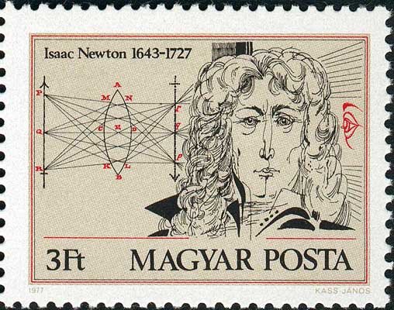

[Course Home Page](http://www.math.luc.edu/~ajs/courses/162spring2013/index.pdf)         [Department Home Page](http://www.math.luc.edu/)        [Loyola Home Page](http://www.luc.edu/)