Worksheet XIII

Absolute & conditional convergence

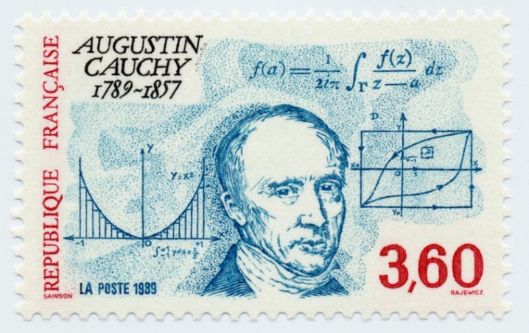

1. Explain how the *ratio* and *root* *tests* can be extended for series more general than positive series.
2. State the **Cauchy-Leibniz rule** for alternating series.
3. For each of the following series, determine *absolute* convergence, *conditional* convergence or *divergence*.

























*A man is like a fraction whose numerator is what he is and whose denominator is what he thinks of himself. The larger the denominator, the smaller the fraction.*

– Leo Tolstoy