Worksheet XIV

Power series

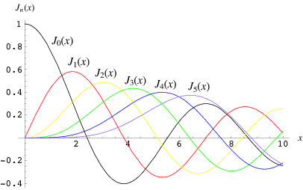

[*Bessel functions*](http://mathworld.wolfram.com/BesselFunctionoftheFirstKind.html) *may be expressed as power series*

For each of the following power series, determine the *interval of convergence*. Consider end-point behavior as well.

























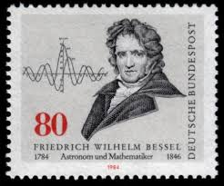

*If people do not believe that mathematics is simple, it is only because they do not realize how complicated life is.*

- John von Neumann