**WORKSHEET III**

Disks and washers

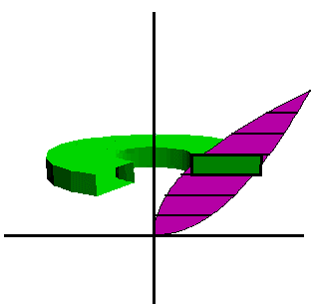

1. Find the volume of the solid of revolution obtained by rotating the region bounded by y = x2, y = 0, x = 2 about the y-axis.
2. Find the volume of the solid of revolution obtained by rotating the region bounded by y = sec x, y = 0, x = -/4, x =  /4, about the x-axis.
3. Find the volume of the solid of revolution obtained by rotating the region bounded by y = x, y = 1, x = 0, about the x-axis.
4. Find the volume of the solid of revolution obtained by rotating the region bounded by 4 – x2, y = 2 – x, about the x-axis.
5. Find the volume of the solid of revolution obtained by rotating the region enclosed by the triangle with vertices (1, 0), (2, 1), and (1, 1), about the y-axis.
6. Find the volume of the solid of revolution obtained by rotating the region in the first quadrant bounded above by y = x2, below by the x-axis, and on the right by the line x = 1, about the line x = -1.
7. Find the volume of the solid of revolution obtained by rotating the region in the second quadrant bounded above by the curve y = - x3 , below by the x-axis, and on the left by the line x = -1, about the line x = -2.

Shells



1. Find the volume of the solid obtained by rotating about the the y-axis the region bounded by y = 2x2 – x3 and y = 0.
2. Find the volume of the solid obtained by rotating about the y-axis the region between y = x and y = x2.
3. Use shells to find the volume of the solid obtained by rotating about the x-axis the region under the curve y = x1/2 from 0 to 1.
4. Find the volume of the solid obtained by rotating the region bounded by y = x – x2 and y = 0 about the line x = 2.
5. Find the volume of the solid obtained by rotating the region bounded x = 1 + (y – 2)2 and x = 2 about the x-axis.
6. Find the volume of the solid obtained by rotating the region bounded by y = 4x – x2  and y = 3 about the axis x = 1.
7. Each of following integrals represents the volume of a solid. Describe the solid:
8. 
9. 
10. 

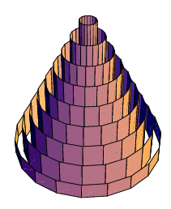

[Course Home Page](http://www.math.luc.edu/~ajs/courses/162spring2013/index.pdf)          [Department Home Page](http://www.math.luc.edu/)        [Loyola Home Page](http://www.luc.edu/)