**WORKSHEET IV**

Arc Length, Surface Area, WOrk

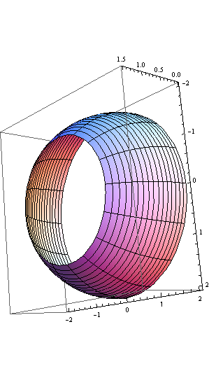

1. Find the arc length of the curve y = cosh x = ½ (ex + e-x) on the interval [0, ln 2].
2. Find the arc length of the curve y = ln( cos x) on the interval [0, /4].
3. Find the arc length of the *astroid* x2/3 + y2/3 = 1.



1. Find the arc length of the parameterized curve x = cos t, y = t + sin t, 0 ≤ t ≤ .
2. Find the arc length of the curve x = y3/6 + 1/(2y) from y = 2 to y = 3.
3. Find the arc length of the parameterized curve x = et cos t, y = et sin t, 0 ≤ t ≤ .
4. Find the surface area of a sphere of radius *r*.
5. Express as a definite integral the area of the surface obtained by rotating the curve y = sin x, 0 ≤ x ≤  about the axis:
6. y = 0
7. y = 5
8. y = -3
9. x = 0
10. x = 7
11. Find the area of the surface (called a spherical zone) obtained by revolving the graph of y = (4 – x2)1/2 on [0, 1] about the x-axis.
12. Find the area of the surface obtained by revolving the parameterized curve x = t – sin t, y = 1 – cos t, 0 ≤ t ≤ 2, about the x-axis.
13. An 8 pound bucket is lifted from the ground into the air by pulling in 30 feet of rope at a constant speed. The rope weighs 0.1 pounds/foot. How much work was spent lifting the bucket and rope?
14. (from *Thomas*) A rectangular tank, with its top at ground level, is used to catch runoff water. The depth of the tank is 20 ft and its base is 10 ft by 12 ft. Assume that water weighs 62.4 lb/ft3.
15. How much work does it take to empty the tank by pumping the water back to ground level once the tank is full.
16. If the water is pumped to ground level with a 5/11 horsepower motor (work output is 250 ft-lb/sec), how long will it take to empty the full tank (to the nearest minute)?
17. Show that the pump in part (b) will lower the water level 10 ft during the first 25 minutes of pumping.
18. What are the answers to parts (a) and (b) in a location where water weighs 62.26 lb/ft3? 62.59 lb/ft3?
19. Consider a right, circular cylindrical tank of radius 20 feet and height 40 feet. It starts out full of oil weighing 60 lb/cubic foot. How much work is done in pumping all the oil to the top of the tank?



*The Koch snowflake has infinite arc length.*

[Course Home Page](http://www.math.luc.edu/~ajs/courses/162spring2013/index.pdf)          [Department Home Page](http://www.math.luc.edu/)        [Loyola Home Page](http://www.luc.edu/)