**WORKSHEET V**

Parametric equations – a brief introduction



1. Sketch the curve x(t) = 3t, y(t) = t2 + 1. Express *y* as a function of *x*.
2. Describe the parameterized curve x(t) = 3 cos t, y(t) = 4 cos t, 0 ≤ t ≤ 2.

What is the relationship between the given curve and each of the following?

1. x(t) = -3 cos t, y(t) = 4 cos t, 0 ≤ t ≤ 2.
2. x(t) = 3 cos 2t, y(t) = 4 cos 2t, 0 ≤ t ≤ 2.
3. x(t) = 1 – 3 cos 2t, y(t) = 1 – 4 cos 2t, 0 ≤ t ≤ 2.
4. Show that the following is a parameterization of the [cycloid](http://mathworld.wolfram.com/Cycloid.html): x() = a( – sin ), y() = a(1 – cos ), -∞ <  < ∞.
5. Show that x = a cos t + h, y = b sin t + k, 0 ≤ t ≤ 2 is a parametric equation of an ellipse with center at (h, k) and axes of length 2a and 2b.

5. Find a parameterization of the straight line y = 3x + 4.

6. Find a parameterization of the straight line segment joining the points P = (3, 5) to Q = (7, 11).

7. Find a parameterization of the curve y = x2 from P = (-1, 1) to Q = (4, 16).

8. Generalize problem 7 for any curve of the form y = f(x) from x = a to x = b.

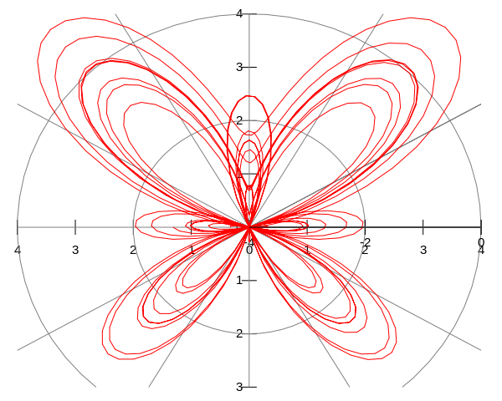

[Course Home Page](http://www.math.luc.edu/~ajs/courses/162spring2013/index.pdf)          [Department Home Page](http://www.math.luc.edu/)        [Loyola Home Page](http://www.luc.edu/)