SURVIVAL SHEET: Math 162 - section 004

Spring Semester 2015

Textbook: George Thomas, et al, Thomas’ Calculus: Early Transcendentals
(Part 1: Single Variable), 13th edition, Addison-Wesley (2014), packaged with MyMathLab or MyMathLab stand-alone.
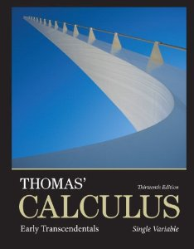

Calculator: The TI-83 Plus or TI-84 Plus graphing calculator or equivalent is required.
Software: Mathematica 9 or 10
Instructor: A. Saleski, 612 BVM Hall (contiguous with IES) building # 37 on map 6349 N. Kenmore Ave., Chicago, IL 60660
phone: (773) 508-3577
e-mail: asalesk@luc.edu OR alan.saleski@gmail.com
Course URL:
http://www.math.luc.edu/~ajs/courses/162spring2015/index.pdf

Office Hours: MWF 10:45 – 11:45 am, MWF 4 – 5 pm,
TTh 2:45 – 4:30 pm
or by appointment.

Important Dates:
• Quizzes: January 16th, 23rd, 30th; February 13th, 20th, 27th;
March 20th, 27th; April 17th
• Tests: February 6th, March 13th, April 10th
• Holidays:
- Martin Luther King, Jr, Day: Monday, January 19th
- Spring break: Monday – Friday, March 2rd – 6th
- Easter break: Friday – Monday, April 3rd – April 5th
• Last Day to Withdraw: Monday, March 23rd (5:00 pm)
• Last Day of Class: Friday, April 24th
• Final Exam: Friday (9 am – noon), May 1st
• Loyola Calendar (Spring Semester of 2015)

Ground Rules: The final grade is computed according to the following recipe:

Quizzes | 21 %
Tests | 24 %
Homework (MyMathLab) | 12 %
Mathematica labs | 6 %
Essay | 6 %
Groupwork & boardwork & Piazza | 6 %
Final Exam | 25 %

Tutoring Services:
The Center for Tutoring & Academic Excellence offers free Small Group tutoring for Loyola students. The groups meet once a week through the end of the semester and are led by a peer tutor who has successfully completed study in the course material and beyond. Drop-in tutor-led Study Hall hours are also available through the end of the semester. There is no need to make an appointment for Study Hall hours, simply bring your coursework and there will be tutors on hand to assist you. To learn more or to request tutoring services, visit the Center online at www.luc.edu/tutoring.

Remarks:
- Piazza will be our main form of communication outside of class. Upon receiving your welcome message from Piazza, you should join. All general questions/remarks/solutions should be posted in Piazza. If you wish to make a personal statement, it might be best to email me directly (although the option of private messages does exist in Piazza).

- Quizzes will be based upon recent class discussion, recent homework and, occasionally, assigned videos. Each quiz will last about 20 minutes. There will be no make-up quizzes unless the student makes prior arrangements with the instructor. The lowest two of the nine quiz grades will be dropped.

- The duration of each test is approximately one hour. Make-up tests will be given only for non-frivolous reasons. The student should make prior arrangements with the instructor, if at all possible.

- MyMathLab homework will be accepted beyond the posted deadline, but with a 25% penalty for those exercises completed after the due date.

- The minimum penalty for cheating is failure in the course. A student who improperly aids another with a homework assignment, a test, the essay, the final exam, or with a Mathematica lab is considered to be equally culpable. If you receive help on an assignment from anyone other than the instructor (this includes another student, a TA, a tutor, a family member, website, or friend), you should acknowledge this fact in a comment at the beginning of your homework or project. Incidents of academic dishonesty will be reported to the appropriate Dean.

- The project/essay will be due at the beginning of the last week of class.

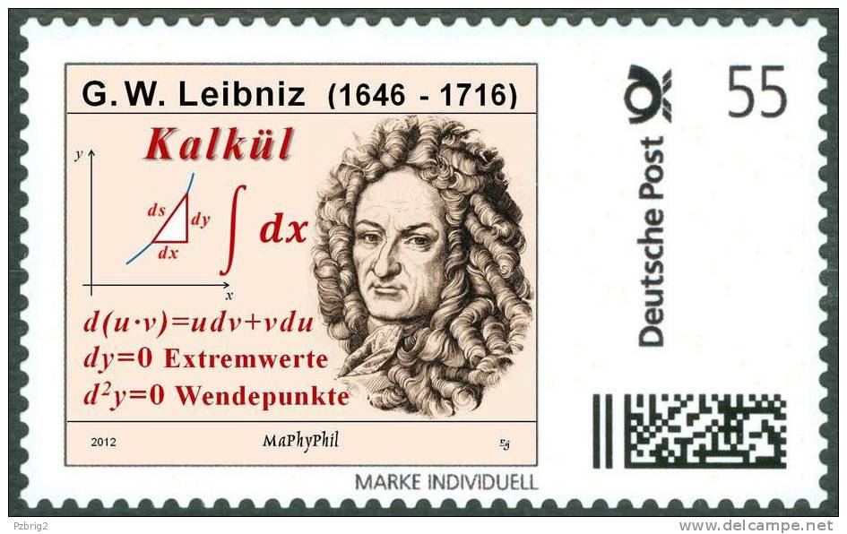

The goal of intellectual education is not to know how to repeat or retain ready-made truths (a truth that is parroted is only a half-truth). It is in learning to master the truth by oneself at the risk of losing a lot of time and of going through all the round about ways that are inherent in real activity.
- Jean Piaget

Course Home Page Department Home Page Loyola Home Page

