## Math 162 - Calculus II

## Spring 2015

Section 004:  MWF 12:35 - 2:30 pm  (227 Dumbach Hall)

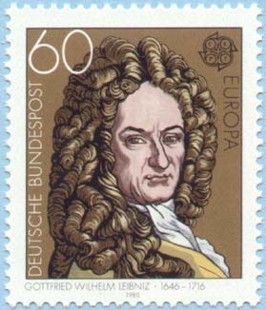

* [Ground Rules](http://webpages.math.luc.edu/~ajs/courses/162spring2015/groundrules.pdf)
* [Syllabus](http://www.luc.edu/math/academics/courses/math162/)
* [Homework & Reading Assignments](http://www.math.luc.edu/~ajs/courses/162spring2015/homework.pdf)
* [Piazza](http://www.piazza.com)
* GroupWork
* [Worksheets](http://www.math.luc.edu/~ajs/courses/162spring2015/worksheets/index.pdf)
* [MyMathLab](http://www.pearsonmylabandmastering.com/northamerica/) ([Getting Started](http://www.math.luc.edu/~ajs/courses/162spring2015/MMLinstructions.pdf))
* [Tutoring Services and Schedule](http://www.luc.edu/tutoring/index.shtml)
* [Project/Essay](http://www.math.luc.edu/~ajs/courses/162spring2015/essayTopics.pdf)
* Practice Quizzes ([Qz 1A](http://www.math.luc.edu/~ajs/courses/162spring2015/oldQuizzes/quiz1A.pdf), [Qz 1B](http://www.math.luc.edu/~ajs/courses/162spring2015/oldQuizzes/quiz1B.pdf), [Qz 1C](http://www.math.luc.edu/~ajs/courses/162spring2015/oldQuizzes/quiz1C.pdf), [Qz 2](http://www.math.luc.edu/~ajs/courses/162spring2015/oldQuizzes/quiz2.pdf), [Qz 3](http://www.math.luc.edu/~ajs/courses/162spring2015/oldQuizzes/quiz3.pdf), [Qz 4](http://www.math.luc.edu/~ajs/courses/162spring2015/oldQuizzes/quiz4.pdf), [Qz 5](http://www.math.luc.edu/~ajs/courses/162spring2015/oldQuizzes/quiz5.pdf), [Qz 6](http://www.math.luc.edu/~ajs/courses/162spring2015/oldQuizzes/quiz6.pdf), [Qz 7](http://webpages.math.luc.edu/~ajs/courses/162spring2015/oldQuizzes/quiz7.pdf), [Qz 8](http://webpages.math.luc.edu/~ajs/courses/162spring2015/oldQuizzes/quiz8.pdf), [Qz 9](http://webpages.math.luc.edu/~ajs/courses/162spring2015/oldQuizzes/quiz9.pdf))
* Practice Tests ([Test 1a](http://www.math.luc.edu/~ajs/courses/162spring2015/practiceTests/test1a.pdf), [Test 1b](http://www.math.luc.edu/~ajs/courses/162spring2015/practiceTests/test1b.pdf), [Test 2a](http://www.math.luc.edu/~ajs/courses/162spring2015/practiceTests/test2a.pdf), [Test 2b](http://www.math.luc.edu/~ajs/courses/162spring2015/practiceTests/test2b.pdf), [Test 3](http://webpages.math.luc.edu/~ajs/courses/162spring2015/practiceTests/test3.pdf))
* Practice Finals ([Final A](http://www.math.luc.edu/~ajs/courses/162spring2015/practiceFinals/finalA.pdf), [Final B](http://www.math.luc.edu/~ajs/courses/162spring2015/practiceFinals/finalB.pdf))
* Mathematica Examples ([revolution](http://www.math.luc.edu/~ajs/courses/162spring2015/MathematicaExamples/revolution.nb), [improper integrals](http://www.math.luc.edu/~ajs/courses/162spring2015/MathematicaExamples/integralsImproper.nb), [sequences](http://www.math.luc.edu/~ajs/courses/162spring2015/MathematicaExamples/sequences.nb), [Taylor series](http://www.math.luc.edu/~ajs/courses/162spring2015/MathematicaExamples/Taylor.nb))
* Mathematica Labs ([Lab I](http://www.math.luc.edu/~ajs/courses/162spring2015/labs/lab1.pdf), [Lab II](http://www.math.luc.edu/~ajs/courses/162spring2015/labs/lab2.pdf), [Lab III](http://www.math.luc.edu/~ajs/courses/162spring2015/labs/lab3.pdf), [Lab IV](http://www.math.luc.edu/~ajs/courses/162spring2015/labs/lab4.pdf))
* Quiz Solutions ([Qz 1](http://www.math.luc.edu/~ajs/courses/162spring2015/quizSolutions/quiz1.pdf), [Qz 2](http://www.math.luc.edu/~ajs/courses/162spring2015/quizSolutions/quiz2.pdf), [Qz 3](http://www.math.luc.edu/~ajs/courses/162spring2015/quizSolutions/quiz3.pdf), [Qz 4](http://www.math.luc.edu/~ajs/courses/162spring2015/quizSolutions/quiz4.pdf), [Qz 5](http://www.math.luc.edu/~ajs/courses/162spring2015/quizSolutions/quiz5.pdf), [Qz 6](http://www.math.luc.edu/~ajs/courses/162spring2015/quizSolutions/quiz6.pdf), [Qz 7](http://webpages.math.luc.edu/~ajs/courses/162spring2015/quizSolutions/quiz7.pdf), [Qz 8](http://www.math.luc.edu/~ajs/courses/162spring2015/quizSolutions/quiz8.pdf), [Qz 9](http://www.math.luc.edu/~ajs/courses/162spring2015/quizSolutions/quiz9.pdf))
* Test Solutions ([Test 1](http://www.math.luc.edu/~ajs/courses/162spring2015/testSolutions/test1.pdf), [Test 2](http://www.math.luc.edu/~ajs/courses/162spring2015/testSolutions/test2.pdf), [Test 3](http://www.math.luc.edu/~ajs/courses/162spring2015/testSolutions/test3.pdf))
* [Final Exam Review Sheet](http://www.math.luc.edu/~ajs/courses/162spring2015/review.pdf)
* Useful References ([Greek alphabet](http://www.ibiblio.org/koine/greek/lessons/alphabet.html); [Mathematica tutorials & websites](http://www.math.luc.edu/~ajs/courses/162spring2015/mathematicaSites.pdf); [supplementary texts](http://www.math.luc.edu/~ajs/courses/162spring2015/texts.pdf))
* [Student Resources for Thomas](http://wps.aw.com/aw_thomas_calculus_11/0,10384,1961402-,00.html)
* [MIT OCW for Calculus](http://ocw.mit.edu/OcwWeb/Mathematics/18-01Fall-2006/VideoLectures/index.htm)
* [History of Calculus](http://www-groups.dcs.st-and.ac.uk/~history/HistTopics/The_rise_of_calculus.html)

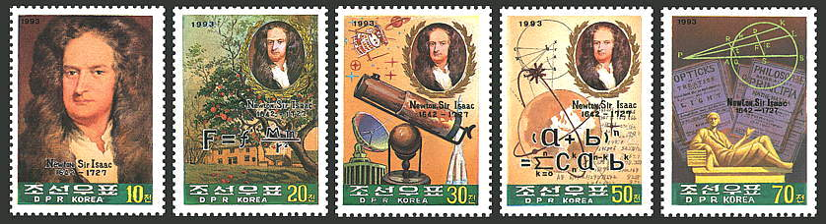

[Department Home Page](http://www.math.luc.edu/)  [Loyola Home Page](http://www.luc.edu/)