**MATH 162 Practice QUIZ IV**

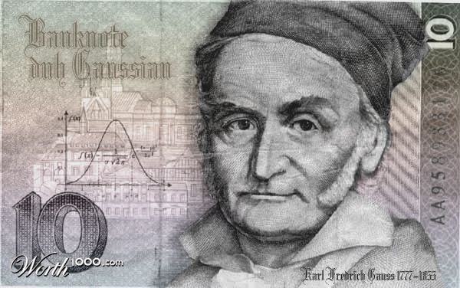

1. Compute the *exact value* of each of the following convergent improper integrals:















1. For each of the following improper integrals, determine convergence or divergence. *Justify your answers!*







3***.*** For each of the following improper integrals, determine *convergence or divergence.*  *Justify each answer! (That is, if you use the comparison test, exhibit the function that you choose to use for comparison and show why the appropriate inequality holds.)*

(a) 

(b) 



4. For which value(s) of the constant *C* will the following improper integral converge?



5. For each improper integral given below, determine convergence or divergence. (You may either perform the integration directly or else use the Comparison Test.) *Justify your answers!*

(a) 

(b) 

(c) 

(d) 

(e) 

(f) 

6. For each improper integral given below, determine convergence or divergence. (You will need to use the *Comparison Test* here.) *Justify your answers!*

(a) 

(b) 

(c) 

(d) 

7. Find the *volume* of the solid of revolution obtained by rotating the curve

y = 1/(1 + x2)1/2 from x = 0 to x = ∞ about the x-axis or explain why no such number exists.

8. For each of the following improper integrals, determine *convergence or divergence.* Use an appropriate version of the *Comparison Test*.

(a) 

(b) 

(c) 

(d) 

9. For each of the following improper integrals, determine *convergence* or *divergence*. *Justify your answers!*

(a) 

(b) 

(c) 

(d) 

10. (*Thomas*) Let *T* be the lifetime in years of an Oz Cell Phone. Assume that this lifetime is modeled with the following exponential density function



1. Verify that this function is a probabilty density function.

Using this model,

1. Find the probability that a cell phone will last for *more than 2 years.*
2. Find the probability that a cell phone will fail in the 4th year.

11. Find the value of *c* so that 

is a probability density funtion.

12. *(University of Michigan)*

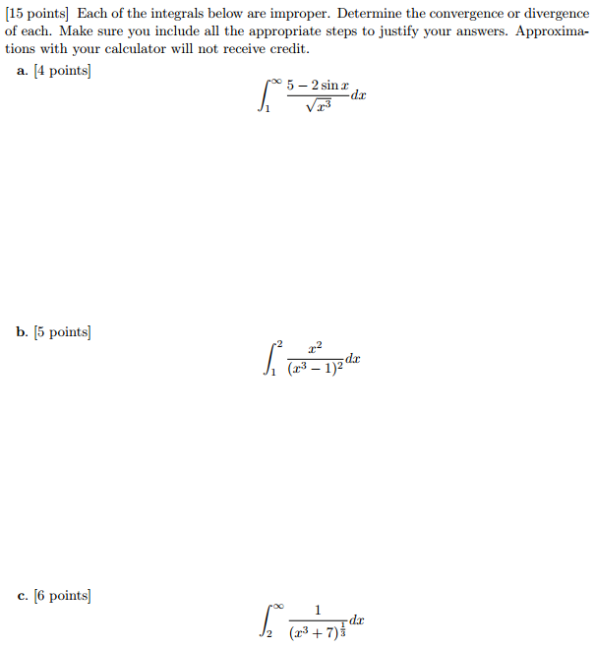

13. *(University of Michigan)*

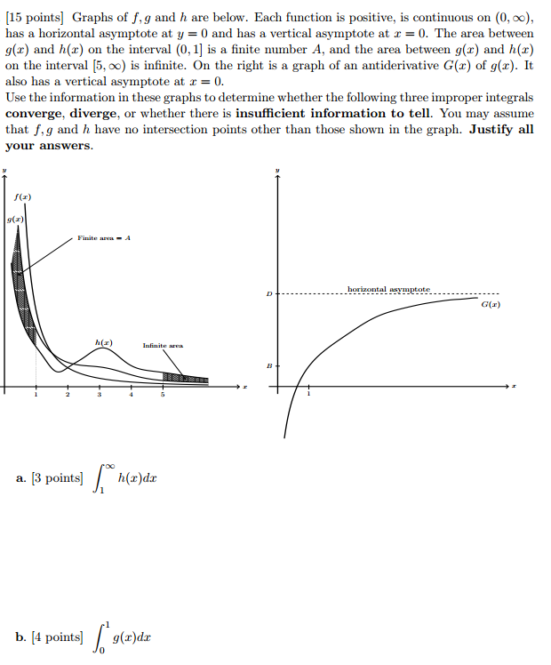

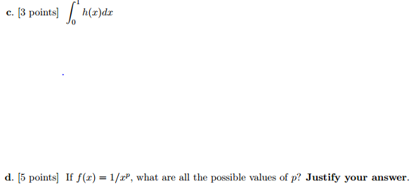

*As far at the laws of mathematics refer to reality, they are not certain; and as far as they are certain, they do not refer to reality.*

- Albert Einstein, **Sidelights on Relativity**

