# MATH 162 Practice QUIZ VI 25 February 2015

Name: ______________________

1. To which of the following series does the “*nth term test for divergence*” apply? Explain!













2. Which of the following infinite series are *geometric* and which are not? For those that are geometric, determine convergence or divergence. In the case of convergence, find the limit. Show your work!











3. Sum each of the following series or explain why the series is divergent.









4. For each of the following positive series determine convergence/ divergence of the series. You may need to use the comparison test. Justify your answers!

(a) 

(b) 

(d) 

(e) 

(f) 

5. *True or False:*

1. An increasing sequence bounded above must converge.
2. A convergent sequence is bounded.
3. A convergent sequence is either increasing or decreasing.
4. A decreasing sequence bounded below must converge.
5. A positive series must converge.
6. A positive series is either convergent or unbounded.
7. The harmonic series diverges.
8. Consider the two series an and bn  where the summation begins at n = 0.

If an and bn each converge to 1 then (3an + bn) must converge to 4.

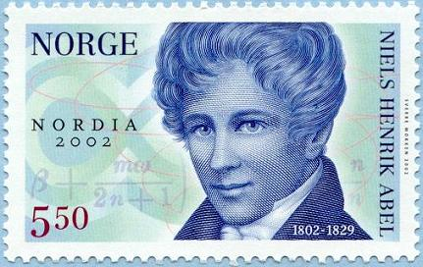

*Divergent series are the invention of the devil, and it is shameful to base on them any demonstration whatsoever.*

- Niels Henrik Abel (1828)

*There is more danger of numerical sequences continued indefinitely than of trees growing up to heaven. Each will some time reach its greatest height.*

- [Friedrich Ludwig Gottlob Frege](http://www.todayinsci.com/F/Frege_Friedrich/FregeFriedrich-Quotations.htm), **Grundgesetz der Arithmetik** (1893)