**MATH 162 Practice QUIZ VIII**

1. For each of the following functions, find the 4th order Taylor polynomial centered at x = *c* :
2. y = sinh x + 3 cosh x, c = 0
3. y = 1 + x + e3x, c = 0
4. y = 1/(x + 2), c = 0
5. y = ln(1 + x), c = 0
6. y = x1/2, c = 4
7. y = sin x, c = /4
8. y = 1 + x + 3x2 – 4x3, c = 0
9. y = 1 + x + 3x2 – 4x3, c = 1
10. y = xe2x, c = 0
11. Using multiplication of power series, find the *first four non-zero* terms of the Maclaurin series expansion of f(x) = e2x cos(3x).
12. Using division of power series, find the *first four non-zero* terms of the Maclaurin series expansion of



1. Using your choice of technique, find the *first four non-zero* terms of the Maclaurin series expansion of:
2. y = xe-4x
3. y = (2 + x)/(1 – x)
4. y = (1 – x – x2) e2x
5. y = (sin x) ln(1 + x)
6. y = x cos2 x
7. 
8. y = exp(1 + x2)
9. Find the Taylor series expansion of y = ex at x = c.
10. *(University of Michigan final exam problem)*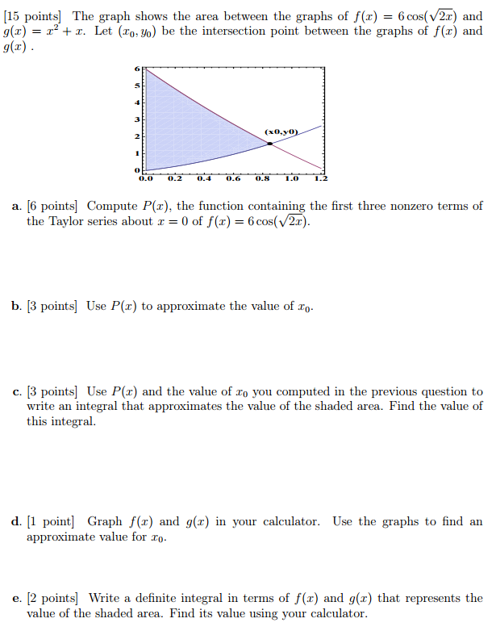
11. Without using L’Hôpital’s rule, find



1. By differentiating an appropriate power series, compute the following sum:



1. Find the Taylor series of



centered at x = -1.

1. Let F(x) = x4 arctan(3x). Find F(2345)(0).

*Hint:* Beginning with a geometric series, find the Maclaurin series expansion of arctan(t).

1. Without using L’Hôpital’s rule, find



1. Find the first four non-zero terms in the Maclaurin expansion of f(x) = tan x by dividing the series for sin x by the series for cos x.

*One cannot escape the feeling that these mathematical formulas have an independent existence and an intelligence of their own, that they are wiser than we are, wiser even than their discoverers.*

- Heinrich Hertz