**MATH 162 Practice TEST III**

**1.**For each series below, determine absolute convergence, conditional convergence or divergence. Justify each answer.











**2.** For each power series below, determine the *radius of convergence* and the *interval of convergence*. Study the behavior of each power series at the *endpoints*.



(b) 

(c) 

**3.**(a) Find the 3rd order Maclaurin polynomial of *cosh x*.

(b) Find the 5th order Taylor polynomial of *cos x* centered at x = /2.

**4**. Find the 4th order Taylor polynomial of ex centered at x = 2.

**5**. Find the 3rd order Maclaurin polynomial of

f(x) = 4 + (x+13)2 + (x+13)3

**6.** By differentiating the power series expansion of y = 1/(1 – x), find the value of



**7**. Find the *first five* non-zero terms of the Maclaurin series expansion of

h(x) = (1 + 2x2) e3x.

**8**. Let f(x) = x8 e5x. Compute f(100)(0). Do not simplify your answer.

***9.*** Find the *radius of convergence* of the power series:



***10.*** Find the *radius of convergence* of the power series:



***11.*** Find the *radius of convergence* of the power series:



**12 .** *Without using* l'Hôpital's rule, calculate the following limit. Show your work!



1. Let G(x) = x3 cosh (3x). Using an appropriate Maclaurin series, compute G(2015)(0). (Do not try to simplify your answer.)
2. Find the first four non-zero terms of the Maclaurin series for each of the following:







15. (a) Express  as a complex number of the form a + bi.

(b) By expressing -1 as an appropriate complex power of *e*, calculate the five fifth roots of -*i*.

Express your answers in the form a + bi.

(c) Using Euler’s formula, express cos(4x) in terms of cos x and sin x.

16. Using division of power series, find the first three non-zero terms of the Maclaurin series expansion of



17. Using multiplication of power series, find the first four non-zero terms of the Maclaurin series expansion of



18. Determine the *interval of convergence* of the following power series. (You need not study end-point behavior.)



19. Analyze the behavior of the series



20. Prove Euler’s formula.

21. What is the relationship between cosh x and cos x? between sinh x and sin x?

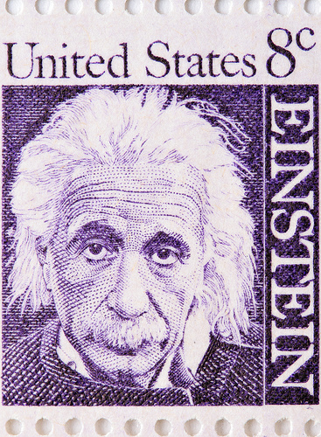

*As far as the laws of mathematics refer to reality, they are not certain; as far as they are certain, they do not refer to reality.*

* Albert Einstein