MATH 162 solutions: QUIZ I

1. The base of a certain solid is an elliptical region given by the inequality

9x2 + 4y2 ≤ 36. Cross-sections *perpendicular to the y-axis* are semicircles. Express the volume of the solid as a definite integral. Sketch. *Do not evaluate.*

*Solution:*

**

*Consider a thin horizontal rectangle between y = -3 and y = 3. The thickness of the rectangle is ∆y. The area of the semicircle associated with this rectangle is ( /2)x2, where x = sqrt ((36 – 4y2)/9). Thus the total volume of the solid is:*



1. Let T be the triangular region with vertices (0, 0), (4, 4) and (0, 5). Suppose that T is rotated about the axis y = -8. Sketch. Using the washer method, write a definite integral that expresses the volume of this solid of revolution. *Do not evaluate.*

*Solution:*

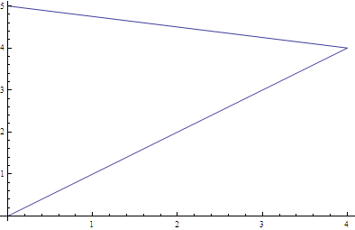

*The equation of the line joining (0,5) and (4,4) is y = 5 – x/4 and the equation of the line joining (0, 0) and (4, 4) is y = x.*

*To use washers, we fix the value of x (between 0 and 4). Consider a corresponding vertical rectangle with width ∆x. The outer radius of the washer is 5 – x/4 – (-8) = 13 – (x/4) and the inner radius of the washer is x + 8. Hence the volume of the solid is:*

**

# *The quarrel [between Newton and Leibniz] is simply the expression of evil weaknesses and fostered by vile people. Just what would Newton have lost if he had acknowledged Leibniz's originality? Absolutely nothing! He would have gained a lot. And yet how hard it is to acknowledge something of this sort: someone who tries it feels as though he were confessing his own incapacity. ... It's a question of envy of course. And anyone who experiences it ought to keep on telling himself: "It's a mistake! It's a mistake! -- "*

# - Ludwig Wittgenstein (1947)