**MATH 162 Solutions: QUIZ II**

1. *[20 pts]* Consider the region R in the first quadrant that is bounded by the curves y = (x – 1)2 and

y = . Sketch! This region is rotated about the axis x = 3. Using the *shell method* write the volume of this solid of rotation as a Riemann integral.

*Solution:*

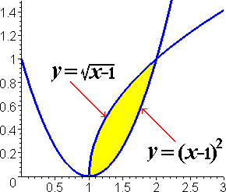

The thickness of the shell is ∆x, so the integrand must be a function of *x*. The distance of the shell from the axis of rotation is 3 – x. Furthermore, the height of the shell is the difference between the two y-values (corresponding to x) which is determined by the two curves.

That is, the height of the shell is

– (x – 1)2

Hence the volume of the solid of revolution can be expressed by the integral:



2. *[10 pts]* Consider the parameterized curve: x = et – 1, y = e2t, where t ≥ 0, describing the position in the xy-plane of Mehitabel, the cat, at time *t*.

1. By eliminating the parameter, *t*, express *y* as a function of *x*.

*Solution: Since x = et – 1, et = x + 1. Hence y = e2t = (x + 1)2. Now, the domain of this function is [0, ∞).*

1. *Sketch* the parameterized curve, using an arrow to indicate the direction of Mehitabel’s journey. Also, indicate the birthplace of Mehitabel.

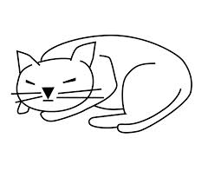 *Solution: When t = 0, x = 0 and y = 1. Thus Mehitabel is born at the point (0, 1) in the xy-plane.*

*As t > 0 increases, both x and y increase. Thus Mehitabel’s direction of motion is northeast.*



3. *[5 pts]* Charlotte travels along a straight line from P = (1, -3) to Q = (5, 7). Find a parameterization for this trip. Let us assume that, when t = 0, Charlotte is at *P* and, when t = 1, Charlotte has reached *Q*.

 *Solution: Let (x(t), y(t)) = (1 – t) (1, -3) + t (5, 7)*

*Thus x(t) = (1 – t)1 + 5t = 4t + 1. and y(t) = (1 – t)(-3) + 7t = 10t – 3*

*The book of nature is written in the language of mathematics.*

- Galileo