# MATH 162 Solutions: QUIZ VI

# 

*Instructions:* For each of the following infinite series, determine *convergence* or *divergence*. You need not find the sum of those series that converge. *You must justify your answers!*

Answer any 6 of the following 7 questions. You may answer all 7 to obtain extra credit.

*[10 pts per problem]*

1. 

*Solution: This series is telescoping. Consider the sequence of partial sums:*



*from which we infer that sn = 1/1789 – 1/(1789+n) → 1/1789 as n → ∞. Thus our series converges and its sum is* ***1/1789****.*

2. 

*Solution:*



*Applying the nth term test for divergence, we see that our series diverges.*

*Alternatively: Applying the ratio test*

**

*we find that the series diverges (since r > 1).*

3. 

*Solution: Since* 

*We already know (from an application of the Comparison Test discussed in class) that*

 *converges.*

*Finally, we can apply the Comparison Test to conclude that* *converges.*

4. 19.113113113113…

*Solution: All repeating decimals converge to a rational number.*

*Or we can just note that separating 19.1 from the decimal expansion yields a geometric series, viz.*

19.113113113113… = 19 + {0.113 + 0.000113 + 0.000000113 + …}

*Now 0.113 + 0.000113 + 0.000000113 + … is geometric with ratio*

*10 -3 < 1. Hence we conclude that the repeating decimal converges. If we wish to compute the sum of the series (which is not required in this problem) we have:*



5. 

*Solution:*  

*Now the series*  *converges by the p-test. (Since we have not yet learned the p-test for 1 < p < 2, everyone receives full credit for this problem.)*

6. 

*Solution: Consider the partial sums:*



*From this we infer that sn = –ln(n + 1). Since the sequence { sn } clearly diverges, we conclude that our original series diverges.*

7. 

*Solution:*



*Applying the nth term test for divergence, we see that our series diverges.*

Extra Extra Credit *(University of Michigan, Calculus 2 final exam question)*



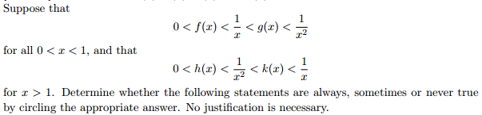

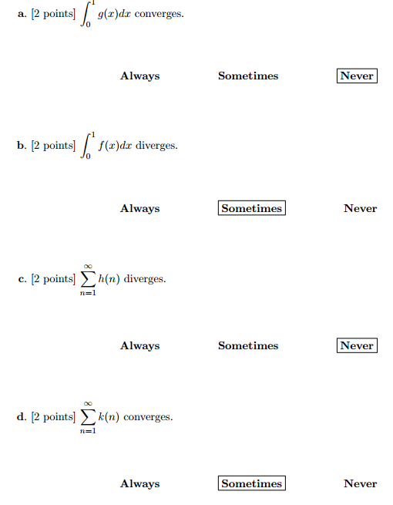

*A mathematician is a blind man in a dark room looking for a black cat which isn't there.*

- Charles R. Darwin