# MATH 162 Solutions: Quiz VIII

Answer any 5 of the 6 problems. You may answer all six to obtain extra credit*.*

1. Let G(x) = e2x. Using an appropriate Maclaurin series, compute G(2015)(0). *(Do not try to simplify your answer.)*

*Solution:*



Here the coefficient of x2015 is 22015/ 2015!

Now the general Maclaurin series has, for its x2015 coefficient:



Hence 

Finally 

**2**. Find the 5th order Taylor polynomial of **f(x) = ln x** centered at x = . (No need to simplify!)

*Solution:*

*Since f(x) = ln x, we find that:*

*f′(x) = x-1*

*f′′(x) = – x-2*

*f(3)(x) = 2! x-3*

*f(4)(x) = – 3! x-4*

*f(5)(x) = 4! x-5*

*Hence f(3) = ln 3, f′(3) = 3-1, f′′(3) = – 3-2 , f(3)(3) = 2! 3-3, f(4)(3) = – 3! 3-4 and*

*f (5)(3) = 4! 3-5.*

*So the 5th order Taylor polynomial of ln x centered at x = 3 is:*



3. Find the 4th order Taylor polynomial centered at x = 1 of the function

F(x) = (x – 4)4.

*Solution:*

*Note that F(1) = 81, F′(1) = -108, F′′(1) = 108, F′′′(1) = -72 and F(4)(1)=24.*

*Thus the 4th degree Taylor polynomial is:*



4. Suppose that the Maclaurin series of **g(x) = sinh-1 (x)** is given by:



Find g(5)(0). *Do not simplify!*

*Solution: The coefficient of x5 corresponds to n = 2. This coefficient is*



Now the general Maclaurin series has, for its x5 coefficient:



Hence 

Finally 

5. Find the first four non-zero terms of the Maclaurin series expansion of:

 (*No need to simplify!)*

*Solution:*



Thus: 

So the first four non-zero terms are:



6. Find the *first four non-zero* terms of theMaclaurin series of *g(x) =*  3 sin x + cos(2x).

*Solution:*





Finally:



Thus the first four non-zero terms are:



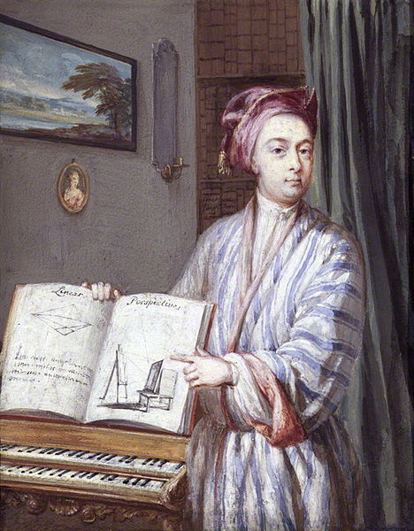

Taylor was one of the few English mathematicians who could hold their own in disputes with Continental rivals, although even so he did not always prevail. Bernoulli pointed out that an integration problem issued by Taylor as a challenge to “non-English mathematicians” had already been completed by Leibniz in Acta eruditorum. Their debates in the journals occasionally included rather heated phrases and, at one time, a wager of fifty guineas. When Bernoulli suggested in a private letter that they couch their debate in more gentlemanly terms, Taylor replied that he meant to sound sharp and “to show an indignation”.

- [Encyclopedia.com](http://www.encyclopedia.com/topic/Brook_Taylor.aspx)