# MATH 162 (Partial) Solutions: TEST I

***Instructions:***Answer any 8 of the following 10 questions. You may answer more than 8 to obtain extra credit. You must show your reasoning; calculator answers are not acceptable.

***1.*** Consider the region bounded by the curves y = 8 – x2 and y = x2. *Sketch!* Find the *volume* of the solid generated by revolving this region about the line x = 5. Express your answer as a Riemann integral. *(Do not evaluate.)*



***2***. Evaluate 

(Hint: recall that d/dx sinh x = cosh x and d/dx cosh x = sinh x)

*Solution: Using integration by parts, we let f(x) = x and g′(x) = cosh 3x. Then f ′(x) = 1 and g(x) = (sinh 3x)/3. Thus*



***3.*** For each of the following statements answer *True* or *False*. *Briefly justify each answer!*

1. x3 ln x + x + 1 = *o*(x4)

*True since (x3 ln x + x + 1) / x4 → 0 as x → ∞.*

1. sinh x = *O*(cosh x)

*True since sinh x / cosh x = (ex – e-x)/ (ex + e-x) → 1 as x → ∞.*

1. 

*True since:*



(d) x = *o*((ln x)2015)

*False since:*



*University of Michigan test problem:*

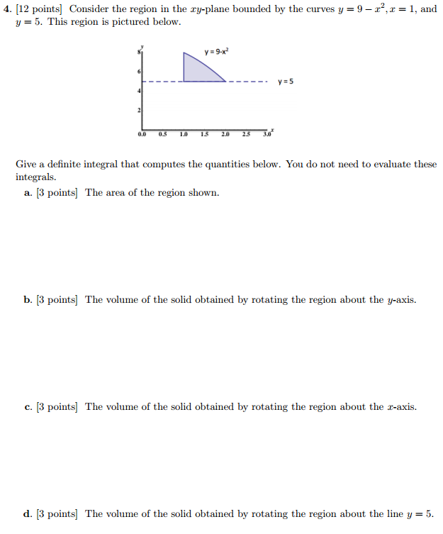

***5.*** Evaluate 

*Solution:*

*Integration by parts: Let f(x) = arc sin x and g′(x) = 1. Then f ′(x) = 1/(1–x2)1/2 and g(x) = x. So*



***6.*** The base of a solid is a disk of radius 5. Each cross section cut by a plane perpendicular to a diameter is an isosceles right triangle with hypotenuse on the base. Express the volume of the solid as a Riemann integral. *(Do not evaluate.)*

*Solution:*



*The equation of this circle is x2 + y2 = 25. Let us assume that the diameter referred to in the question lies on the x-axis. Then, taking a typical slice at x (in the interval [-5, 5], with thickness ∆x, the volume of the corresponding slice (an isosceles right triangle with hypotenuse 2y = 2 Sqrt(25 - x2) is given by*

*∆V= ½  y (2y) ∆x =(25 - x2) ∆x. Thus:*



***7.*** *University of Michigan test problem:*

The RideJoyfully company wants to design a bicycle ramp using the shape of the function  where L is the length in meters of the base of the ramp.

Find the length of the ramp.

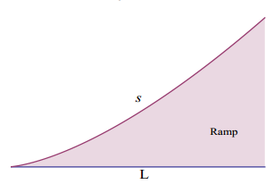

*Solution:*





***8.*** Consider the triangle with vertices (0, 2), (6, 2), (3, 4). This triangle is rotated about the axis y = -3. Express the volume of this solid of revolution as a Riemann integral. *(Do not evaluate.)*

*Solution:*



*The equations of the two non-horizontal sides are: y = (2/3)x + 2 and y = (-2/3)x + 6. Solving for x, we obtain: x = (3/2) (y – 2) and x = -(3/2) (y – 6), respectively.*

*Using shells, the radius of the shell at y is y – (-3) = y + 3 and the length of the shell is -(3/2) (y – 6) – ((3/2) (y – 2)) = 12 – 3y. Hence:*



***9.*** Assume that *m* and *n* are positive integers. Using integration by parts, derive the following reduction formula:



*Solution:*

*Let f(x) = (ln x)n and g′(x) = xm. Thus f′(x) = n(ln x)n-1(1/x) and g(x) = xm+1/(m+1). Thus:*



10. *University of Michigan test problem:*

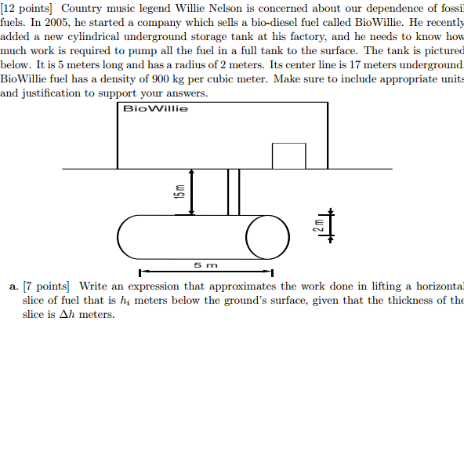

*Solution: Using the ground’s surface as our horizontal axis and h be the variable on the vertical axis, then the cross section of the tank can be descirebed by*

*x2 + (h + 17)2 = 4.*



Distance = -h



b. [ 5 pts] Help Willie Nelson by computing the work required to pump all the fuel in a full tank to the ground’s surface. Express your answer as a Riemann integral. *(Do not evaluate.)*

*Solution:*



*If a lion could talk, we could not understand him.*

- [**Ludwig Wittgenstein**](http://www.brainyquote.com/quotes/quotes/l/ludwigwitt165052.html)