# MATH 162 Solutions: TEST II

# Friday the 13 March 2015





**PART I** *(Answer all four problems.)*

1. Compute the value of the following improper integral:



*Solution:*



1. Albertine ponders the following recursively defined sequence:

c1 = 1,

 for n ≥ 1

(a) Find the values of c2 , c3 and c4.

*Solution:*

*Setting n = 1:*

**

*Setting n = 2:*

**

*Setting n = 3:*

**

(b) Assuming that the limit of cn as *n* → ∞ exists, help Albertine to find its *exact* value.

*Solution:*

*Assume that L = lim cn exists. Then:*



*and so:*

**

*Multiplying both sides by L yields: L2 = 1 + 3L. So: L2 – 3L – 1 = 0. Using the quadratic formula:*

**

*We reject the negative root, since c1 > 0 and all subsequent terms of the sequence are also positive (reasoning inductively).*

*Thus, if lim cn exists, this limit must be*

**

1. Determine *convergence* or *divergence* of the following improper integral. Justify your answer:

 (*Hint:* Integrate.)

*Solution:*



1. The life-span (in years) of a vampire bat can be modeled by a random variable *X* with probability density function

 

1. Find the constant *c*. (*Hint:* Every bat must die.)

*Solution:*



Hence c = 1/10

1. Find the probability that a randomly chosen vampire bat will *live longer than 11 years*. (Express your answer to the *nearest hundredth*.)

*Solution:*



**PART II** *Select any 4 of the following 5 sequences.* For each selected sequence, determine *convergence* or *divergence*. *Briefly* justify each answer. *In the case of convergence, find the limit.*  Calculator results will not earn full credit. (You may answer all 6 to earn extra credit.)

1. 

*Solution: Let h = 1/(13n). Then n = 1/(13h) and as n → ∞, h → 0. Hence:*



*Hence the sequence an converges to 1/13.*

2. 

*Solution: Note that:*



*Hence the sequence bn converges to e2.*

3. 

*Solution: Rationalizing the “numerator” yields:*

**

*Hence the sequence cn converges to 13.*



*Solution*: The sequence converges:





*Solution*: *The sequence converges:*

*ln n/ n → 0*

*cos (/n) → cos(0) = 1*

**

*Thus*



**PART III** Select any 4 of the following 5 series. For each selected series, determine *convergence* or *divergence*. Justify each answer. (You may answer all 5 to earn extra credit.)

1. 

*Solution: Since this series is telescoping, we will consider the sequence of partial sums:*

*s1 = arctan(0) – arctan(1)*

*s2 = (arctan(0) – arctan(1)) + (arctan(1) – arctan(2) = – arctan(2)*

*s3 = (arctan(0) – arctan(1)) + (arctan(1) – arctan(2)) + (arctan(2) – arctan(3))*

*= – arctan(3)*

*We infer that, in general, sn = -arctan(n).*

*Now sn = -arctan n → - /2 as n → ∞. So the series is convergent.*

2. 

*Solution: Applying the ratio test*

**

*we find that the series converges since r < 1.*

3. 

*Solution:*

*Since ln x < x , we have:*



*Thus, invoking both the p-test and the Comparison Test, our original integral converges.*

4. 314.314314314…

*Solution: This is the geometric series: 314 + (314)10 -3 + (314)10 -6 + …*

*Since r = 10 -3 < 1, our series converges.*

*Its sum is*



1. 

*Solution: Consider the following inequality:*



*Using the p-test, we see that the smaller series diverges and hence our series diverges as well.*

**PART IV**. Select any three of the following four problems. You may answer all four for extra credit. For each improper integral below, determine convergence or divergence. ***Justify each answer!***



*Solution: Since ln x < x for x > 1*



Now using the Comparison Test, and the p-test for p = 3, we see that our improper integral converges.



*Solution: Observe that*







*Thus, invoking the Comparison Test, our original integral converges.*



*Solution: Observe that*



*Thus, invoking the Comparison Test, our original integral converges.*



*Solution:*

*Observe that*



*Thus, invoking the Comparison Test, our original integral diverges.*

**PART V**. Select any 3 of the following 4 problems. You may answer all four for extra credit. For each numerical series below, determine *convergence* or *divergence*. Justify each answer.

(A) 

*Solution: Applying the ratio test to this positive series:*

**

*Since r < 1, we conclude that our positive series converges.*

(B) 

*Solution: Applying the nth root test to this positive series:*



*Since  < 1, we conclude that our positive series converges.*

(C) 

*Solution: Applying the ratio test to this positive series:*

**

(D) 

*Solution: Since*



*We may invoke the n th Term Test for Divergence to conclude that our original series diverges.*

*Since  we apply the nth Term Test for Divergence to conclude that our series diverges.*

EXTRA CREDIT (University of Michigan midterm problem)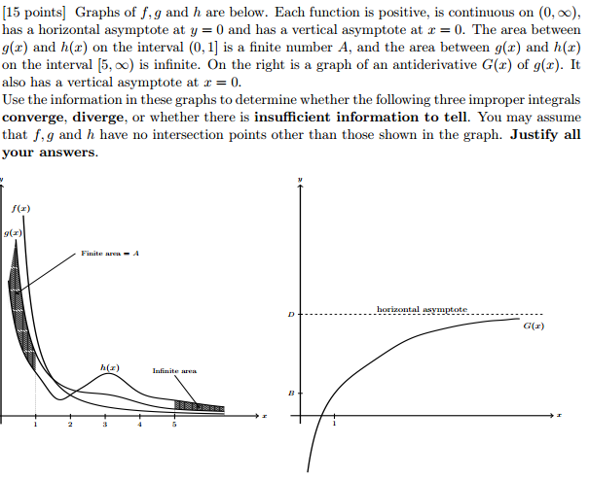



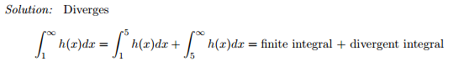



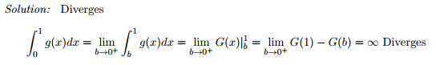



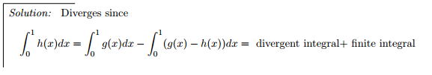



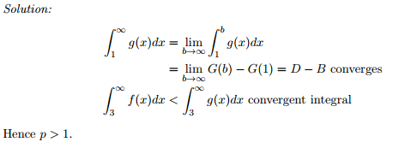

*I tell them that if they will occupy themselves with the study of mathematics they will find in it the best remedy against the lusts of the flesh.*

Thomas Mann, **THE MAGIC MOUNTAIN**