**WORKSHEET I**

Review

1.   Find the *area* of the region bounded by the x-axis and the curve

y = x(x – 1)(x – 3)

*Sketch!*

2.   Find the area under one arch of the curve y = sin 4x *Sketch!*

3.   Find the area bounded between the curves y = x2/2 and y = x + 4.

4.   Evaluate by first interpreting as area:



5.   Evaluate



(*Hint:*  Think about the area interpretation of this integral.)

6. Evaluate



*Sketch!*

7.   Show that



8.   Using the *Fundamental Theorem of Calculus*, compute the derivative of the function



9.   Suppose that Charlotte, the spider, travels along the x-axis from time t = 0 until t = 3 hrs and that her velocity function is given by:

v(t) = t(1+t2)1/2  mph.

How far does Charlotte travel during these three hours?



10. Using the method of *judicious guessing* or *substitution*, evaluate each of the following indefinite integrals:

(a) 

(b) 

(c) 

(d) 

11. Find the *maximum* value of the function G(x) = - x4 ln x .

12. *Sketch* the curve below, finding all zeroes, singularities, horizontal and vertical asymptotes.



13. *Sketch* the following curve, finding all *local extrema* and *points of inflection*. Where is the function *concave up*? *concave down*? Find *global extrema* if they exist.



14. Compute the following limit:



15. Find the point on the line x/a + y/b = 1 that is *closest* to the origin.

16. Find the values of *p* and *q* for which the function

F(x) = x3 + px2 + qx

(a) has a *local max* at x = -1 and a *local min* at x = 3.

(b) has a *local min* at x = 4 and a *point of inflection* at x = 1.

17. Express the following as a Riemann integral and evaluate:



18. Give the definitions of the hyperbolic functions sinh x, cosh x, tanh x and sech x. Prove that (cosh x)2 – (sinh x)2 = 1 and

1 – (tanh x)2 = (sech x)2.

19. Find the *area* of the region bounded by the curves y = x2014 and

y = x2015. Sketch!



*Twice and thrice over, as they say, good is it to repeat and review what is good.*

– Plato

* 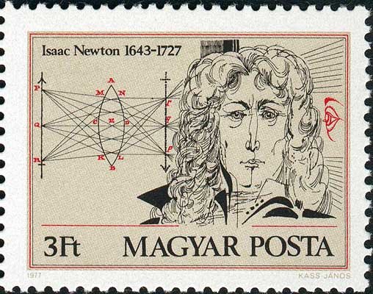

[Course Home Page](http://www.math.luc.edu/~ajs/courses/162spring2015/index.pdf)         [Department Home Page](http://www.math.luc.edu/)        [Loyola Home Page](http://www.luc.edu/)