**WORKSHEET XVII**

Taylor polynomials, Taylor series



1. Find the 5th degree Maclaurin polynomial of e3x.
2. Find the 4th degree Maclaurin polynomial of (1 – x) ex.
3. Find the 3rd degree Taylor polynomial of  1/(1 + x2)  centered

at c = 1.

1. Find the 5th degree Maclaurin polynomial of  (3x – sin(3x))/x3.
2. Find the first four *non-zero* terms of the Maclaurin series of exp(x2 + x).
3. Write the Maclaurin series expansion for x/(1 + x2) and for

ln(1 + x2).  Find the interval of convergence for each series.  What is the relationship between these two series?

1. Using an appropriate power series expansion, compute

 n/7n.    (*Hint:* Differentiate an appropriate geometric series.)

1. Find the Maclaurin series of each of the functions:

2/(3 – x),  5/(4 – x),  and   (23 – 7x)/ [(3 – x)(4 – x)].

1. Find the 99th derivative of 1/(a – bx) by using an appropriate power series.
2. Find the *binomial expansion* of (1 + x)-4.  What is its radius of convergence?
3. Find the Maclaurin series expansion of 1/(1 + x2)1/2.
4. Find the 23rd derivative of 1/(1 + x2)1/2.
5. Using an appropriate Maclaurin series, evaluate the limit of

(sin x – x)/x3  as x 0.

1. Evaluate the limit of (sin x – tan x)/x3  as x 0 without using l’Hôpital’s rule.
2. Evaluate the limit of (ln x) / (x – 1) as x 1 without using l’Hôpital’s rule.
3. Evaluate the limit of 1/(sin x) – 1/x as x 0 without using l’Hôpital’s rule.
4. Evaluate the limit of (sin x – x)/(tan x – x) as x 0 without using l’Hôpital’s rule.
5. Evaluate the limit of ln x / (ex – e) as x 1 without using l’Hôpital’s rule. (Hint: Let t = x – 1.)
6. Find  without using l’Hôpital’s rule.
7. State Taylor's inequality.   Using this inequality, prove that the Maclaurin series of ex, sin x, cos x, and cosh x each converge to the given function everywhere.

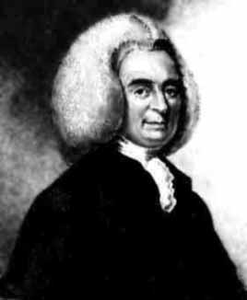

[Colin Maclaurin](http://www-history.mcs.st-and.ac.uk/Biographies/Maclaurin.html) (1698 – 1746)



[Brook Taylor](http://www.britannica.com/EBchecked/topic/584793/Brook-Taylor) (1685 - 1731)

[Course Home Page](http://www.math.luc.edu/~ajs/courses/162spring2015/index.pdf)          [Department Home Page](http://www.math.luc.edu/)        [Loyola Home Page](http://www.luc.edu/)