WORKSHEET XVIII
Complex Numbers; Euler’s formula
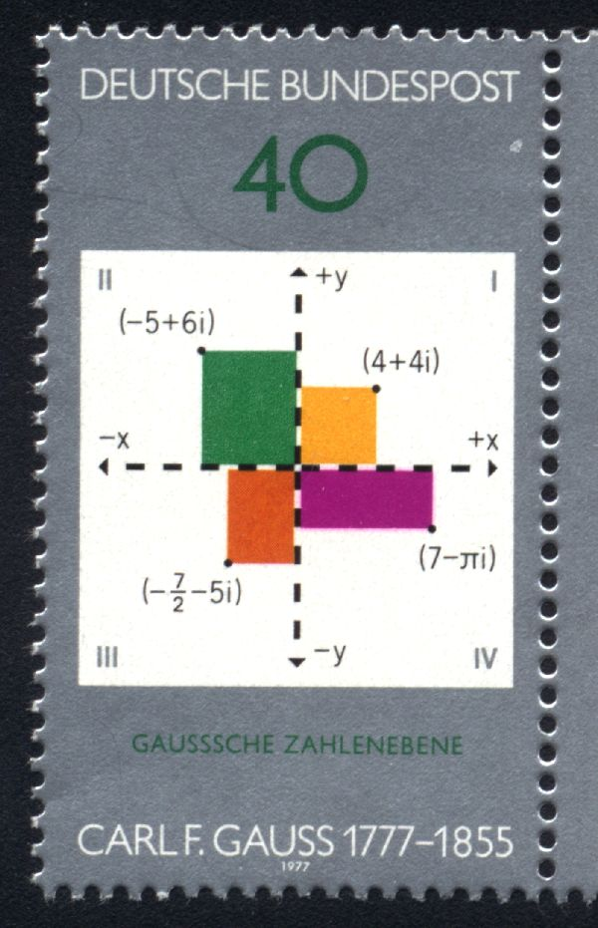
1. Let z = 2 + 3i and w = 6 – i. Compute and express each of the following in the form a + bi. Plot each number in the complex plane.
- z + w
- 5z
- z – 3w
- zw
- 1/z
- z/w
- 2z² + 1/w

- Find the modulus and argument of each of the following:
- 1 + i
- -1 – i
- 1 + 2i
- 3 + 5i

- Justify Euler’s formula using power series.

- Explain how de Moivre’s theorem is a special case of Euler’s formula.

- Express z = 1 + i in polar form, re^{iθ}. What is the modulus of z? What is its argument?

- Express each of the following in the form a + bi
- e^{πi}
- i^{i}
- (1 + i)¹⁰⁰

- Using de Moivre’s theorem, express sin 3θ in terms of sin θ and cos θ.

- Using de Moivre’s theorem, express cos 5θ in terms of sin θ and cos θ.

- Find the four fourth roots of -1.

- Find the three cube roots of 8i.

- Find the five fifth roots of 1.

- Using power series, determine a relationship between cosh x and cos x and between sinh x and sin x.

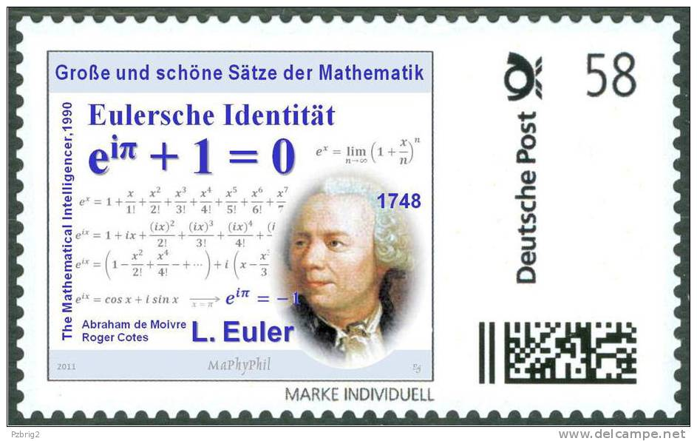

The imaginary number is a fine and wonderful resource of the human spirit, almost an amphibian between being and not being.
- Gottfried Wilhelm Leibniz (1646-1716)

Course Home Page Department Home Page Loyola Home Page

