**WORKSHEET II**

Volume & Cavalieri’s principle

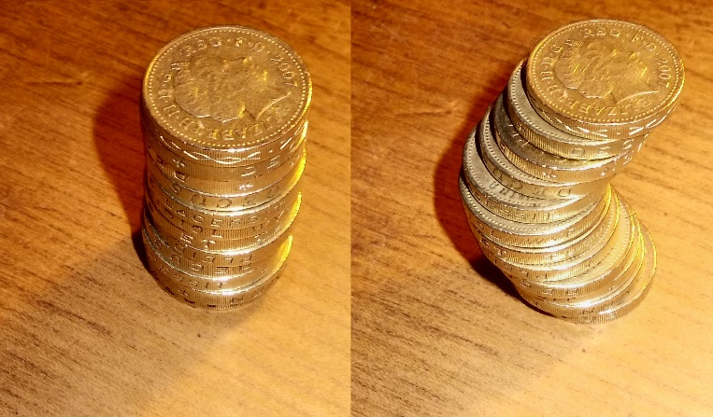

1.   The base of a solid is the region bounded by the curve y = (sin x)1/2 and the interval [0, ] on the x-axis. The cross sections perpendicular to the x-axis are equilateral triangles with bases running from the x-axis to the curve. Find the volume of this solid.

2. The cross sections of a solid are squares perpendicular to the x-axis with their centers on the axis. If the square cut off at x has edge length of 2x2, find the volume of the solid between x = 0 and x = a.

3. Find the volume of a right circular cone of height *h* and base radius *r*. (*Hint:* Revolve an appropriate triangle about the x or y-axis.)

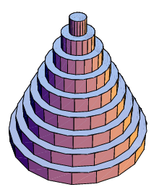

4. Consider the triangle *T* with vertices (0, 0), (2, 0), and (1, 1). Find the volume of the solid of revolution obtained by rotating *T* about:

1. the x-axis
2. the y-axis
3. the vertical line x = 3
4. the horizontal line y = -1
5. The horizontal line y =2

5. Consider the portion of the ball of radius *R* centered at the origin for *y ≥ R – h* where *0 < h < R*. Find the volume of this spherical cap.

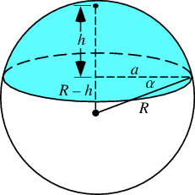

6. Consider the region R bounded by the curves y = x2 and y = 2 – x. Find the volume of the solid obtained by rotating R about axis x = -3.

7. Let C be the region bounded by the lines y = x, y = 2x and y = 2. Find the volume of the solid obtained by rotating C about the x-axis.

8. Consider the region A bounded by the curve y = x2 – x3 and the x-axis. Find the volume obtained by rotating A about:

1. the y-axis
2. the vertical line x = 1
3. the vertical line x = 3
4. the vertical line x = -3

9. The region in the xy-plane defined by the inequalities 0 ≤ x ≤ 2 and x2/4 ≤ y ≤ 1 is rotated about the given axis below. Find the volume of the solid of revolution so generated.

(a) the x-axis

(b) the y-axis

(c) the vertical line x = 2

(d) the horizontal line y = 1

10. Find the volume of the *torus* obtained by revolving the disk x2 + y2 ≤ a2 about the line x = b,

where b > a.

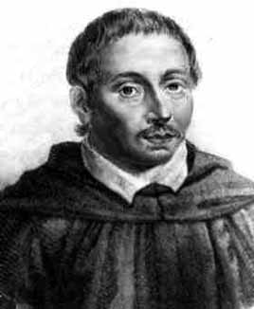

[**Bonaventura Francesco Cavalieri**](http://www-history.mcs.st-and.ac.uk/Biographies/Cavalieri.html) (1598 – 1647)

[Course Home Page](http://www.math.luc.edu/~ajs/courses/162spring2015/index.pdf)          [Department Home Page](http://www.math.luc.edu/)        [Loyola Home Page](http://www.luc.edu/)