**WORKSHEET VI**

Integration by Parts

1. Using *integration by parts*, find the indefinite integral of each of the following functions.
2. x sin x
3. x2 sin x
4. x ln x
5. ln x
6. (ln x)2
7. x e3x
8. arctan x
9. ex sin x
10. (ln x)/x
11. arcsin(2x)
12. cos(ln x)
13. (ln x)4/x

(m) x arctan(x2)

1. sec3 x

(o) x cosh x

1. (a) Derive the reduction formula:



(b) Using this reduction formula, compute anti-derivatives of sec4 x and of sec5 x.

1. (a) Derive the reduction formula:



(b) Using this reduction formula, compute an anti-derivative of x3 sin x.

***Common integration is only the memory of differentiation.***

### - [Augustus de Morgan](http://www-groups.dcs.st-and.ac.uk/~history/Mathematicians/De_Morgan.html) (1806 – 1871)

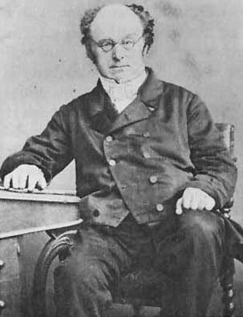

***Nature laughs at the difficulties of integration.***

- [Pierre-Simon de Laplace](http://www.gap-system.org/~history/Biographies/Laplace.html) (1749 - 1827)

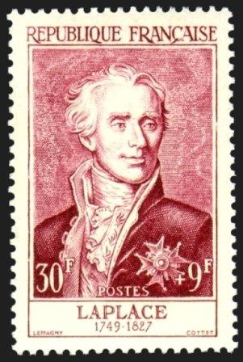

[Course Home Page](http://www.math.luc.edu/~ajs/courses/162spring2015/index.pdf)          [Department Home Page](http://www.math.luc.edu/)        [Loyola Home Page](http://www.luc.edu/)