**Worksheet VII**

Hyperbolic Functions

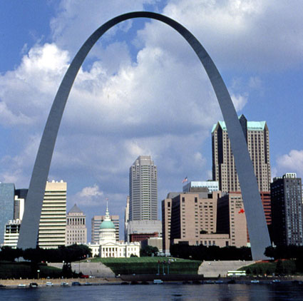

*The St. Louis arch is in the shape of a hyperbolic cosine.*

Hyperbolic functions are very useful in both mathematics and physics.  You may have already encountered them in Math 118 or in Math 161.   If not, here are their definitions:

**sinh x = (ex - e-x)/2**   
**cosh x = (ex + e-x)/2**   
**tanh x = sinh(x) / cosh(x)**   
**coth x = 1/tanh(x)**   
**sech x = 1/cosh(x)**   
**csch x = 1/sinh(x)**

Oddly enough, they enjoy certain similarities with the trigonometric functions, with which you are much more familiar.

1.  Graph the six hyperbolic functions:  sinh x, cosh x, tanh x, coth x, sech x, csch x.  For each curve, determine the limit of *y* as *x* tends toward infinity or negative infinity.  Which of the functions are *odd*?  which are *even*?  (Remember that an *odd function* is one that is symmetric with respect to the origin;  an *even function* is one that is symmetric with respect to the y-axis.)

2.   Find the derivative and the indefinite integral of each of the six hyperbolic functions.

3.  Expand cosh(x+y), cosh(2x), tanh(x+y), and tanh(2x).

4.   Show that  (cosh x)2 – (sinh x)2 = 1.

5.   Show that   1 – (tanh x)2 = (sech x)2.

6.   Show that:



(Note that this corresponds to the half-angle formula for cosine. Similar formulas exist for sinh(x/2) and tanh(x/2).)   
(*Hint:* Compare the squares of each of the two sides.)

7.   Find the limit of (sinh x) / ex  as *x* tends toward infinity.

8.    Simplify the expression:



Use your answer to find a formula for the inverse of sinh(x).

9.   The inverse of sinh x in Mathematica is represented by ArcSinh[x].   Graph the curve y = ArcSinh(x).  Find formulas for the derivative and the integral of arcsinh(x).

10.   Repeat question 9 for the functions ArcCosh(x) and ArcTanh(x).

11.  If the ends of a chain are attached to the points (-1, 0) and (1, 0), the chain will take the shape of the curve (called a *catenary*) given by:



where the constant *a* depends upon the length of the chain.

Show that for any value of *a*, the graph of y = f(x) passes through the two points (-1, 0) and (1, 0).

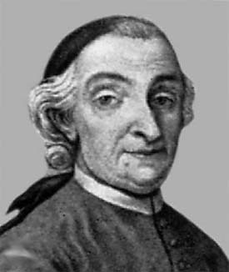  
[**Vincenzo Riccati**](http://www-gap.dcs.st-and.ac.uk/~history/Mathematicians/Riccati_Vincenzo.html) (1707 - 1775) is given   
credit for introducing the hyperbolic functions.

[Course Home Page](http://www.math.luc.edu/~ajs/courses/162spring2015/index.pdf)          [Department Home Page](http://www.math.luc.edu/)        [Loyola Home Page](http://www.luc.edu/)